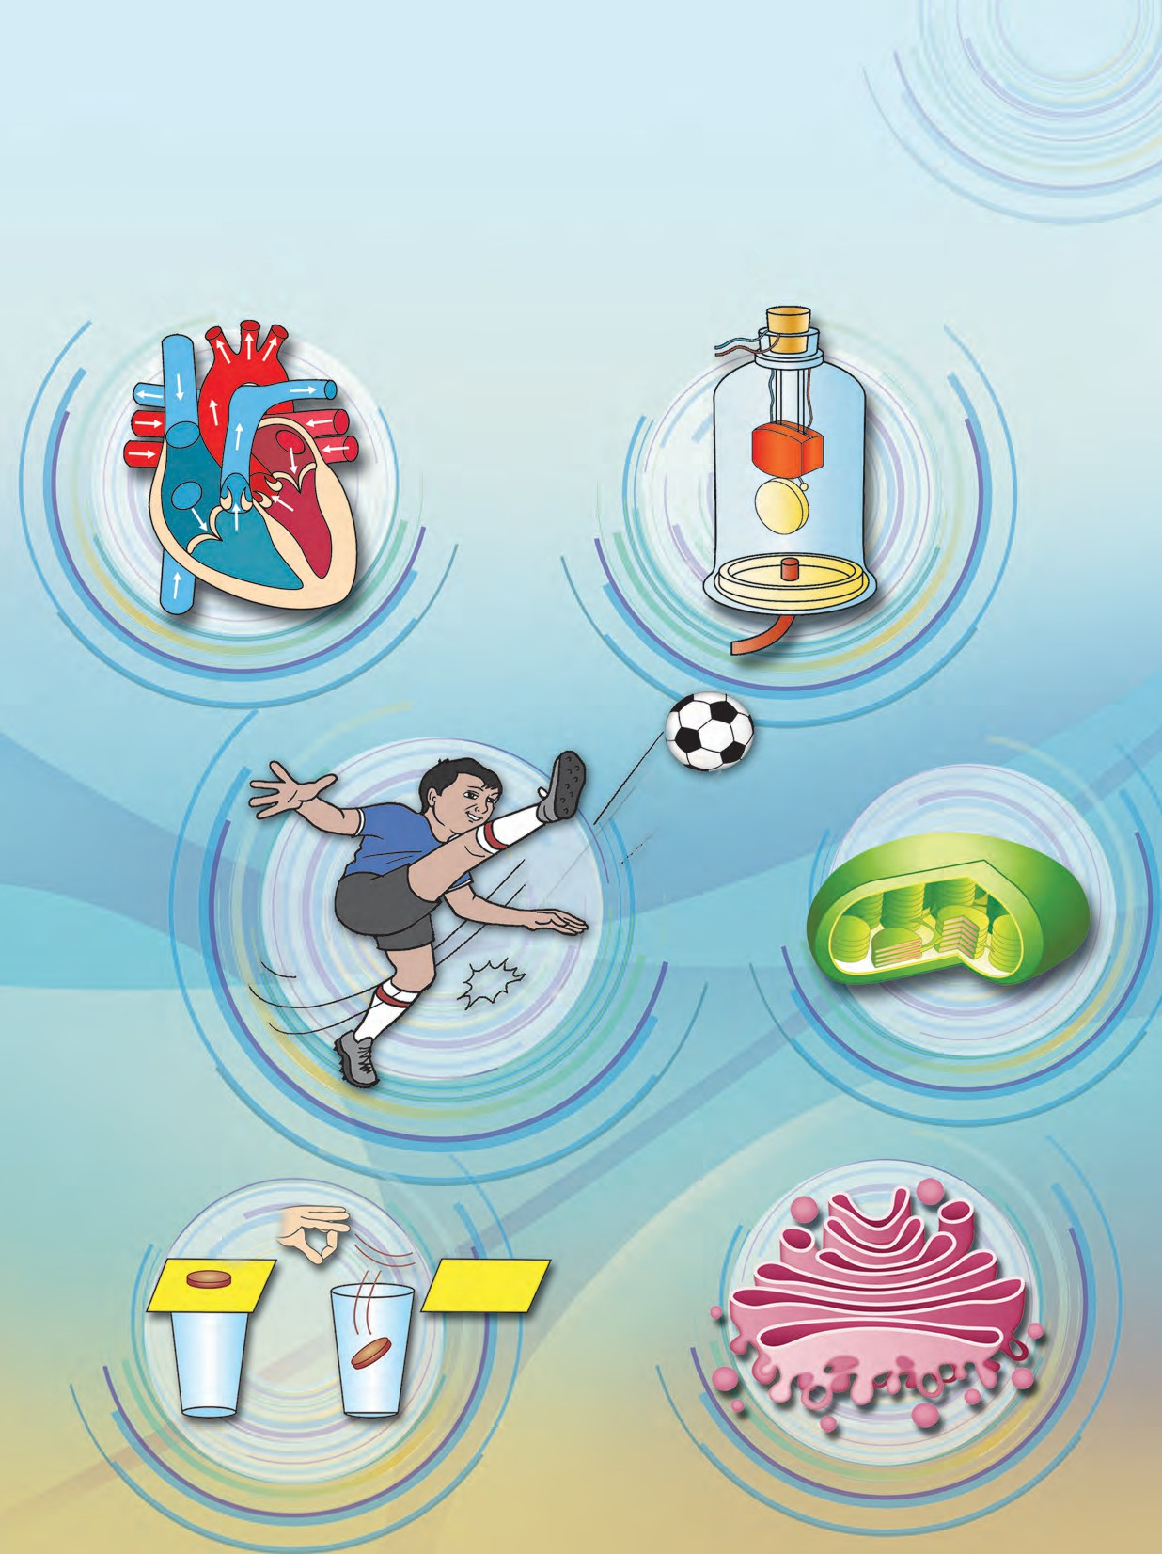

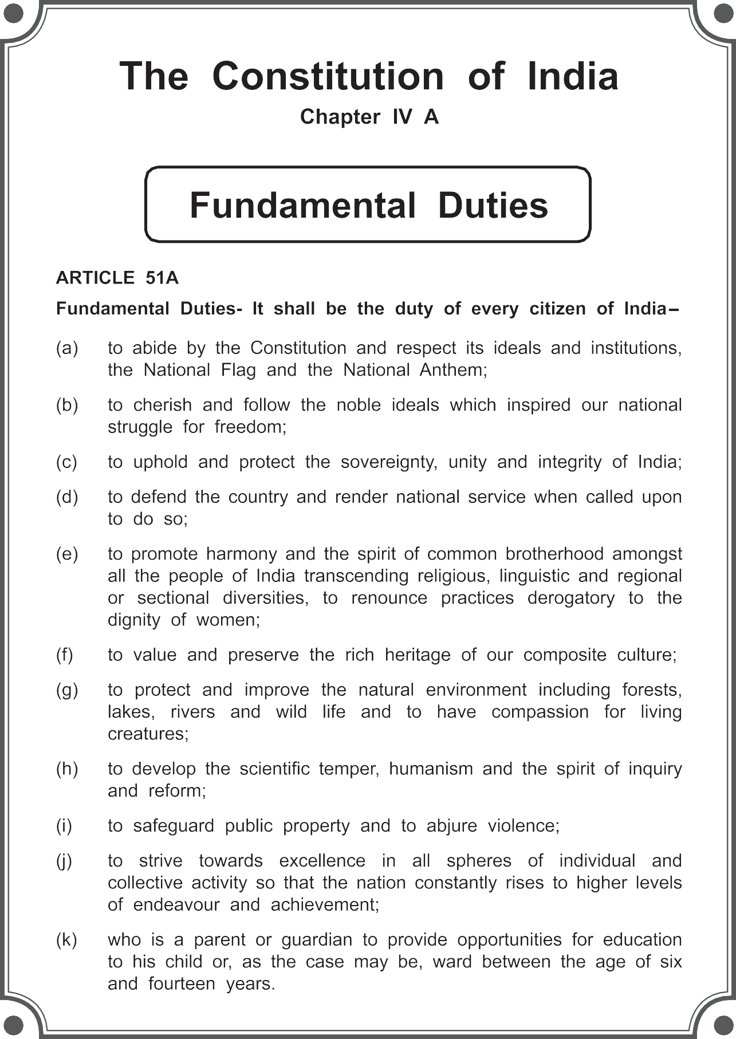

Permission is granted for enforcing this textbook from the academic year 2018-19 in the meeting, held on the date 29.12.2017, of the coordination committee constituted by the Government Resolution No: Abhyas-2116/(pra kra.43/16) S.D -4 dated 25.4.2016

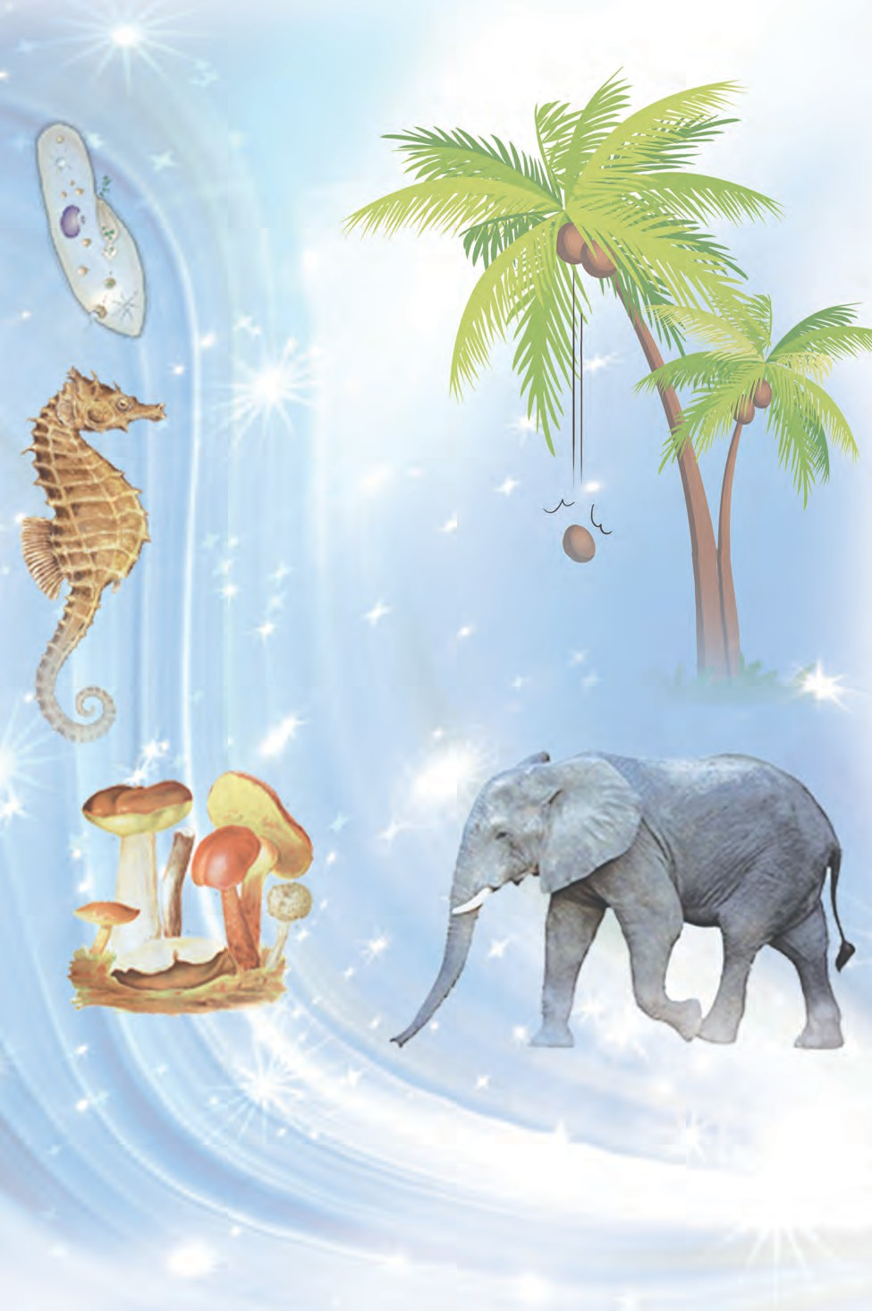

## STANDARD EIGHT

**Maharashtra State Bureau of Textbook Production and Curriculum Research, Pune.**

The digital textbook can be obtained through DIKSHA App on your smartphone by using the Q.R.Code given on title page of the textbook and useful audio-visual teaching-learning material of the relevant lesson will be available through the Q.R. Code given in each lesson of this textbook.

**First Edition : 2018 © Maharashtra State Bureau of Textbook Production**

**Reprint : 2022**

**and Curriculum Research, Pune - 411 004.**

The Maharashtra State Bureau of Textbook Production and Curriculum Research reserves all rights relating to the book. No part of this book should be reproduced without the written permission of the Director, Maharashtra State Bureau of Textbook Production and Curriculum Research, ‘Balbharati’, Senapati Bapat Marg, Pune 411004.

**Science Subject Committee :**

**Dr. Chandrashekhar Murumkar, Chairman**

Dr. Dilip Sadashiv Joag, Member Dr. Sushma Dilip Joag, Member Dr. Pushpa Khare, Member

Dr. Imtiyaz S. Mulla, Member

Dr. Jaydeep Vinayak Sali, Member Dr. Abhay Jere, Member

Dr. Sulabha Nitin Vidhate, Member Smt. Mrinalini Desai, Member

Shri. Gajanan Suryawanshi, Member Shri. Sudhir Yadavrao Kamble, Member Smt. Dipali Dhananjay Bhale, Member

Shri. Rajiv Arun Patole, Member-Secretary

**Science Study Group :**

Dr. Prabhakar Nagnath Kshirsagar Dr. Vishnu Vaze

Dr. Prachi Rahul Chaudhary

Dr. Shaikh Mohammed Waquioddin H. Dr. Ajay Digambar Mahajan

Dr. Gayatri Gorakhnath Choukade Shri. Prashant Panditrao Kolase Shri. Sandip Popatlal Chordiya Shri. Sachin Ashok Bartakke

Smt. Shweta Dilip Thakur Shri. Rupesh Dinkar Thakur

Shri. Dayashankar Vishnu Vaidya Shri. Sukumar Shrenik Navale Shri. Gajanan Nagoraoji Mankar

Shri. Mohammed Atique Abdul Shaikh Smt. Anjali Lakshmikant Khadke

Smt. Manisha Rajendra Dahivelkar Smt. Jyoti Milind Medpilwar

Smt. Dipti Chandansingh Bisht

Smt. Pushpalata Ravindra Gawande Smt. Anita Rajendra Patil

Smt. Kanchan Rajendra Sorate Shri. Rajesh Vamanrao Roman Shri. Nagesh Bhimsevak Telgote Shri. Shankar Bhikan Rajput Shri. Manoj Rahangdale

Shri. Hemant Achyut Lagvankar Smt. Jyoti Damodar Karane Shri. Vishwas Bhave

**Cover and illustrations :**

Shri. Vivekanand Shivshankar Patil Ashana Advani

**Typesetting :**

DTP Section, Textbook Bureau, Pune

**Translation :**

Dr. Sushma Dilip Joag Dr. Dilip S. Joag

Dr Pushpa Khare Dr. Jaydeep V. Sali

Shri. Sandip P. Chordiya Smt. Shweta D. Thakur

**Scrutiny :**

Dr. Pushpa Khare Smt. Shweta Thakur

Paper : 70 GSM Creamwove Print Order :

Printer :

**Production :**

**Shri. Sachchitanand Aphale**

Chief Production Officer

**Shri. Rajendra Vispute**

Production Officer

**Publisher :**

**Shri. Vivek Uttam Gosavi**

Controller Maharashtra State Textbook

Bureau, Prabhadevi, Mumbai - 400 025.

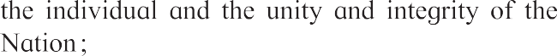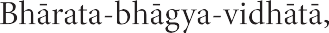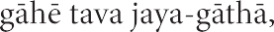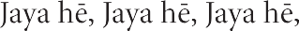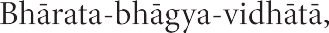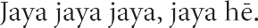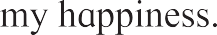

# Preface

Dear students,

Welcome to std VIIIth. We have great pleasure in offering you this General Science textbook based on the new syllabus. From Primary level till today, you have studied Science through various textbooks. From std 8th onwards, you will be able to study the fundamental concepts and technology through the medium of different branches of Science.

The basic purpose of this 'General Science' text book is 'Understand and explain to others' the science that relates to our day to day lives. While studying the concepts, principles and theories in Science, understand their connection to daily affairs. While studying this textbook, use the sections 'Can you recall? and 'Can you tell?' for revision. You will learn Science through many activities given under the titles such as 'Observe and discuss' and 'Try this' or ' Let's try this'. Activities like 'Use your brain power', 'Research', 'Think about it' will stimulate your thinking power. We insist that you must perform all these activities.

Many experiments have been included in this text book. Follow the given procedure, make your own observations and conclusions to perform these experiments. You can ask for help from your teachers, parents or classmates - whenever needed. This book reveals the Science, interesting information and the developed technology behind many day to day happenings. All of this is explainecd through the medium of activities.

In today's world of speedy technology, you are already close to computers and smartphones. While studying this textbook, make full and proper use of Information and Communication Technology tools.

For effective learning, Q.R. code app will provide you additional infromation, useful audio-visual material regarding each lesson. This will definitely help you and make you content rich.

While performing given activities and experiments take all precautions regarding handling of apparatus, chemicals etc. and encourage others to do the same.

When the activities involve plants and animals, you must perform them keeping in mind the nature and environment conservation. Harm to animals and plants must be strictly avoided.

Do communicate with us about the part you liked as well as about the difficulties that you faced while reading, understanding and studying the book. Our best wishes for

your academic progress.

Pune

Date : 18 April 2018, Akshaya Tritiya Indian Solar Year : 28 Chaitra 1940

**(Dr. Sunil Magar) Director**

Maharashtra State Bureau of Textbook Production and Curriculum Research, Pune

## For Teachers

* The real objective of science education is to develop the ability to think logically and with discretion about events that are happening around us.
* From std IIIrd to Vth we have explained easy science to our students through the medium of 'Environmental Study' while from std VIth to VIIth we are introducing them Science through the text books.
* Considering the age group std 8th students, they should be given an opportunity and scope for their curiousity about the events of the world, their propensity to find out the causes behind them and to develop their own initiative and capacity to take the lead.
* In the process of learning Science, the skill of performing experiments is necessary for observation, logic, conclusion, comparison and application of recieved information. Therefore purposeful efforts must be taken to develop all these skills. All the observations by the students should be accepted and we should help them to reach upto expected conclusion.
* It is our responsibility that students will take interest to enrich their science. As usual, you must be leading to develop scientific attitude, creativity, skills and content in your students.
* You can use ‘Let’s recall’ to review the previous knowledge required for a lesson and ‘Can you tell?’ to introduce a topic by eliciting all the knowledge that the students already have from their own reading experience. You may of course use any of your own activities or questions for this. Activities given under ‘Try this’ and ‘Let’s try this’ help to explain the content. Former are for students to do themselves and latter are those that you are expected to demonstrate.

‘Use your brain power!’ is meant for application of previous knowledge as well as the new lesson, and ‘Always remember’ gives important suggestions/information or values. ‘Research’, ‘Find out’, ‘Do you know?’, ‘Introduction to scientists’ and ‘Institutes at work’ are meant to give some information about the world outside the textbook and to develop the habit of doing independent reference work to obtain additional information.

* This textbook is not meant only for reading and explaining but to guide students to obtain knowledge through activities. An informal atmosphere in the classroom is required to achieve the aims of this textbook. Encourage more and more student to participate in discussions, experiments and activities. Special efforts should be made to organise presentations or report-reading in the class based on students’ activities and projects. Science Day and other relevant occasions/ days must be observed.
* The science content of the textbook has been complemented with Information Communication Technology. To study different scientific contents these techniques must be used under your observation. Also you should encourage the students to gain additional information by using Q.R. codes.

**Front and back covers : Pictures of various activities, experiments and concepts in the book.**

DISCLAIMER Note : All attempts have been made to contact copy righters (©) but we have not heard from them. We will be pleased to acknowledge the copy right holder (s) in our next edition if we learn from them.

**Learning Outcomes : Standard VIII**

The learner...

**The learner is to be provided with opportunities in pairs /groups/ individually in an inclusive setup and encouraged to ...**

* Explore surroundings, natural

**•**

**•**

**•**

**•**

processes, phenomena using senses viz.watching, touching, tasting, smelling, hearing.

Pose questions and find answers through reflection, discussion, designing and performing appropriate activities, role plays, debates, use of ICT, etc.

Record the observations during the activity , experiments, surveys, field visits, etc.

Analyse recorded data, interpret results and draw inference / make generalisations and share findings with peers and adults.

Exibits creativity presenting novel ideas, new designs /patterns

,improvisation, etc.

* Internalise, acquire and appreciate values such as cooperation, collaboration, honest reporting, judicious use of resources, etc .
* To do different activities by awaken different crisis /disaster improvising in vicinity.
* Understand the astronomical

**•**

**•**

**•**

concepts and progress done by human about it.

Discuss on scientific research stories and understand its importance.

To take efforts for protection of the environment. For eg: The use of fertilizers and pesticides, to take efforts for conservation of the environment.

To use the available raw materials using proper planning and format.

* To spread awareness about consequences of misuse of natural resources.
  + 1. differentiates materials and organisms, such as, natural and human made fibres; contact and non -contact forces; liquids as electrical conductors and insulators; plant and animal cells; viviparous and oviparous animals,on the basis of their properties, structure and functions.
    2. classifies materials and organisms based on properties /characteristics, for example, metals and non metals; useful and harmful microorganisms; sexual and asexual reproduction; celestial objects; exhaustible and inexhaustible natural resources, etc.
    3. conducts simple investigations to seek answers to queries, for example, What are the conditions required for combustion ? Why do we add salt and sugar in pickles and murambas? Do liquids exert equal pressure at the same depth ?
    4. relates processes and phenomenon with causes, for example, smog formation with the presence of pollutants in air; deterioration of monuments with acid rain, etc .
    5. explains processes and phenomenon, for example, various processes in human and animals; production and propagation of sound; chemical properties of electric current etc.
    6. write word equation for chemical reactions, for example, reactions of metals and non- metals with air, water and acids, etc.
    7. measures angles of incidence and reflection.
    8. prepares slides of microorganisms; onion peel, human cheek cells, etc and describes their microscopic features.
    9. draws labelled diagram/flow charts, for example, structure of cells, structure of heart and respiratory system, experimental set ups, etc .
    10. constructs/prepare models using materials from surroundings and explains their working, for example, ektari, electroscope, fire extinguisher, string instruments, periscope etc.
    11. exhibits creativity in designing, planning making use of available resources, etc.
    12. applies learning of scientific concepts in day–to-day life, for example, purifying water; segregating biodegradable and non-biodegradable wastes; increasing crop production;using appropriate metals and non-metals for various purposes; increasing/reducing friction; challenging myths, legends and taboos regarding adolescence, etc.
    13. discusses and appreciates stories of scientific discoveries.
    14. makes efforts to protect environment, for example, using resources judiciously; making controlled use of fertilisers and pesticides; suggesting ways to cope with environmental hazards, etc.
    15. sensitises others with the over utilization of natural resources.
    16. exhibits values of honesty, objectivity, cooperation, freedom from fear and prejudices.
    17. explains the formation of universe and the progress of humans in space technology.
    18. uses different ICT equipments to understand the different scientific concepts.

## Contents

**Page No.**

**Name of Lesson**

**No.**

1. Living World and Classification of Microbes 1
2. Health and Diseases 6
3. Force and Pressure 14
4. Current Electricity and Magnetism 23
5. Inside the Atom 28
6. Composition of Matter 39
7. Metals and Nonmetals 49
8. Pollution 54
9. Disaster Management 62
10. Cell and Cell Organelles 67
11. Human Body and Organ System 75
12. Introduction to Acid and Base 83
13. Chemical Change and Chemical Bond 89
14. Measurement and Effects of Heat 95
15. Sound 104
16. Reflection of Light 110
17. Man made Materials 116
18. Ecosystems 122
19. Life Cycle of Stars 129



1. **Living World and Classification of Microbes**
2. What is the hierarchy for classification of living organisms?



**Can you recall?**

1. Who invented ‘bionomial system’ of nomenclature?
2. Which levels of hierarchy are considered while writing the name in binomial nomenclature?

Biodiversity and need of classification

**In History......**

* Carl Linnaeus in 1735 divided living world in 2 kingdoms - Vegetabilia and Animalia.
* Haeckel in 1866 considered 3 kingdoms- Protista, Plants and Animals.
* In 1925 - Chatton created two groups Prokaryotes and Eukaryotes.
* In 1938 Kopland divided living organisms into 4 kingdoms- Monera, Protista, Plants and Animals.

Last year we learnt that all the living organism on earth have adapted according to geographic regions, food ingestion, defence etc. While adapting, many differences are observed in the organisms of same species too.

According to 2011 census, around 87 million species of living organisms are found on the earth- including land and sea. To study such a vast number, it was essential to divide them into groups. So groups and subgroups were created considering the similarities and differences among the living organisms.

This process of dividing living organism into groups and subgroups is called Biological classification.

Robert Harding Whittaker (1920-1980) was an American Ecologist. In 1969 he divided living organisms into 5 groups.

For this classification Whittaker considered following criteria

Kingdom 4. Plantae

Cell wall present and organisms can performs photosynthesis

Kingdom 3. Fungi

Cell wall present

but organisms can’t perform photosynthesis.

Kingdom 2. Protista

Kingdom1. Monera

Unicellular

Kingdom 5. Animalia No cell wall

Eukaryotes

Unicellular

Multicellular

Prokaryotes

Living Organisms

1. **Complexity of cell structure** : Prokaryotic and Eukaryotic.
2. **Complexity of organisms** : Unicellular or Multicellular.
3. Mode of nutrition :

Plants - Autotrophic- Photosynthetic

Fungi- Saprophytic- Absorption from dead organisms.

Animals- Heterotrophic and ingestive.

1. Life style :

Plants - Producers Animals - Consumers Fungi - Decomposers

1. Phylogenetic relationship :

Prokaryotic to Eukaryotic,

unicellular to multicellular.

* 1. **Five Kingdom system of classification**

*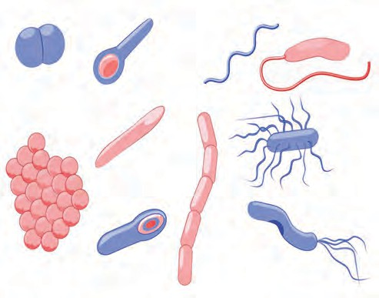Clostridium tetani*

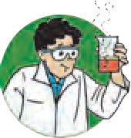

**Try this**

*Treponema pallidum*

*Vibrio choleri*

Kingdom 1 : Monera

**Activity :** Take a small drop of curd or buttermilk on a clean glass slide. Dilute it with a little water. Carefully keep a cover slip. Observe it under high power of compound microscope. What did you see ?

Moving, small rod-like microbes are lactobacilli bacteria.

All type of bacteria and blue green algae are included in the kingdom Monera.

Characteristics :

*Streptococcus pneumoniae*

*Staphylococcus aureus*

*Legionella pneumoniae*

*Clostridium botulinum*

*Salmonella typhi*

1. All the organisms are unicellular.
2. They may be autotrophic or heterotrophic.
3. These are prokaryotic cells without distinct nucleus or cell organelles

Kingdom 2. Protista

**Activity :** Prepare a temporary mount of one drop of pond water on a glass slide. Observe it under low power and high power of microscope. You will find some motile microbes with irregular shape. These are amoebae.

Characteristic :

1. Protista are single celled organisms with well defined nucleus enclosed in a nuclear membrane.
2. They have pseudopodia or hair like cilia or whip like flagella for locomotion.
3. Autotrophs- eg. *Euglena, Volvox* contain chloroplast.

Heterotrophs- eg. *Amoeba, Paramoecium*

Kingdom 3. Fungi

**Activity :** Take a moist piece of bread or bhakri and keep it in a container with lid for 2-3 days. After 2-3 days a fine cotton thread like tuft is found growing on the surface of the bread. Prepare a temporary mount of few threads from this culture and observe it under the microscope.

* 1. **Organisms from Kingdom Monera**

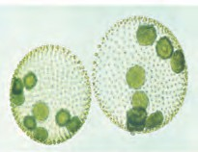

*Volvox Paramoecium*

*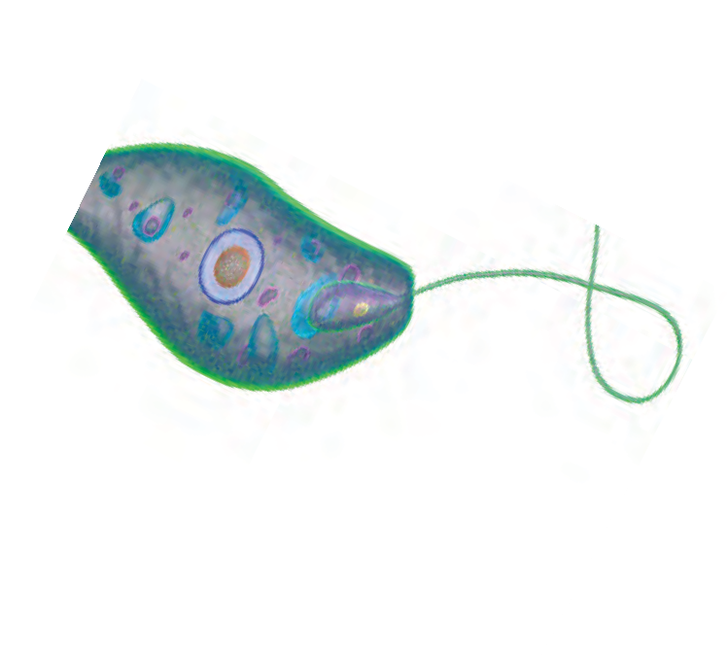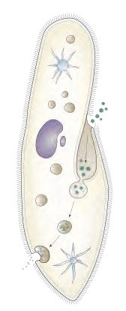Euglena*

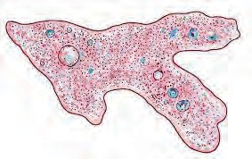

*Amoeba*

* 1. **Organisms from Kingdom Protista**

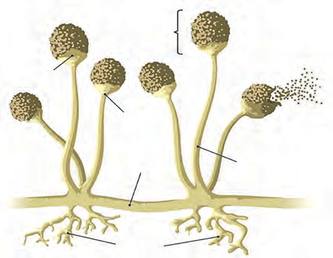

Sporangium

Columella

Apophysis

Hypha

Sporangiophore

Rhizoids

* 1. **Fungi**

**Institutional Work :** National Institute of Virology, Pune is involved in research on viruses. This institute has been founded in 1952 under the jurisdiction of Indian Council of Medical Research.

Characteristics :

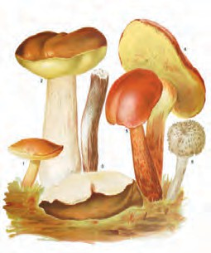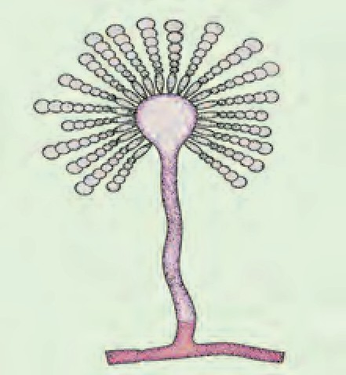

1. These are non-green, eukaryotic, heterotrophic organisms.
2. Most of them are saprotrophs. They feed upon decaying organic matter.
3. Their cell wall is made up of tough and complex sugar called ‘Chitin’.
4. Some fungi are thread like and many nuclei are present in the cytoplasm.
5. Examples- Baker’s yeast, *Aspergillus* (Fungus on corn),

*Penicillium*, Mushrooms.

Though many systems of classification are introduced after the Whittaker's, his five kingdom system is widely accepted.

Explain merits and demerits of Whittaker’s classification.



**Use your brain power**

Classification of Microbes

Among the living organisms, microorganisms are largest in number. Hence they are classified as follows.

* 1. **Some Fungi**

With reference to size of microbes, remember-

Microorganisms

Prokaryotes

Eukaryotes

Algae

Fungi

Protista

Bacteria

1 meter = 106 micrometer (m)

1 meter = 109 nanometer (nm)

* 1. **Classification of Microorganisms**

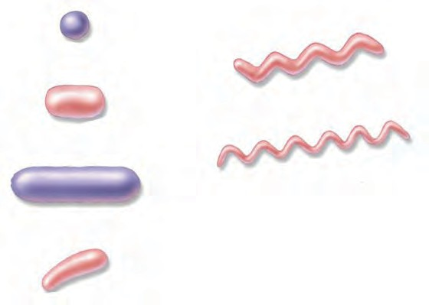

Coccus

Cocco-bacillus

Spirillum

Bacillus

Vibrio (Comma shaped)

1. **Bacteria** (size – 1 m to 10 m)
2. Unicellular, independent / parasitic organisms. Sometimes many bacteria together form colonies.
3. Bacterial cell is prokaryotic with cell wall, but distinct nucleus or cell organelles are absent.
4. They reproduce by simple binary fission.
5. In favourable conditions, bacteria grow vigorously and can double their number in 20 minutes.
   1. **Some Bacteria**
6. **Protozoa** (size - approximately 200 m)
7. Protozoans are found in soil, fresh water and sea water. Some are found in the body of other organisms and are pathogenic.
8. These are unicellular organisms with eukaryotic cell.
9. There is great variation in cell structure, organs of locomotion and modes of nutrition among protozoans.
10. These organisms reproduce by simple cell division.

Eg.- *Amoeba, Paramoecium* - Free living in dirty water.

*Entamoeba histolytica -* causes amoebiasis.

*Plasmodium vivax*- causes malaria

*Euglena* - autotrophic

1. **Fungi-** (size- approximately 10 m to 100 m)
2. These are found on decaying organic matter and dead bodies of plants and animals.
3. These are eukaryotic organisms. Some are unicellular and others are visible with naked eyes.
4. Saprotrophic, absorb their food from decaying organic matter.
5. They reproduce sexually and asexually by cell division or by budding.

Eg. Baker's yeast, *Candida*, Mushroom.

1. **Algae-** (size- approximately 10 m to 100 m)
2. They are aquatic.
3. Eukaryotic, unicellular, autotrophic organisms.
4. Photosynthesis is carried out with the help of chloroplast present in the cell.

Eg. *Chlorella, Chlamydomonas*

very few species of algae are unicellular. Most of them are multicellular and visible with naked eyes.

1. **Viruses**-( size- approximately 10 nm to 100 nm)

Generally, viruses are not considered as living organisms or they are said to be “Organisms at the edge of living and nonliving.” They are studied under microbiology.

1. Viruses are extremely minute i.e. they are 10 to 100 times smaller than bacteria and can be seen only with electron microscope.
2. They are found in the form of independent particles .

Virus is a long molecule of DNA (Deoxyribo Nucleic Acid) or RNA (Ribo Nucleic Acid) covered by a protein coat.

1. Viruses survive only in living plant or animal cells and produce their own proteins with help of host cell and create their numerous replica. Then they destroy the host cell and become free. These free viruses again infect new cells.
2. Viruses cause many diseases to plants and animals.

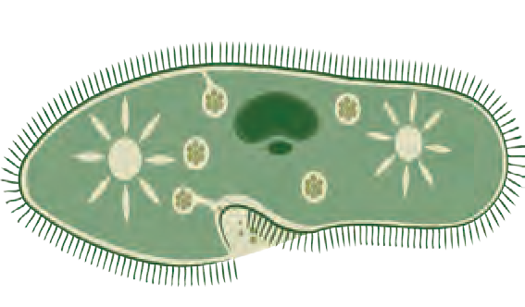

*Paramoecium*

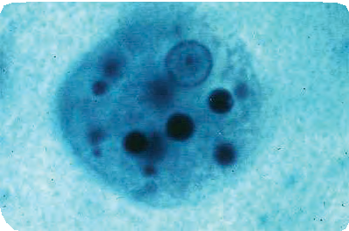

*Entamoeba*

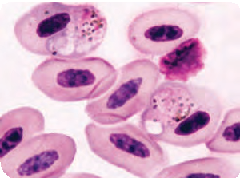

*Plasmodium*

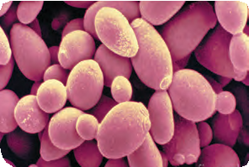

*Saccharomyces*

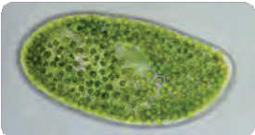

*Chlorella*

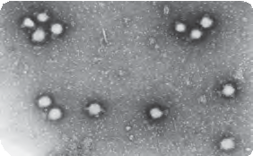

Tomato Wilt Virus

* 1. **Some Microorganisms**

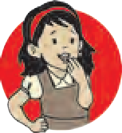

**Do you know?**

Human – polio virus, Influenza virus, HIV – AIDS virus etc. Cattle- picorna virus

Plants- Tomato- Wilt virus, Tobacco mosaic virus etc. Bacteria- Bacteriophage (viruses attack bacteria).

**Internet My Friend** Collect pictures and characteristics of different microbes. Prepare a chart.



**Exercises**

* + 1. **Use Whittaker method to classify bacteria, protozoa, fungi, algae, prokaryotic and eukaryotic microbes.**
    2. **Complete the five kingdom method of classification using- living organism, prokaryotes, eukaryotes, multicellular, unicellular, protista, animals, plants, fungi.**

Unicellular

Unicellular

Living organisms

* + 1. **Find out my partner**

|  |  |
| --- | --- |
| A | B |
| Fungi | *Chlorella* |
| Protozoa | Bacteriophage |
| Virus | *Candida* |
| Algae | *Amoeba* |
| Bacteria | Prokaryotic |

* + 1. **State whether the following statements are true or false. Explain your statement.**
       1. *Lactobacilli* are harmful bacteria.
       2. Cell wall of fungi is made up of chitin.
       3. Organ of locomotion in amoeba is pseudopodia.

e. Tomato wilt is a viral disease.

* + 1. **Give answers.**
       1. State the merits of Whittaker’s method of classification.
       2. Write the characteristics of viruses.
       3. Explain the nutrition in fungi.
       4. Which living organisms are included in the kingdom monera ?
    2. **Who am I ?**
       1. I don’t have true nucleus, cell organelles or plasma membrane.
       2. I have nucleus and membrane bound cell orgenelles.
       3. I live on decaying organic matter.
       4. I reproduce mainly by cell division.
       5. I can produce my replica.
       6. I am green, but don’t have organs.
    3. **Draw neat and labelled diagrams.**
       1. Different types of bacteria.
       2. Paramoecium
       3. Bacteriophage.
    4. **Arrange the following in ascending order of size Bacteria, Fungi, Viruses, Algae.**

**Project :**

1. Prepare a chart showing infectious bacteria and the diseases caused by them.
2. Visit a nearby pathology lab. Get the information about pathogenic microbes, methods to observe them, different microscopes from the technicians there.





5



1. **Health and Diseases**

**Can you recall?**

1. 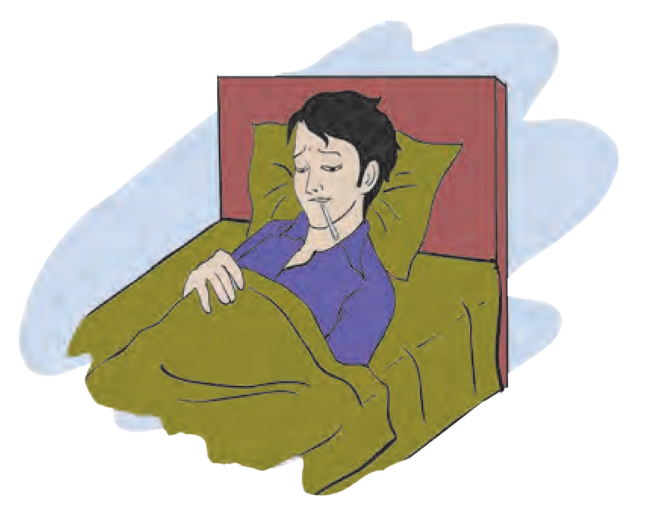Have you ever taken the leave from school due to sickness?
2. What happens exactly when we become sick?
3. Sometimes, we feel good even without taking any medicines and sometimes we need to consult doctor and take regular medicines in sickness. Why is it so?

Health

Health is a state of complete physical, mental and social well-beingness and not merely the absence of any disease.

What is disease?

* 1. **Checking Fever**

Condition of disturbances in physiological or psychological processes of body is called as disease. Each disease has its own specific symptoms.

**Types of diseases :** You must have heard the names of various diseases like diabetes, common cold, asthma, Down’s syndrome, heart disease, etc. Reasons and symptoms of all these diseases are different. To bring coordination in scientific study of diseases, diseases are classified as follows.

**Types of diseases**

According to duration

According to reasons

1. Chronic disease
2. Acute disease

Hereditary diseases Ex. Down's syndrome

Acquired diseases

Infectious diseases Ex. Common cold, flu, dengue

Non-infectious diseases Ex. Diabetes, heart diseases



**Can you tell?**

1. How do the following diseases spread? (Hepatitis, malaria, scabies, T.B., dengue, dysentery, ringworm, swine flu)

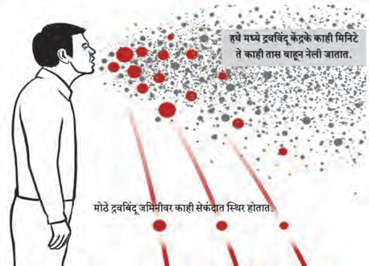

In this area small droplets are vaporised into fine mist

Mist remains in the air for several minutes to few hou

Large droplet settle on the ground within few seconds.

1. What do we mean by pathogen?
2. What do we mean by infectious diseases?

rs.

* 1. **Infection through sputum**
  2. **Infectious Diseases:** Diseases spread through contaminated air, water, food or vectors (insects and other animals) are called as infectious diseases.

|  |  |  |  |  |
| --- | --- | --- | --- | --- |
| **Name of disease** | **Pathogen** | **Mode of infection** | **Symptoms** | **Prevention and treatment** |
| Tuberculosis | *Mycobacterium tuberculae* | Spitting by patient, through air, prolonged contact with and sharing of materials of patient | Chronic cough, bloody spitting, emaciation, difficult breathing | BCG vaccine, isolation of patient, regular medication like DOT |
| Hepatitis (Jaundice) | Hepatitis virus- A, B, C, D, E | Contaminated water, sharing of needles, blood transfusion | Anorexia, yellow urine, general weakness, nausea, vomiting, grey stool | Drinking boiled water, proper cleaning of hands |
| Dysentery | *Bacteria, virus, Shigella, bacilli, Entamoeba histolytica* | Contaminated food and water | Watery stool, pains in abdomen | Drinking of boiled water, proper storage of food, ORS consumption |
| Cholera | *Vibrio cholerae*  (bacterium) | Contaminated food and water | Vomiting, severe diarrhea, cramps in legs | Following hygienic practices, avoiding open place food, drinking boiled water, vaccination against cholera |
| Typhoid | *Salmonella typhi*  (bacterium) | Contaminated food and water | Anorexia, headache, rash on abdomen, dysentery, fever up to 104 0F. | Drinking clean water, vaccination, proper disposal of sewage |

* 1. Some infectious diseases



**Complete the table**

Prepare similar table of information about various diseases like enteritis, malaria, plague, AIDS.

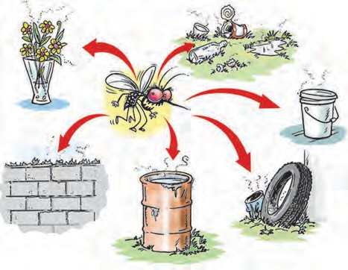

**Observe and discuss.**

**Internet My Friend**

1. Search the reasons, symptoms and other information of chicken pox.
2. Collect additional information

a. Pulse polio drive, b. WHO

* + 1. Where do you see the water-logged materials shown in picture?
    2. Which hazards do you anticipate with the help of picture?
  1. **Dirtiness in the surrounding**

Some important diseases of present days

* + 1. How can we observe personal hygiene?



**Can you tell?**

* + 1. Why should we drink boiled water in rainy season?
    2. Why the ‘clean hands drive’ is run in schools?

**Dengue:** Mosquitoes lay the eggs in water-logged places and thereby their population increases. Different species of mosquitoes spread different diseases. Dengue is spread by *Aedes aegypti*. This disease is caused by DEN-1 - 4 virus belonging to the type- flavivirus.

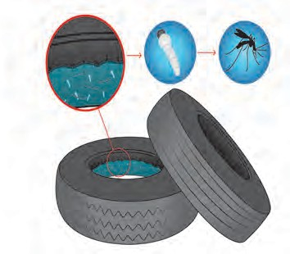

**Understand and explain to others**

Symptoms

1. Acute fever and headache, vomiting.
2. Pains in eye socket is very prominent symptom.
3. Decrease in platelet count that may lead to internal hemorrhage.

Observe the pictures shown in following and write description in the boxes.



**Observe and discuss.**

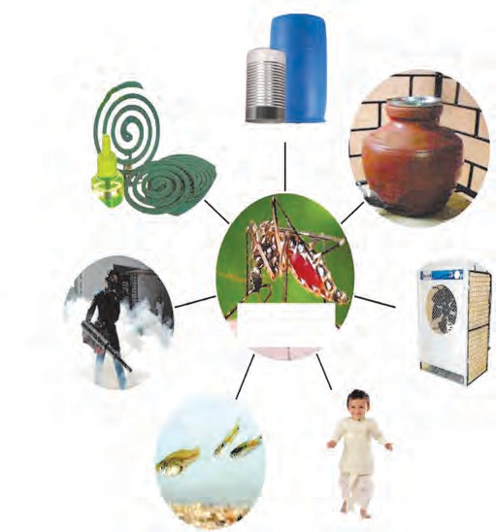

***Aedes aegypti***



**Collect information**

Which measures are taken for mosquito control by grampanchayat, municipal council, municipality of your area?

* 1. **Dengue : reasons and preventive measures**



**Do you know?**

Malaria is spread by female *Anopheles* while elephantiasis by

*Culex*. *Anopheles*

female

and

*Aedes* grow in clean water while *Culex* in dirty, sewage water.

Swine Flu: Reasons of infection

* Infection for swine flu occurs through pigs and humans.
* Viruses of swine flu are spread through secretions of nose, throat and saliva.

Symptoms of Swine Flu

* Difficulty in breathing.
* Sore throat, body pains.

**Diagnosis of Swine Flu:** For diagnosis of swine flu, liquid from throat of patient is sent in laboratory. Diagnostic facilities are available in National Institute of Virology (NIV), Pune and National Institute of Communicable Diseases (NICD), Delhi.



**Do you know?**

First case of swine flu was reported in Mexico in 2009. Swine flu is caused by the virus influenza A (H1N1). Persons who come in contact with pigs can contract this disease.

**AIDS (Acquired Immuno Deficiency Syndrome) :** This disease is caused by HIV (Human Immunodeficiency Virus). In this disease, victim suffer from various diseases due to progressive weakening of natural immunity. Diagnosis of AIDS cannot be confirmed without tests in medical laboratories. ELISA test is used for its proper diagnosis. Symptoms of AIDS are person specific.



**Always remember**

* AIDS does not occur due to touching to and sharing the food with HIV infected person, or by nursing the HIV patient.
* Our behaviour with HIV infected person must be normal.



**Do you know?**

HIV was first reported in an African species of Monkeys. According to the National AIDS Control Program and UNAIDS, 80 – 85% HIV infections in India occur through unsafe sexual contacts.

Infections through Animals

* 1. Which measures are taken at your home to control the rats?



**Can you tell?**

* 1. Why is it necessary to care about health of domestic dogs, cats and birds?
  2. Is there any relation between pigeons, stray animals and human health?
  3. What are effects of rats, cockroaches on human health?

**Rabies:** This is a viral disease. It occurs due to the bite of the infected dog, rabbit, monkey, cat etc. Virus enters the brain via neurons. Hydrophobia is one of the important symptom of this disease. In this case, the victim shows extreme fear for water. Rabies is fatal disease. However, fatality can be prevented by timely vaccination before onset of symptoms. Symptoms start to appear within 90 – 175 days of dog bite.

**Symptoms of Rabies:**

1. Fever for 2 – 12 weeks
2. Exaggerations in behaviour.
3. Hydrophobia.

**Internet My Friend**

1. Watch the videos about Rabies on internet.
2. Collect information about various preventive measures on Rabies, make a list and discuss with friends.
   * 1. Why the animal cages and their living places should not be near the kitchen?



**Can you tell?**

* + 1. Depending upon which symptoms, rabies can be identified?



**Do you know?**

**Modern diagnostics and treatment of cancer :** Various techniques like CT scan, MRI scan, mammography, biopsy are used in diagnosis of cancer. In case of treatment, along with conventional methods like chemotherapy, radiation therapy and surgery, modern techniques like robotic and laparoscopic surgery are also followed.

* 1. **Non-infectious diseases :** Diseases which do not occur through infections and body contacts are called as non-infectious diseases. Such diseases arise in human body itself due to certain reasons.
     1. **Cancer :** Uncontrolled and abnormal cell growth is called as cancer. Group or lump of cancerous cells is called as malignant tumor. Cancer can occur in various organs like lungs, mouth, tongue, stomach, breast, uterus, skin and tissues like blood.

**Reasons :** Consumption of tobacco, gutkha, smoking, alcoholism, lack of fiber content (fruits and leafy vegetables) in food, excessive consumption of junk food (pizza, burger etc) are some of the many possible reasons. Heredity may also be a reason.

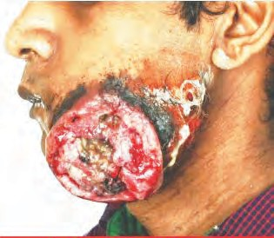

**Always remember**

Controlled diet helps to prevent some types of cancers. Physical exercise along with modern treatment is more beneficial to cure the cancer.

Avoid addictions chewing, smoking etc.

like

tobacco

Symptoms :

1. Chronic cough, hoarse voice, difficulty in swallowing.
2. Incurable scar and inflammation.
3. Lumps in breast.
4. Unexplained weight-loss.

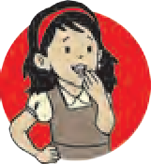

**Discuss**

Discuss the control of cancer and prepare poster for the displaying in classroom.

Do you remember any person drinking the sugar-free tea or avoiding consumption of sweets? What may be the possible reason for this?



**Can you tell?**

* + 1. **Diabetes:** The hormone- insulin produced in pancreas controls the level of sugar- glucose in blood. If insulin is secreted in low quantity, glucose level cannot be controlled; this disorder is called as diabetes.

Symptoms which cannot be ignored-

* + - * Frequent urination at night, increased obesity or weight loss

**Reasons for diabetes :** • Heredity • Obesity

* + - * Lack of physical exercise • Mental stress

Preventive measures: Following the proper diet, medicines and exercise under the supervision of doctor helps to keep the diabetes under control.



**Do you know?**

India has largest number of diabetes patients in the world. At present, approximately 7 crore diabetes patients are present in the country.

**Internet My Friend**

Watch the various videos giving information about diabetes on internet. Note important information and present it in the class using MS-power point presentation.

1. **Heart Diseases :** Efficiency of the heart decreases due to decreased blood supply and thereby oxygen and nutrient supply to the heart muscles. Due to this, heart has to perform more work that leads to stress on it. This may cause heart attack. If someone has heart attack, immediate consultation of doctor and treatment is necessary.



**Always remember**

Each disease has specific scientific reason. Diseases do not occur due to divine curse or hating by any one. Diseases can be cured by proper medical treatment and not by chanting mantras or performing magic tricks.

One should not ignore these symptoms

Severe chest pains, pains in shoulder, neck and arms, cramps in hand, uneasiness, tremors.

**Reasons of heart attack :** Smoking, alcoholism, diabetes, hypertension, obesity, lack of physical exercise, heredity, mental stress, anger, anxiety.

By-Pass surgery

Heart diseases

Installation of stents

Installation

of pace maker

Heart transplant

Open heart surgery

Angioplasty



**Always remember**

**First Aid for Heart Disease**

First, call 108 for ambulance. Check the consciousness of patient by shaking the shoulders. Keep the patient lying on the back in horizontal position on hard surface and perform compression only life support (C. O. L. S.). In this, press the centre of thorax for at least 30 times at the rate of 100 to 120 strokes per minute.

**Collect information**

1. Have you ever seen your grandparents taking the decoction? Discuss about it with them.
2. Collect information from your grandparents about use of aloe vera, turmeric, ginger, garlic as medicines.

**Misuse of Medicines :** Sometimes, some people take the medicines without prescription of doctor. Overdose of medicines may affect our body. Ex. Overdose of pain killers may damage nervous system, excretory system, liver. Overdose of antibiotics may lead to nausea, stomach ache, dysentery, rash, white patches on tongue etc.

**Internet My Friend**

Collect the information about different methods of treatment like ayurveda, homeopathy, natural healing, allopathy, unani, etc.



**Think about it.**

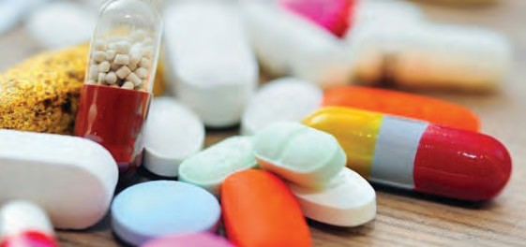Poor people do not afford the costly medicines. Is there any alternative for this? Which one?

**Generic medicines :** Generic medicines are also known as general medicines. These are manufactured and distributed without any patent. These medicines are *at par* in quality with branded medicines. Production cost of these medicines is very low due to fewer expenses on research as their formula is readily available.

**2.6 Generic medicines**

**Use of ICT**

You can easily obtain the generic medicines using mobile apps like Healthkart and Jan Samadhan. Download those apps on your mobile and use it if necessary.

**Lifestyle and diseases :** Lifestyle includes the daily routine and the type of food. Nowadays, habits like staying in bed till late morning and going to bed late in night, frequent changes in meal timings, lack of physical exercise, consumption of junk food, etc. have been increased. Due to this, such people are getting sick frequently.

If frequency of becoming sick is to be lowered, people should follow right lifestyle. It must include sufficient sleep, right food, yogasanas, pranayam and physical exercise. Physical exercise should also be as per one’s own capacity.

Pranayam and yogasanas should be performed under the expert supervision. See the videos of pranayam and yogasanas.

**Vaccination:** Vaccination is important to prevent the infectious diseases. Collect the vaccination schedule chart from nearby clinic and study it.



**Do you know?**

* Government of India declared the Pradhan Mantri Jan Aushadhi Yojana on 1st July 2015. In this scheme, best quality medicines are made available in affordable prices to the citizens. 'Jan Aushadhi Stores' are launched for this purpose.
* Indian companies export the generic medicines on large scale. However, those medicines are sold under brand name with high prices in India. In America, 80% medicines used are generic. Due to this, hundreds of billions of money is saved there.

**Let us celebrate Health Awareness Days**

7th April – World Health Day

29th September – World Heart day

14th June – World Blood Donation Day 14th November – World Diabetes Day

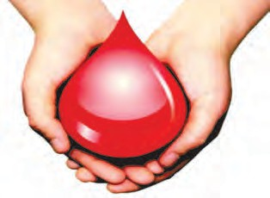

**Understand The Importance...**

**Blood Donation :** One unit blood donated by a person can fulfill the need of three persons at a time, for example- RBCs, WBCs and platelets. One can save the life of twelve persons by donating the blood for four times a year.



**Exercises**

1. **Distinguish between- Infectious and non- infectious diseases.**
2. **Identify the odd term.**
   1. Malaria, hepatitis, elephantiasis, dengue.
   2. Plague, AIDS, cholera, T.B.
3. **Answer in one to two sentences.**
   1. Which are various media of spreading the infectious diseases?
   2. Give the names of five non-infectious diseases other than given in the lesson.
   3. Which are the main reasons of diabetes and heart diseases?
4. **What can be achieved / can be prevented?**
   1. Drinking boiled and filtered water.
   2. Avoiding smoking and alcoholism.
   3. Regular balanced diet and exercise.
   4. Proper checking of blood before blood donation.
5. **Read the passage and answer the questions.**

Master ‘X’ is a 3 year old child. He is living with his family in a slum. Public toilet is present near his house. His father is drunkard. His mother does not know the importance of balanced diet.

* 1. Master ‘X’ can suffer from which different possible diseases in above conditions?
  2. How will you help him and his family in this situation?
  3. Which disease can occur to the father of master ‘X’?

1. **Give the preventive measures of following diseases.**
   1. Dengue. b. Cancer. c. AIDS.
2. **Explain the importance.**
   1. Balanced diet.
   2. Physical exercise / Yogasanas.
3. **Make a list.**
   1. Viral diseases.
   2. Bacterial diseases.
   3. Diseases spread through insects.
   4. Hereditary diseases.
4. **Write the information on modern diagnostics and treatments of cancer.**
5. **Enlist the names and composition of the medicines present at your home.**

**Project :**

1. Prepare posters giving information about various diseases, public awareness and arrange exhibition in school.
2. Visit the public health center / clinic nearby and collect the information about vaccination.
3. Compose a street-play to increase public awareness about dengue, malaria, swine flu and present it in the area nearby your school.





13



1. **Force and Pressure**

**Can you recall?**

What is a force?

A stationary object on which no force is acting, remains stationary. An object in motion continues to move with the same speed and direction when no force is acting on the object. This is Newton’s first law of motion.

**Observe**

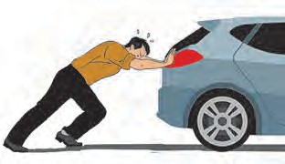

Observe the pictures in figures 3.1 and 3.2.

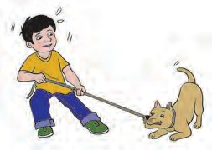

* 1. 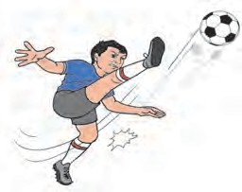**Various Actions**

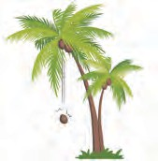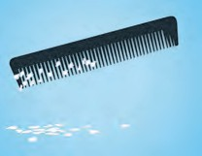**Contact and Non contact forces :** In fig. 3.1 a car moves in forward direction when a man applies force from behind. A reluctant dog is being pulled by his master and a boy playing football is kicking the ball away. What do you observe from these? A force acts on two bodies through an interaction between them.

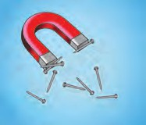As seen in fig 3.2, iron nails get attracted to the pole of a magnet due to magnetic force.

A coconut is falling from the coconut tree. Objects are attracted to the earth due to the force of gravity. When a comb gets rubbed against hair, small pieces of paper kept on a table get attracted to the comb. The comb has an electrostatic charge and there is an induced opposite charge on the pieces of paper and the pieces stick to the comb.

In fig 3.1 a force is seen to act through a direct contact of the objects or via one more object. Such a force is called ‘Contact force’. In fig 3.2, a force is applied between two objects even if the two objects are not in contact, such a force is called a ‘Non contact force’.

Muscular force is an example of contact force and is applied to objects with the help of our muscles. It is applied in several cases such as lifting, pushing, pulling. On the

* 1. **Some events**

contrary, forces like magnetic force, gravitational force, electrostatic force act without a contact. Therefore, these are the examples of non contact forces.

When a ball is kept on a table and pushed a little, it moves ahead and gets slow and stops. A car running on a plane road travels some distance and stops after the engine is switched off. This is because of the force of friction between the ground surface and the object in motion. In the absence of frictional force, the object would have remained in motion. Frictional force is very useful in daily life. While walking, we push the ground behind with our feet. In the absense of friction, we will slip and will not be able to walk. All the objects in motion have a frictional force acting on them which is acting in the direction opposite to the

direction of motion. You must have seen that one tends to slip over banana peel on the street. Similarly one can slip due to mud. Both these examples occur due to reduced friction.



**Use your brain power**

Make a list of some more examples in which contact and non contact forces are applied. Write the types of force.

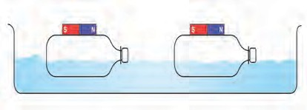Take two plastic bottles with rectangular shape. Close their openings by fitting the lids tightly. Keep two small bar magnets on them and fix them neatly using a sticking tape. (fig 3.3)



**Try this**

* 1. **Non contact force**

Fill a big plastic tray with water and leave the two bottles floating with magnets at the top. Take one bottle near the other. If the north pole of the magnet is near the south pole of the other magnet, the bottles will head towards each other, because unlike poles attract each other. Observe what will

happen when the directions of the bottles are changed. We can observe change in the motion of the bottles without any direct contact. This means that there exists a non contact force between the two magnets.

You have learnt about static electricity in the previous standard. Electrostatic force is a non contact force. To verify this, which experiment will you perform?



**Use your brain power**

Balanced and unbalanced force



**Try this**

* 1. 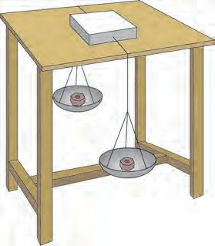**Balanced and unbalanced force**

Take a cardboard box, tie thick string to its two sides and keep it on a smooth table as shown in fig. 3.4. Take the strings on both sides of the table. Tie weighing pans of equal masses to the two ends. Keep equal masses in both the pans. The box does not move on the table. If more mass is kept in one of the pans than in the other, the box starts moving in the direction of that pan. Equal gravitational force acts on both the pans when equal masses are kept in them. This means balanced forces act on the box, with effective force equal to zero as these are acting in opposite directions. On the contrary, if more mass is kept in one pan than in the other, the box starts moving in the direction of the pan with more mass. When unequal forces are applied to the box on the two sides, an unbalanced force acts on the box resulting in imparting motion to the box.

Children playing tug of war pull the rope in their respective directions. If the pull of the force is equal on the two sides, the rope does not move. If the force is more on one side, the rope moves in that direction. This means that initially, the two forces are balanced; the rope moves in the direction of higher force when the forces become unbalanced.

Let us see one more example. When big grain storage container is required to slide on the ground, it becomes easier if two persons push it rather than one person. When the force is applied by both in the same direction, the movement is easy. You may have experienced this. What do we understand from this example?

1. If several forces are applied on an object in the same direction, a force equal to their addition acts on that object.
2. If two forces are applied on one object in directions opposite to each other, a force equal to their difference acts on the object.
3. A force is expressed in magnitude and direction. Force is a vector quantity.

When a force is applied on a stationary object it moves, its speed and direction change. Similarly, a force is required to stop an object in motion. An object can change its shape due to force. While kneading a dough made from flour, the dough changes its shape when a force is applied. A potter applies a force in a specific direction while shaping the pot. Rubber band, when stretched, expands. There are many such examples.

If more than one force are acting on a body, then the effect on the body is due to the net force.

**Inertia :** We have seen that an object changes its state of motion due to force. In the absence of a force, objects exhibit a tendency to remain in the existing state of motion. Let us see the following examples.



**Try this**

**Activity 1 :** Take a postcard and keep it on a glass. Keep a 5 Rupee coin

on it. Now skillfully push the card. The coin straight away falls in the glass. Have you ever done this?

**Activity 2 :** Hang a half a kg mass to a stand, with a string 1. Tie another string 2 to the mass and keep it hanging. Now pull the string 2 with a jerk. The string 2 breaks but the mass does not fall. Heavy mass does not move. Now pull the string 2 slowly. The string 1 breaks and the mass falls down. This is because of the tension developed in the string 2 due to the mass.



**Always remember**

**The tendency of an object to remain in its existing state is called its inertia.** This is why an object in stationary state remains in the same state and an obect in motion remain in the state of motion in the absence of an external force.

**Pressure :** You must have observed the tyres of two wheelers and four wheelers getting ‘Pressurized’. The air filling machine has a ‘pressure’ indicating dial or a digital meter showing the digital reading of ‘pressure’. The machine fills the ‘pressure’ to a certain value. You are aware that a force has to be applied for filling air in the bicycle tyre with a hand pump. By applying force, air ‘pressure’ is increased and then the air is pushed into the tyre. Are ‘force’ and ‘pressure’related?



**Activity 3 :** Take some sharp pointed nails and push them into a wooden plank by hammering on their heads. Now take a nail and hold it with its head on the plank and hammer it down from the pointed end. When pressing the drawing pins into a drawing board, they get into the board easily. By applying a force using the thumb one can push the pins into the board. On the contrary, while pressing ordinary pins into the board with a thumb, the thumb may get hurt.

**Types of inertia : 1. Inertia of the state of rest :** An object in the state of rest can not change its state of rest due to its inherent property. This property is called the inertia of the state of rest. **2. Inertia of motion :** The inherent property of an object due to which its state of motion can not change, is called its inertia of motion. For exmaple a revolving electric fan continues to revolve even after it is switched off, passengers sitting in the running bus get a jerk in the forward direction if the bus suddenly stops.

* + 1. **Directional inertia :** The inherent property of an object due to which the object can not change the direction of its motion, is called directional intertia. For example, if a vehicle in motion along a straight line suddenly turns, the passengers sitting in it are thrown opposite to the direction of turning.

### 16

What does this simple experiment tell? The nail easily penetrates into wood from its pointed end. From this you will notice that when a force is applied on the head of the nail, it is easy to hammer it into the plank.

It is easy to cut vegetables, fruits with a sharp knife. A blunt knife does not work here. Why does this happen?



**Use your brain power**

The force exerted perpendicularly on a unit area is called ‘pressure’ Pressure = Force

Area on which the force in applied

**Unit of pressure :** The SI unit of force is Newton

Presently we are considering only the force acting on an area in a direction perpendicular to it.

(N). Area is measured in m2. Therefore, the SI unit of pressure is N/m2. It is known as Pascal (Pa). In atmospheric science, the unit for pressure is bar

1 bar = 105 Pa. Pressure is a scalar quantity.

If area increases, pressure reduces for the same force, and if the area decreases, the pressure increases for the same force.

For example, due to natural adaptation the bottom surfaces of camel’s feet are broad. Hence the camel’s weight is exerted on a large area and the pressure on the sand is reduced. This is why camel’s feet do not penetrate into the sand and it becomes easy to walk.

**Pressure on solids :** Air pressure is exerted on all the objects kept in air. When a weight is kept on a solid, pressure is exerted on it. This pressure depends on the value of the weight and the contact area between the two.

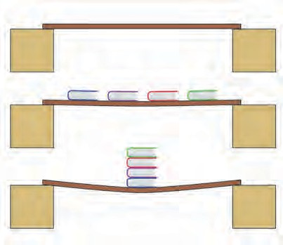

**Try this**

Do the activity as depicted in fig 3.5. What is seen?



**Use your brain power**

* 1. **Force and Pressure**



**Try this**

Pressure of liquid

You must have seen a vegetable vendor carrying a basket on her head. She keeps a twisted piece of cloth on the head, below the basket. How does it help?

We can not stand at one place for a long time. How then can we sleep on a place for 8 and odd hours?

For skiing on ice, why are long flat ski used?

**Activity 1 :** Take a plastic bottle. Take a 10 cm long piece of a glass tube on which a rubber balloon can be fitted. Warm up one end of the glass tube and gently push in the bottle at about 5 cm from the bottom (fig 3.6). To avoid water leakage, apply molten wax on the side of the glass tube. Now fill water slowly in the bottle and see how the balloon inflates. What is observed? The pressure of water acts on the side of the bottle as well.

* 1. 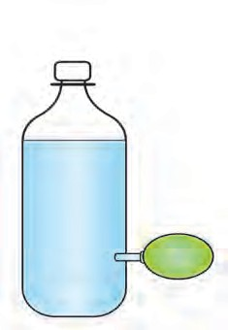**Pressure of Liquid**

**Activity 2 :** Take a plastic bottle. Pierce it with a thick needle at the points 1,2,3 as shown in the fig. 3.7. Fill water in the bottle upto full height. As shown in the figure, water jets will be seen emerging and projecting out. The water jet emerging from the hole at the top will fall closest to the bottle. The jet from the lowest hole falls farthest from the bottle. Also, jets coming out from the two holes at the same level fall at the same distance from the bottle. What is understood from this? At any one level, the liquid pressure is the same. Also, the pressure increases as the depth of the liquid increases.

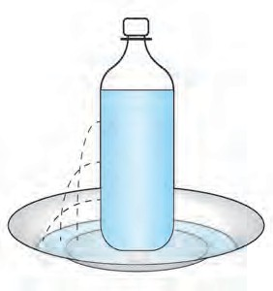

3

2

1

* 1. **Level and Pressure of Liquid**

**Gas pressure :** If a balloon is inflated by filling air by mouth, it inflates on all sides. If a pin hole is created in the balloon, air leaks out and the balloon does not inflate fully. It is realized that like a liquid, gas also exerts pressure on the wall of the container in which it is enclosed. All gases and liquids have a common name ‘fluid’. Fluids in a container exert pressure from within, on the walls and the bottom of the container. A fluid enclosed in a containers exerts its pressure equally in all directions at a point within the fluid.

**Atmospheric Pressure :** Air surrounds the earth from all sides. This layer of air is called atmosphere. The atomosphere exists to about 16 km height. It further extends up to about 400 km in a very dilute form. The pressure created due to air is called the atmospheric pressure. Imagine that a very long hollow cylinder of unit cross-sectional area is standing on the surface of the earth, and it contains air (fig.3.8). Weight of this air is the force applied in the direction of the centre of the earth. This means that atmospheric pressure is the ratio of this weight divided by the area of the surface.

The air pressure at the sea level is called 1 Atomosphere pressure. Air pressure decreases as one goes up in height from the sea level.

1 Atomosphere = 101 x 103 Pa = 1 bar = 103 mbar 1 mbar 102 Pa (hecto pascal)

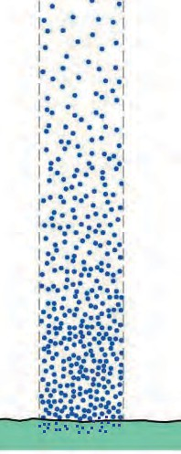

1 cm2

Atmospheric pressure is specified in the units mbar or hectopascal (hPa). The atmospheric pressure at a point in air is equal from all sides. How is this pressure created? If air exists in a closed container, the air molecules in random motion continuously hit the walls of the container. In this interaction a force is exerted on the walls of the container. Pressure is created due to this force.

We constantly bear the atmospheric pressure on our heads. However the cavities in our body are also filled with air and arteries and veins are filled with blood. Therefore we do not get crushed under water and due to atmospheric pressure, as the pressure is balanced. The earth’s atmospheric pressure decreases with height from the sea level as shown in

* 1. **Atmospheric Pressure** fig 3.9.

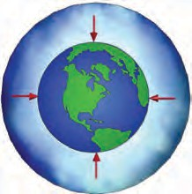100

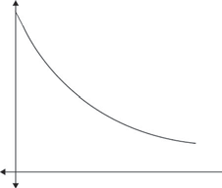

Atmospheric Pressuure

2000

6000 10000

Height (m)

**Use your brain power**

At the sea level the atmospheric pressure 101 x 103 Pa is acting on a table top of size 1m2. Under such a heavy pressure, why doesn’t the table top crumble down?

* 1. **Atomospheric Pressure**

Buoyant Force :

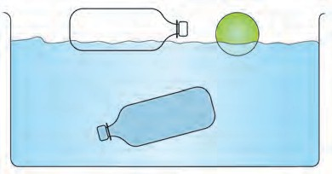

**Try this**

fb

fg

* 1. **Balanced and unbalanced Buoyant force**

Take a plastic bottle and fix the lid tightly. Now place it in water and see. It will float on water. Try and push it into the water. Even when pushed, it continues to float. This experiment can also be done with a plastic hollow ball (fig 3.10)

Now fill the bottle with water to the fullest capacity and close the lid, and release in water. The bottle will float inside the water. Why does this happen?

The empty plastic bottle floats on the surface of water. On the contrary, the bottle full of water floats inside water but does not go to the bottom. The weight of the empty bottle is negligible as compared with the weight of the water inside. Such a bottle with water neither floats on the surface, nor does it go to the bottom. This means the force due to gravity acting downwards (fg), must have been balanced by an opposing force in the upward direction (fb) on

the bottle filled with water. This force must have originated from the water surrounding the

bottle. The upward force acting on the object in water or other fluid or gas is called Buoyant force (fb).

While pulling a bucket from a well, the bucket full of water immersed fully in water appears to weigh less than when it has been pulled out of water. Why?



**Use your brain power**

Take a piece of thin aluminium sheet and dip it in water in a bucket. What do you observe? Now shape the same piece of aluminium into a small boat and place it on the surface of water. If floats, isn’t it?



**Try this**

An iron nail sinks in water, but why does the massive steel ship float on it? When an object is dipped in a liquid, a buoyant force acts on it and hence it appears that the weight of the object is reduced.

It becomes easier to swim in sea water than in fresh water. This is because the density of sea water is higher than the density of fresh water, due to salts dissoved in sea water. In this book you have seen that lemon sinks in a glass filled with water but it floats when we stir in two spoons of salt in the water. In salty water the buoyant force exceeds the gravitational force. What is understood from these examples? Buoyant force depends on two factors

1. Volume of the object - The buoyant force is more if the volume of the dipping object is more.
2. Density of liquid - More the density of liquid, more is the force of buoyancy.

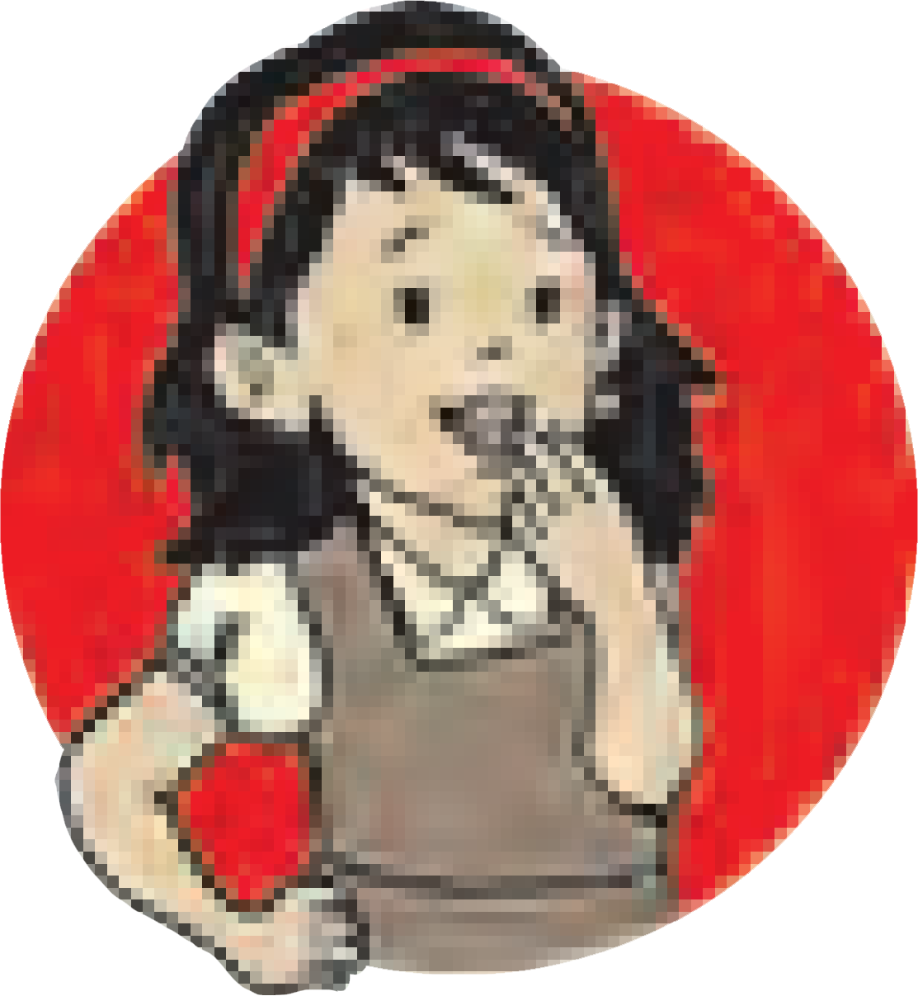

**Do you know?**

How is it decided that in object left in liquid will get sink in the liquid, will float on the surface, or will float inside the liquid?

1. The object floats if the buoyant force is larger than its weight.
2. The object sinks if the buoyant force is smaller than its weight.
3. The object floats inside the liquid if the buoyant force is equal to its weight. Which forces are unbalanced in the above cases ?

Archimedes Principle :

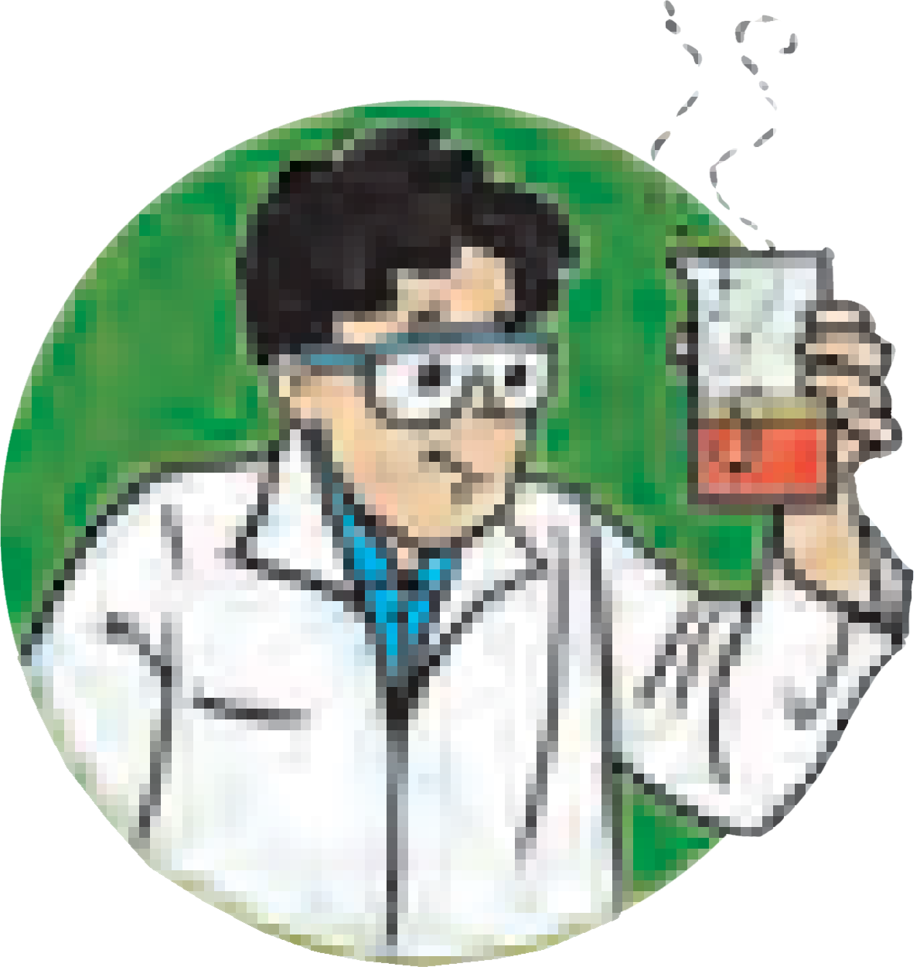

**Try this**

Take a long rubberband and cut it at one point. At one of its ends tie

a clean washed stone or a 50 g weight as shown in figure 3.11.

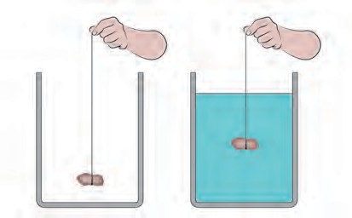Now hold the other end of the rubberband and make a mark there. Keep the stone hanging in air and measure the length of the rubberband from the stone to the mark made earlier. Now take water in a pot and hold the rubberband at such a height that the stone sinks in it. Again measure the length of the rubberband up to the mark. What is observed? This length in shorter than the earlier length. While dipping the stone in water, length of the stretched rubber gets slowly reduced and is minimum when it

sinks completely. What could be the reason for a shorter length of the rubberband in water?

* 1. **Buoyant Force**

When the stone is sunk in water, a buoyant force acts on it in the upward direction. The weight of the stone acts downwards. Therefore, the force which acts on it in the downward direction is effectively reduced.

How much is the magnitude of the buoyant force? Is it the same for all the liquids? Is the buoyant force of equal magnitude for all objects? The answers to these questions are embodied in Archimedes Principle. This principle states that : **When an object is partially or fully immersed in a fluid, a force of buoyancy acts on it in the upward direction. This force is equal to the weight of the fluid displaced by the object.**

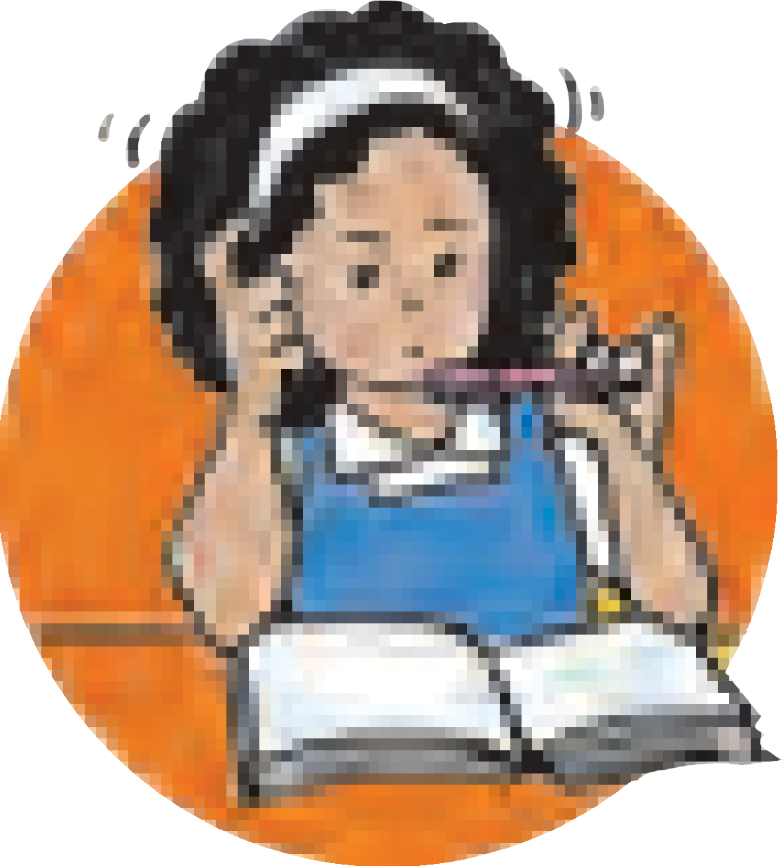

**Use your brain power**

Explain the obsevations in the earlier experiments according to the Archimedes Principle.

**Introduction to the Scientist :**

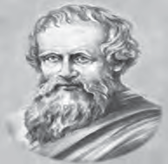

Archimedes (287 B.C - 212 B.C)

Archimedes was a Greek Scientist and a mathematician with sharp intelligence. He found out the value of  by numerical calculations. His knowledge of levers, pulleys, wheels in physics was useful to the Greek army in fighting against the Roman army. He became famous due to his work in geometry and mechanics. When he entered a bath tub for taking bath, he discovered the above principle by observing the overflowing water. He came out in the same state shouting ‘eureka’, ‘eureka’, meaning ‘I found it’, ‘I found it.’

The use of Archimedes Principle is very wide. This principle has been used in the construction of ships and submarines. The instruments such as lactometer, hygrometer are based on this principle.

**Density of substance and Relative density**

Mass

Density =

Volume

The SI unit of density is kg/m3. The property density is very useful in deciding the purity of the substance. The relative density of a substance is expressed w.r.t. the density of water.

Density of substance

Relative density =

Density of water

this being a ratio of two equal physical quantities it has no unit. Relative density of a substance is called its ‘specific gravity.’

Solved examples

**Example 1.** The area of the bottom of a tiffin E F

box is 0.25 m2 and weight is 50 N, Calculate D C

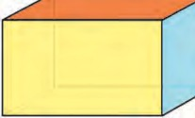

the pressure exerted by the box on the shelf.

Given : Area = 0.25 m2, weight of the box = H 20

50 N, Pressure = ? 10G

Pressure =

force =

area

50 N

0.25 m2

= 200 N/m2

A 50 B

**Given :** Weight of the block = mg

**Example 2.** Calculate the relative density of iron if the density of water is 103 kg/m3 and the density of iron is 7.85 x 103 kg/m3.

Given : density of water = 103 kg/m3, density of iron = 7.85 x 103 kg/m3

=10 x 9.8N =98 N

For the surface ABCD, length = 50 cm, height = 20 cm.

Area = 50 cm x 20 cm

= 1000 cm2 = 0.1m2

Relative density of iron = ?

Relative density of iron

weight

Pressure = area

98

= (0.1)

= 980 Pa

= (density of iron) (density of water)

= 7.85 x 103 kg/m3 = 7.85

3 3

##### 10 kg/m

For the surface CDEF, length = 50 cm breadth = 10 cm

Area = 50 cm x 10 cm = 500 cm2

= 0.05 m2

**Example 3.** The area of the tip of a screw is

0.5 mm2 and its weight is 0.5 N. Calculate the pressure (in Pa) exerted by the screw on

weight

Pressure = area =

##### 9800

5 = 1960 Pa

a wooden plank.

Given : Area = 0.5 x10-6 m2

Weight of the screw = 0.5 N, Pressure =?

For the surface BCFG, height = 20 cm

breadth = 10 cm

Area = 20 cm x 10 cm

weight

0.5N

= 200 cm2

Pressure = area = (0.5x10-6m2) = 106 N/m2

= 106 Pa

**Example 4.** Mass of a block of metal is 10

= 0.02 m2

weight

Pressure = area

= 98 N

##### 0.02 m2

kg and its dimensions are length 50 cm, breadth 10 cm, height 20 cm. (See fig.) If the metal block is placed on the following suface on the table, find out on which of the surface ABCD, CDEF and BCFG will the pressure exerted on the table be maximum.

= 4900 Pa : Maximum Pressure. Hence, smaller the area of contact, larger is the pressure.

**Example 5.** A piece of marble tile weighs 100 g in air. If its density is 2.5 g/cc, what will be its weight in water ?

**Given :** Weight in air = 100 g

Density = 2.5 g/cc  Volume = 100g /(2.5 g/cc ) = 40 cc

Therefore, according to Archemedes principle, when the piece is dipped in water, water of volume equal to the volume of the piece i.e. 40 cc will be displaced. The loss in the weight of the piece will be equal to the weight of displaced water 40g.

 Weight in water = 100 g - 40 g = 60 g



**Exercises**

1. **Write proper word in the blank space.**
   1. The SI unit of force is ............... (Dyne, Newton, Joule)
   2. The air pressure on our body is equal to. pressure.

(Atmospheric, Sea bottom, Space)

* 1. For a given object, the buoyant force in liquids of different.... is............... . (the same, density, different, area)
  2. The SI unit of pressure is ............... (N/m3, N/m2, kg/m2, Pa/m2)

1. **Make a match.**

**A group B group**

1. Fluid a.Higher pressure
2. Blunt knife b. Atmospheric Pressure
3. Sharp needle c. Specific gravity
4. Relative density d. Lower pressure
5. Hecto Pascal e. Same pressure in all directions
6. **Answer the following questions in brief.**
   1. A plastic cube is released in water. Will it sink or come to the surface of water?
   2. Why do the load carrying heavy vehicles have large number of wheels?
   3. How much pressure do we carry on our heads? Why don’t we feel it?
7. **Why does it happen?**
   1. A ship dips to a larger depth in fresh water as compared to marine water.
   2. Fruits can easily be cut with a sharp knife.
   3. The wall of a dam is broad at its base.
   4. If a stationary bus suddenly speeds up, passengers are thrown in the backward direction.
8. **Complete the following tables.**

|  |  |  |
| --- | --- | --- |
| **Mass (kg)** | **Volume (m3)** | **Density (kg/m3)** |
| 350 | 175 | - |
| - | 190 | 4 |

|  |  |  |
| --- | --- | --- |
| **Density of Metal (kg/m3)** | **Density of water (kg/m3)** | **Relative Density** |
|  | 103 | 5 |
| 8.5 x 103 | 103 | - |

|  |  |  |
| --- | --- | --- |
| **Weight (N)** | **Area (m2)** | **Pressure (Nm-2)** |
| - | 0.04 | 20,000 |
| 1500 | 500 | - |

1. **The density of a metal is 10.8 x 103 kg/ m3. Find the relative density of the metal.**

**(Ans. 10.8)**

1. **Volume of an object is 20 cm3 and the mass in 50 g. Density of water is 1 gcm-3. Will the object float on water or sink in water?**

**(Ans : Sink)**

1. **The volume of a plastic covered sealed box is 350 cm3 and the box has a mass 500 g. Will the box float on water or sink in water? What will be the mass of water displaced by the box?**

**(Ans : Sink, 350 g)**

**Project :**

Video record all the experiments (Try it) in this chapter with the help of mobile phone and send to others.



22



1. **Current Electricity and Magnetism**

Which constituents are present in an atom ?



**Can you recall?**

An atom has same number of postively charged protons and negatively charged electrons. So an object doesn't show any charge though its atoms contain charged particles. Therefore, we can say that plenty of electrical charge is filled in the objects around us. What will happen if a glass rod is rubbed on a silk cloth? How do objects get charges ? What are static and moving charges ? Moving charges get transferred from one object to the other. These are negatively charged. Moving negatively charged particle are the electrons. Can this negative charge be made to flow? Can electricity be made to flow like water flowing from higher to lower level ? You have learnt that a force will have to be applied to put a stationary object into motion. We get current electricity when the elctrons in an electrical conductor are made to flow.

**Current Electricity :** A large current flows when lightning takes place from a cloud to the ground, while sensation is felt by us due to a microscopically small current flowing to the brain. You are aware of the current flowing through wires, electric bulbs, and equipments in the house. In the electric cells of a radio or in a car battery, a current is produced by the flow of both negatively and positively charged particles.

**Electrostatic Potential :** Water or a liquid flows from a higher level to a lower level. Heat always flows from a body at higher temperature to a body at lower temperature. Similarly, there is a tendency of the positive charge to flow from a point of higher electric level to a point of lower electric level. This electric level deciding the direction of flow of electric charges is called electrostatic potential.

**Potential difference :** Similar to the height of a waterfall, the temperature difference of hot and cold bodies, the difference between the potential of two points, i.e. potential difference is interesting to us.



**Try this**

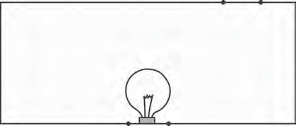

* 1. **(a) Electrical Circuit**

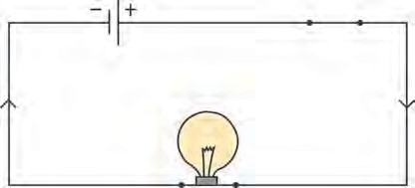

* 1. **(b) Electrical Circuit**

Take connecting copper wires and connect the ‘circuit’ as shown in fig 4.1 (a). No current is seen to flow in the bulb. Now connect in the same ‘circuit’ a 1.5 V dry cell available in the market as shown in fig 4.1 (b). Now it will be realized from glowing of the bulb that a current is flowing in the circuit. Electrons in the wire flow due to the potential difference between the two ends of the dry cell. These flow from the negative terminal of the cell to the positive terminal of the cell. Conventional current flows in the opposite direction and is shown in the figure by the sign of an arrow. We will learn about an electrical circuit later in this chapter.

In fig 4.1 (a), there is no current as there is no potential difference in the absence of any cell. Current starts flowing in the circuit as soon as the potential difference is applied. The unit of potential difference in SI system is Volt (V). We will learn about it in the next standard.

How can we measure water flow emerging from a pipe? We can find it from the amount of water (litres) coming out in a specific time period. How then is the electric current measured?



**Think about it.**

We have seen that electric current is produced due to the flow of charged particles. Electrical charge flowing through a wire in 1 second can be called unit current. The SI unit of electric current is Coulomb per second or Ampere.

1 Ampere = 1A = 1 Coulomb/1 second = 1 C/s. Electric current is a scalar quantity.

**Electric cell :** A source is required to produce a uniform flow of charges in a circuit. Such a general device is an electric cell. Various types of electric cells are available today. These are used in a range of machines from wrist watches to submarines. Out of these, you must be aware of solar cells. The main function of various electric cells is to maintain a constant potential difference between its two terminals. The electric cells work on the electric charges to maintain a constant potential difference, about which you will learn later. Let us learn about the electic cells that are currently in use.

**Dry Cell :** The dry cells are used in our radio sets, wall clocks and torches. These are available in 3-4 sizes. The construction of a dry cell is as shown in fig. 4.2.



**Try this**

Take a lead dry cell and remove its outer coating. Inside you will find a whitish, metal layer. This is the Zinc (Zn) metal layer. This is the negative terminal of the cell. Now, carefully break open this layer. There is another layer inside. An electrolyte is filled between these two layers. The elctrolyte contains negatively charged and positively charged ions. These are the carriers of electricity. The electrolyte is a wet pulp of Zinc chloride (ZnCl2) and Ammonium chloride (NH4Cl). There is a graphite rod at the centre of the cell. This

Carbon electrode

Divisor

Positive terminal

Zinc cover elcectrolyte

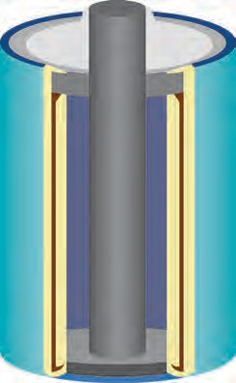

is positive terminal of the cell. A paste of Manganese dioxide (MnO2) is filled outside the rod. Because of the chemical reactions of all these chemicals, electrical charge is produced on the two terminals (graphite rod and zinc layer) and an electric current flows in the circuit.

Protectti~~ve~~  cover

Manganese

dioxide

negative terminal

* 1. **Dry cell**

Due to the wet pulp used in this cell, the chemical reaction proceeds very slowly. Hence a large electric current can not be obtained from this. Compared to the electric cells using liquids, the shelf life of dry cells is longer. Dry cells are very convenient to use as these can be held in any direction with respect to ground and can be used in mobile instruments.

**Lead-Acid Cell :** Figure 4.3 depicts the design of a Lead-Acid cell. Let us examine its principle. This type of cell can be recharged after getting electrically discharged. The lead- acid cell contains a lead electrode and a lead dioxide electrode and both are dipped in dilute sulfuric acid. PbO2 carries a positive charge, while the Pb electrode carries a negative charge. The potential difference between these two is nearly 2V. Because of the chemical reaction between the substances in the cell, electrical charge is produced on both the electrodes and electric current flows through the load (e.g. bulb) in the cicuit.

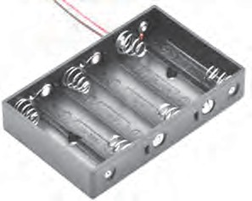

**4.4 (a) Cell holder**

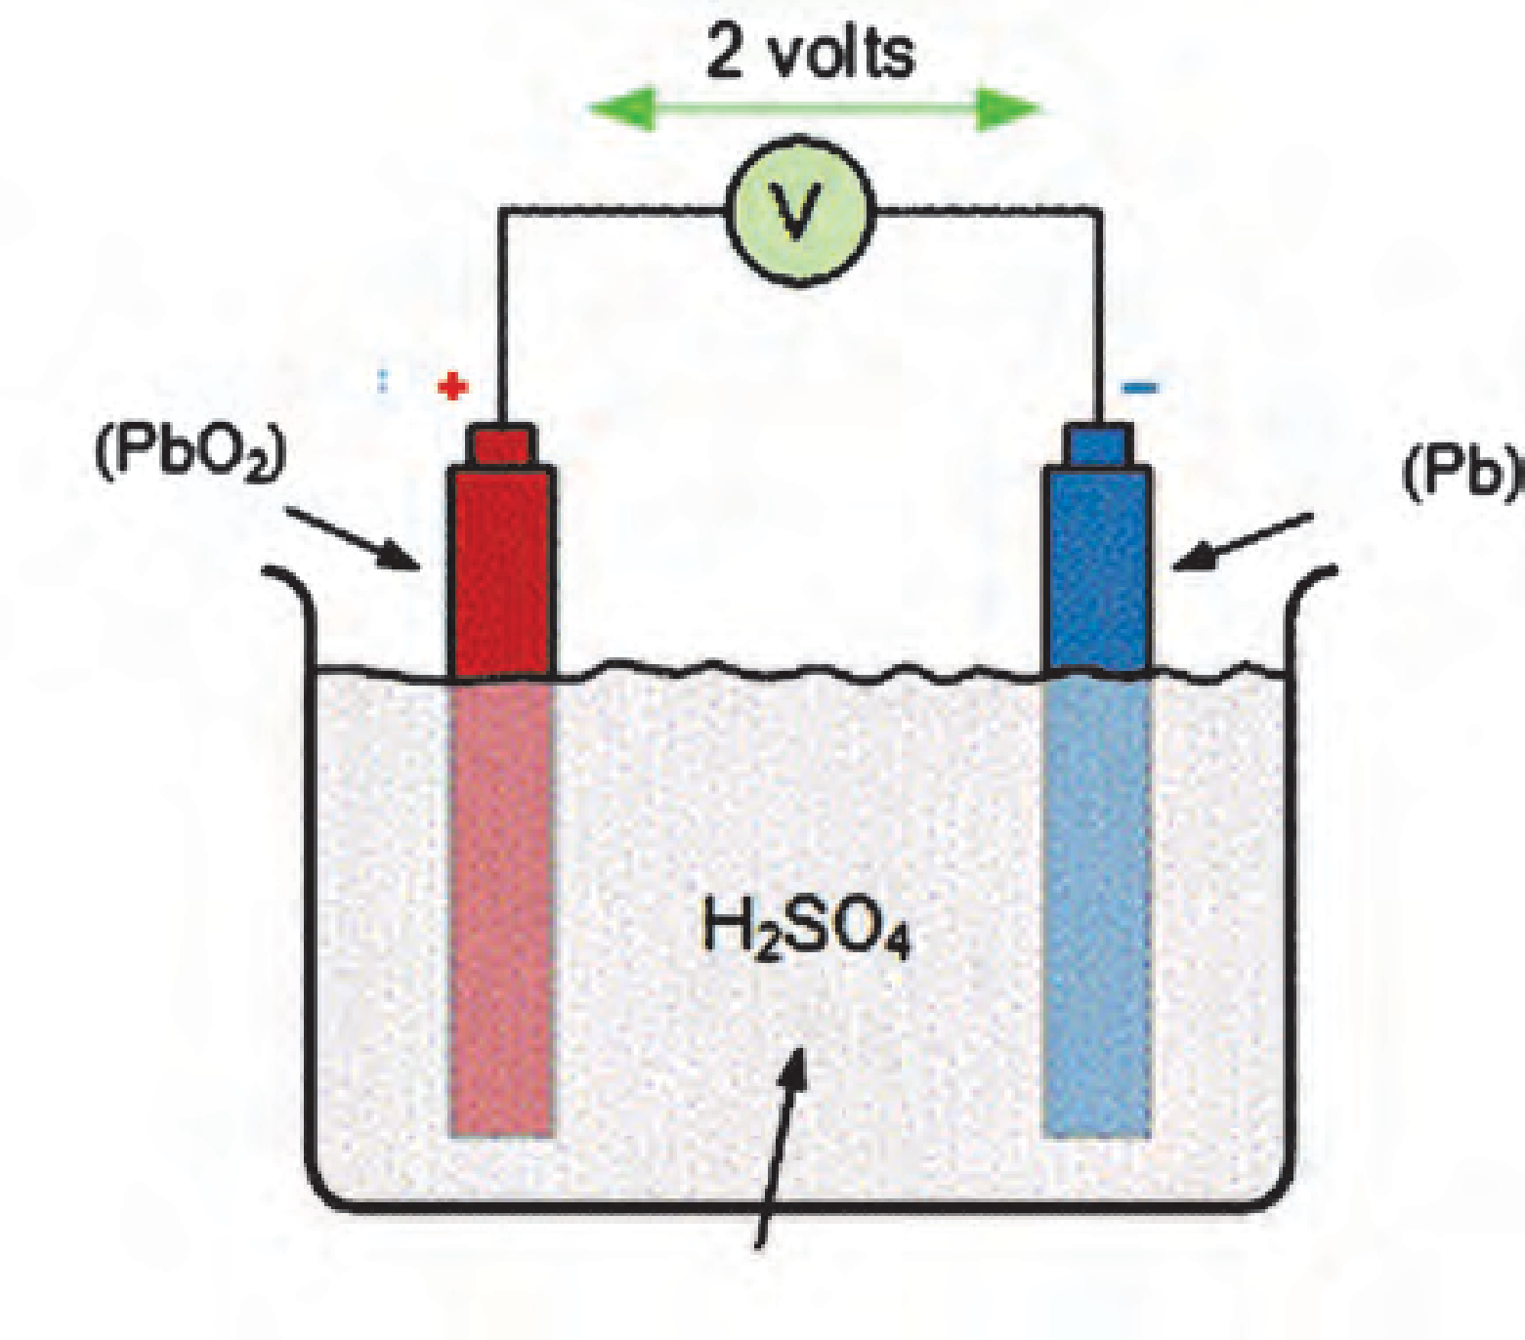Positive terminal negative terminal Lead Lead

dioxide

Electrolyte

* 1. **Lead-Acid Cell**
  2. **(b) Simple electric circuit**

This kind of electric cells have a capacity to deliver large current. Hence lead-acid cells are used in cars, trucks, motorcycles and uninterrupted power supplies (UPS).

**Ni-Cd cell :** These days, a variety of gadgets are available, which are required to be carried to different places. Such gadgets use Ni-Cd cells. The cells deliver 1.2 V potential difference and are rechargeble.

**Electric Circuit :** When a cell holder, an electric bulb and a plug key are connected by connecting wires, as shown in fig. 4.4 (b) and a dry cell is fitted in the holder (fig

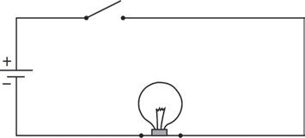

Plug key

Cell

Electric bulb

4.4 (a)), then the bulb lights up by closing the plug key. This means that a current flows through the circuit and bulb lights up. On the removal of the cell, the electric current flowing through the circuit stops as indicated by the bulb which ceases to glow. This type of connection of electrical components is called an electrical circuit. A circuit is shown in fig 4.4. (b) The cell is shown by the symbol.  .

An electrical ciruit is also used in the home supply. However,

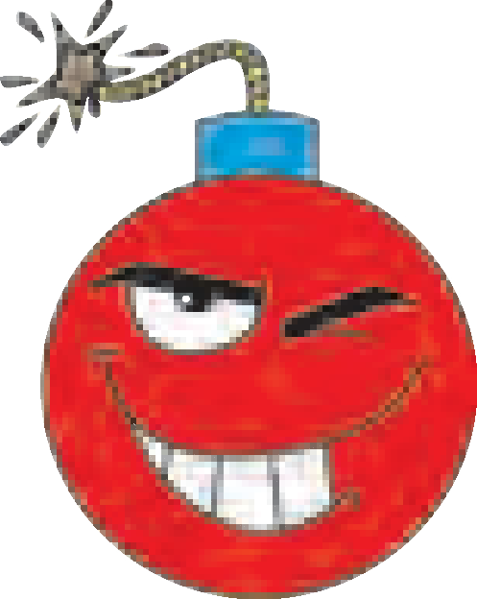

**Research**

Lithium ion cells are used in modern equipments for exam- ple smart phone, laptop etc. These cells can be recharged. More elec- trical energy can be stored in these cells as compared to that in Ni- cd cells.

the electricity supply is made from outside, instead of the electric cells. You will learn about it later.

**Connecting cells :** You must have seen more than one electric cells connected in an electrical circuit (see figure 4.5 (a)). In the transister radio, 2-3 dry cell are seen to be connected in series. The purpose of doing this is to obtain more potential difference than that of a single cell. Therefore, it is possible to obtain higher current. If the cells are connected as seen in fig 4.5 (b), the connection of cells is known as a Battery of cells.

In this series connection, the postive terminal of one cell is connected to the negative terminal of second cell and the positive terminal of the second cell is connected to the negative terminal of the third one. Therefore, if each cell has a potential difference of 1V the total potential difference of 3 cells will be 3V.

(+)

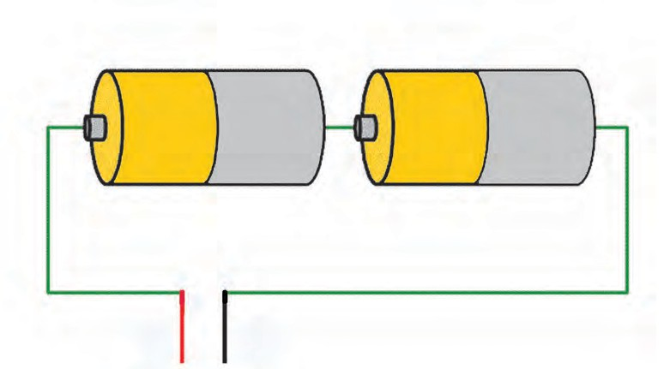

(-)

(+)

(-)

Flow of electrons

(+) (-)

Electrical resistance/Load

**(a)**

* 1. **Connecting cells**

**(b)**

You must have seen the car battery available in the market. It is called a battery and not a cell. Why?



**Use your brain power**

Magnetic effects of electric current :

* 1. **Magnetic effect of current**

**Activity 1.** Take the inside tray of an used up match box place a small magnetic needle inside the tray. Now take a long connecting wire and wind it around the tray. Complete the electric circuit by connecting in it, this wire, electric cell, plug key and a bulb (fig. 4.6)

Mark the position of the magnetic needle. Take a bar magnet near to the magnetic needle. What do you observe ? keep looking at the needle and close the plug key. The bulb will light up, and you will realize that the current has started flowing. Does the magnetic needle change its position ? Now open the plug key. Does the magnetic needle come back to the original position ? What will you conclude from this experiment?

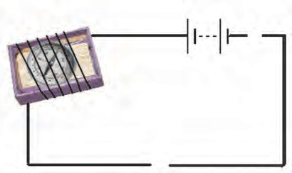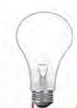

**Try this**

(.)

You know that a magnetic needle is indeed a magnet. You have seen that the magnetic needle changes its direction when a bar magnet is taken near the magnetic needle. Also, you have observed that the magnetic needle changes its direction when a current starts flowing in the circuit. This means that magnetic field is created when an electric current flows in a wire. Hans Christian Oerstead made this observation first. Briefly we can say that when an electric current passes through a wire, a magnetic field in produced around that wire.

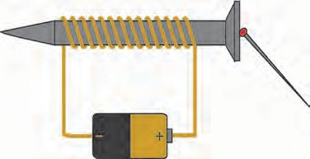**Activity 2 :** Take a meter long flexible copper wire having resistive coating and wind tightly on a long iron screw. Connect the two ends of the wire in a circuit as shown in the figure 4.7. Also connect an electric cell and a plug key in the circuit. Keep 2-4 iron pins/small nails near the screw. Now start the current in the circuit by plugging the key. It will be noticed that the pins/nails

(.)

* 1. Electro magnet

have stuck to the tip of the screw. Will the pins/nails continue to stick when the plug key is opened?

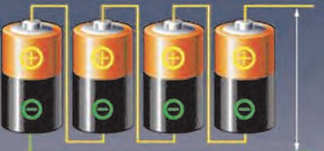When the electic current flows in the wire, magnetism is produced in the coil around the screw and because of that the screw also attains magetism. As soon as the current is stopped, this magnetism vanishes. The system of coil and the screw is called an electromagnet. You have seen various uses of the electromagnet in the sixth standard. Electromagnets are used to produce strong magnetic field useful in scientific research.

**Electric Bell :** Many of you must have seen the simple electric door bell. Open such a bell which is out of order. Fig 4.8 depicts a bell with its outer cover removed. We see that there is an electromagnet inside. Let us understand the working of the bell. A copper wire is wound around an iron piece. This coil acts as an electromagnet. An iron strip along with a striker is fitted near to the electromagnet.

Striker Bell

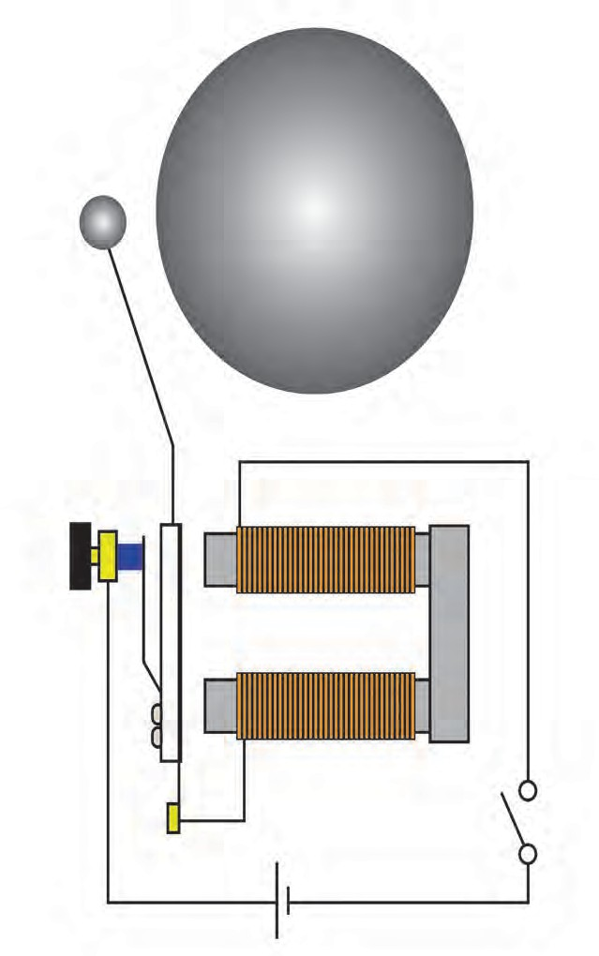

Electro

A contact screw is in touch with the strip. The electric circuit is connected as shown in fig 4.8. The current flows in the circuit when screw is in contact with the strip, and hence the coil becomes a magnet and attracts the iron strip towards it. Therefore, the striker hits the gong and the sound is created. However, at the same time, the contact screw loses the contact with the strip and the current in the circuit stops. In this situation, the electromagnet loses its magnetism and the iron strip moves back and comes in contact with the contact screw. The electric current is then immediately restored and again the striker hits the gong by

Iorn strip Contact screw

+ -

magnet

Key

the above process. This action repeats itself and the bell rings.

* 1. **Electric bell**



**Exercises**

1. **Write proper words from the following group of words in the blanks.** (magnetism, 4.5V, 3.0V, gravitational attraction, potential difference, potential, higher, lower, 0V)
   1. Water in the waterfall flows from a higher level to the lower level because of
   2. In an electric circuit, electrons flow from a point of potential to the point of potential.
   3. The difference between the electrostatic potential of the positive end the negative end of an electric cell is the of the cell.
   4. Three electric cells of potential difference

1.5 V each have been connected as a battery. The potential difference of the battery will be V.

* 1. An electric current flowing in a wire creates around the wire.

1. **A battery is to be formed by joining 3 dry cells them with connecting wires. Show how will you connect the wires by drawing a diagram.**
2. **In an electric circuit, a battery and a bulb have been connected and the battery consists of two cells of equal potential difference. If the bulb is not glowing, then which tests will you perform in order to find out the reason for the bulb not glowing?**
3. **Electric cells having 2V potential difference each have been connected in the form of a battery. What will be the total potential difference of the battery in both cases?**

(i)



+ - + - + -

(ii)



+ - + - + - + -

1. **Describe the construction, working and usefulness of a dry Cell, with the help of a diagram.**
2. **Describe the construction and working of an electric bell with the help of a diagram.**

**Project :**

Present all the activities that you performed in this chapter in Science exhibition.



**Can you recall?**

# Inside the Atom

1. What is meant by matter ? 2. What is an atom ?



3. What is the smallest unit of matter ?

We have seen that matter is made of molecules. Molecules are formed from atoms. Effectively an atom is the smallest unit of matter. An atom is the smallest particle of an element which retains its chemical identity in all the physical and chemical changes.

The table 5.1 shows names and formulae of some substances. Complete the table by putting tick marks in appropriate box to indicate the information of the smallest particle and the type of matter.

|  |  |  |  |  |  |  |  |
| --- | --- | --- | --- | --- | --- | --- | --- |
| **Name of substance** | **Formula** | **Smallest particle of the substance** | | | | **Type of matter** | |
| **is an atom** | **is a molecule** | **single type of atoms in the molecule** | **different types of atoms in the molecule** | **Element** | **Compound** |
| Water | H2O |  | ✓ |  | ✓ |  | ✓ |
| Oxygen | O2 |  | ✓ | ✓ |  | ✓ |  |
| Helium | He | ✓ |  | ✓ |  | ✓ |  |
| Hydrogen | H2 |  |  |  |  |  |  |
| Ammonia | NH3 |  |  |  |  |  |  |
| Nitrogen | N2 |  |  |  |  |  |  |
| Methane | CH4 |  |  |  |  |  |  |
| Argon | Ar |  |  |  |  |  |  |
| Neon | Ne |  |  |  |  |  |  |
| Chlorine | Cl2 |  |  |  |  |  |  |

* 1. **Types of substances**

We have learnt in the earlier standard that the smallest particles of most of the substances are molecules. The molecules of a few substances contain only one atom. Molecules are formed by chemical of combination of atoms. From this we understand that the smallest particle of an element taking part in chemical combination is an atom. The concept of atom is more than 2500 years old. However, it was forgotten in the course of time. In the modern times, scientists on the basis of experiments explained the nature of atom as well as the internal structure of atom. It started with Dalton’s atomic theory.



**Do you know?**

* Indian philosopher Kanad (6th century B.C.) stated that there is a limit to divide matter into small particles. The indivisible particles that constitute matter were named by Kanad Muni as ‘Paramanu’ (meaning the smallest particles). He also stated that ‘Paramanu’ is indistructible.
* Greek philosopher Democritus (5th century B.C.) stated that matter is made of small particles and these cannot be divide. The smallest particle of matter was name by Democritus as ‘Atom’. (In Greek language ‘Atomos’ means the one which cannot be cut.)

**Dalton’s atomic theory :** British scientist John Dalton put forth in 1803 A.D. his celebrated ‘Atomic Theory’. According to this theory matter is made of atoms and atoms are indivisible and indestructible. All atom of an element are alike while different element have different atom with different mass.

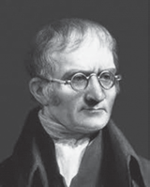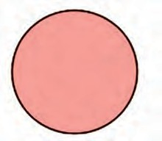

John Dalton

Dalton's atomic model

* 1. **Dalton's atomic model**
     1. Take a solid ball and a ‘Bundi Laddu.’ Press both these spheres with your palms. What did you find ?



**Try this**

* + 1. Cut the solid ball with a sharp knife. What did you find?

A ‘Bundi Laddu’ is found to have an internal structure. It is formed by sticking smaller particles, the ‘Bundis’ to each other. However, the solid ball, broadly speaking, does not have any internal structure. The atom, as described by Dalton, turns out to be a hard, solid sphere with no internal structure. According to Daltons atomic theory the mass is distributed uniformly in an atom. The scientist J.J. Thomson demonstrated experimentally that the negatively charged particles inside an atom have a mass 1800 times less than a hydrogen atom. Later these particles were named as electron. Common substances are usally electrically neutral. Obviously the molecules of substances and the atom which combine chemically to form molecules are electrically neutral.

How is an atom electrically neutral in spite of having negatively charged electrons in it ? Thomson overcame this difficulty by putting forth the plum pudding model of atomic structure.

**Do you know?**



Thomson’s plum pudding model of atom

The plum pudding model of atom put forth by Thomson in the year 1904 is the first model of atomic structure. According to this model the positive charge is distributed throughout the atom and the negatively charged electron are embedded in it. The distributed positive charge is balanced by the negative charge on the electrons. Therefore the atom becomes electrically neutral.

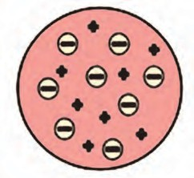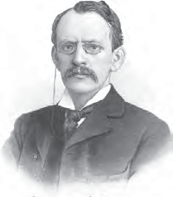

J.J. Thomson

Thomson's plum pudding model of atom

* 1. **Thomson's plum pudding model of atom**



**Use your brain power**

How will you think about atomic mass distribution according to Thomson's model? Whether this distribution is uniform or non uniform as per Dalton's atomic theory ?

Plum pudding or plum cake is sweetdish prepared during Christmas. In old times, this dish was made in Western countries by adding pieces of dried fruit called plum. These days, raisins or dates are used.

* + 1. If the striker flicked by you misses the coin that you aimed at, where would the striker go?



**Can you tell?**

* + 1. If the striker hits the coin, in which direction would it go? Straight forward to a side or in the reverse direction?

Rutherford’s nuclear model of atom (1911)

Rutherford studied the inside of atom by his celebrated scatterring experiment and put forth the nuclear model of atom in the year 1911.

Rutherford took a very thin gold foil (thickness : 10-4mm) and bombarded it with positively charged  - particles emitted by a radioactive element. (fig. 5.4) He observed the path of  - particles by means of a fluorescent screen around the gold foil. It was expected that the - particles would get reflected from the gold foil if the positively charged mass were evenly distributed inside the atoms. Unexpectedly, most of the  - particles went straight through the foil, a small number of  - particles get deflected from the original path through a small angle, a still smaller number of - particles get deflected throught a larger angle and susprisingly one  - particle out of 20000 bounced back in the direction opposite to the

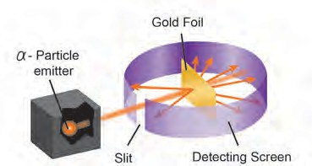

original path.

Golden foil

 - Particle emitter

Fluoroscent screen

Slit

* 1. **Rutherford’s scatterring experiment**

The large number of the  - particles that went straight through the foil indicates that there was no obstacle in their path. It meant that there must be mainly an empty space inside the atoms in the solid gold foil. The small number of  - particles that get deflected through a small or a big angle must have faced an obstacle in their path. It meant that the positively charged and heavy part causing obstruction would be in the centre of the atom. From this Rutherford put forth a nuclear model for atom as follows :

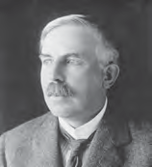Rutherford’s atomic model

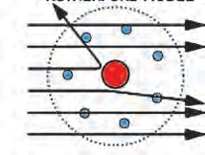

* 1. **Rutherford’s Nuclear atomic model**

1. There is a positively charged nucleus at centre of an atom. 2. Almost the entire mass of the atom is concentrated in the nucleus.

3. Negatively charged particles called electrons revolve around the nucleus. 4. The total negative charged on all the electron is equal to the positive charge on the nucleus. As the opposite charges are balanced the atom is electrically neutral. 5. There is an empty space between the revolving electron and the atomic nucleus.



**Use your brain power**

1. Which discovery did point out that an atom has internal structure?
2. What is the difference between the solid atom in Dalton’s atomic theory and Thomson’s atomic model?
3. Explain the difference between the distribution of positive charge in Thomson’s atomic model and Rutherford’s atomic model.
4. What is the point difference between the place of electron in the atomic models of Thomson and Rutherford?
5. What is the thing which is present in Rutherford’s atomic model and not present in Dalton’s and Thomson’s atomic models?

An established law of physics an electrically charged body is revolving in a circular orbit, its energy decreases. According to this law the atom described in Rutherford’s model turns out to be unstable. In reality, however all atom, except radioactive atom, are stable. This shortcoming of Rutherford’s atomic model was removed by the atomic model put forth by Niels Bohr in the year 1913.

Bohr’s stable orbit atomic model (1913)

In the year 1913 Danish scientist Niels Bohr explained the stability of atom by putting forth stable orbit atomic model. The important postulates of Bohr’s atomic model are as follows.

* 1. The electrons revolving around the atomic nucleus lie in the concentric circular orbits at certain distance from the nucleus.
  2. Energy of an electron is constant while it is in a particular orbit.
  3. When an electron jumps from an inner orbit to an outer orbit it absorbs energy equal to the difference of its energy level and when it jumps from an outer orbit to an inner orbit it emits energy equal to the difference of its energy level.



**Do you know?**

When table salt (Sodium chloride) is thrown on LPG gas stove flame, immediatly yellow spark forms on that place. If sodium metal put in water, it burns to give yellow flame. On road sodium vapour lamp gives yellow colour light. From all above example, the electron of sodium absorb energy and goes to outermost shell and come back to inner shell by emitting energy. The difference of energy level of these two shells of sodium is fixed. This difference is similar to energy of yellow light. Therefore in above example same specific yellow light emitted.

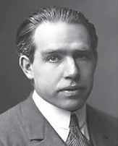N Shell M Shell L Shell K Shell

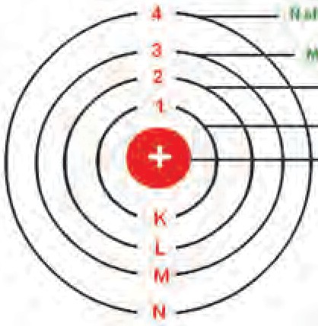

Positively charged nucleus

* 1. **Bohr's stable orbit atomic model**

Some more atomic models were put forth after Bohr’s atomic model. Atomic structure was studied at depth with the advent of a new branch of science called quantum mechanics. With all those some well accepted fundamental principles of atomic structure are as follows :

Atomic structure

An atom is formed from the nucleus and the extranuclear part. These contain three types of subatomic particles.

Nucleus

The atomic nucleus is positively charged. Almost entire mass of the atom is concentrated in the nucleus. The nucleus contains two types of subatomic particles together called nucleons. Protons and neutrons are the two types of nucleons.

Proton (p)

Proton is a positively charged subatomic particle in the atomic nucleus. The positive charge on the nucleus is due to the proton in it. A proton is represented by the symbol ‘p’. Each proton carries a positive charge of

+1e. (1e = 1.6  10-19 coulomb). When total positive charge on the nucleus is expressed in the unit ‘e’ , its magnitude is equal to the number of proton in the nucleus. The number of protons in the nucleus of an atom is the atomic number of that element and is denoted by the ‘Z’ mass of one proton is approximately 1u (1 Dalton)

(1u = 1.66  10-27 Kg) (The mass of one hydrogen atom is also approximately 1 u.) **Neutron (n)**

Neutron is an electrically neutral subatomic particle and is denoted by the symbol ‘n’. The number of neutron in the nucleus is denoted by the symbol ‘N’. Atomic nuclei of all the elements except hydrogen with atomic mass 1u, contain neutrons. The mass of a neutron is approximately 1 u, which is almost equal to that of a proton.

Extranuclear part

The extranuclear part in the atomic structure includes electrons revolving around the nucleus and the empty space in between the nucleus and the electron.

Electron (e-)

Electron is a negatively charged subatomic particle and is denoted by the symbol ‘e-’. Each electron carries one unit of negative charge (-1e). Mass of an electron is 1800 times less than that of a hydrogen atom. Therefore the mass of an electron can be treated as negligible.

Electron in the extranuclear part revolve in the discrete orbits around the nucleus. The orbits being three dimensional in nature, a term ‘shell’ is used in stead of the term ‘orbit’. The energy of an elctron is determined by the shell in which it is present.

The number of electron in the extranuclear part is equal to the number of proton in the nucleus (Z). Therefore electrical charges are balanced and the atom is electrically neutral.



**Use your brain power**

1. How many types of subatomic particles are found in atom?
2. Which subatomic particles are electrically charged?
3. Which subatomic particles are present in the nucleus?
4. Where are electrons revolving around the nucleus placed?

The mass of an electron being negligible, therefore the mass of an atom is mainly due to the protons and neutrons in its nucleus. The total number of protons and neutron in an atom is the atomic mass number of that element. The mass number is denoted by the symbol ‘A’. The convention to denote atomic symbol, atomic number and mass number are together is shown as follows.

Asymbol. For example, the conventional



**Use your brain power**

1. The symbol used for oxygen is ‘O’. There are 8 protons and 8 neutrons in its nucleus. From this determine the atomic number

(Z) and mass number (A) of oxygen and arrange these in a conventional symbol.

1. Atomic number of carbon is 6. How many electrons are there in a carbon atom ?
2. A sodium atom contains 11 electrons. What is the atomic number of sodium ?
3. The atomic number and mass number of magnesium are 12 and 24 respectively. How will you show this by the convention symbol ?
4. The atomic number and mass number of calcium are 20 and 40 respectively. Deduce the number of neutron present in the calcium nucleus.

**Distribution of electron :** As per Bohr’s atomic model, electrons revolve in stable shells. These shells have a definite energy. The shell nearest to the nucleus is called the first shell. The next shell is called the second shell. A symbol ‘n’ is used for the ordinal number of a shell. The shells are referred to by the symbols K, L, M, N,. corresponding

to the ordinal numbers n = 1, 2, 3, 4, The

maximum number of electron a shell can contain is obtained by the formula ‘2n2’. As the magnitude of ‘n’ increases, the energy of an electron in that shell increases.



**Complete the table**

Z

symbol

12C means that the atomic number,

6

|  |  |  |  |
| --- | --- | --- | --- |
| **Shell** | | **Electron capacity of the shell** | |
| **Symbol** | **n** | **Formula : 2 n2** | **Number of Electrons** |
| K | 1 | 2  (1)2 |  |
| L |  |  |  |
| M |  |  |  |
| N |  |  |  |

that is, the proton number of carbon is 6 and the mass number of carbon is 12. From this it is also learnt that the nucleus of carbon contain (12-6) i.e. 6 neutrons.

Write the maximum number of electron in a shell using the above table. K Shell : ..., L Shell : ..., M Shell :..., N Shell :...

1. There is a similarity in the atomic structure and solar system. The planets revolve around the sun due to the gravitational force. Which force might be acting in the atomic structure ?



**Can you tell?**

1. Positively charged proton are together in the nucleus. What might be, one of the function of the neutrons in the nucleus ?

Electronic configuration of elements :

We have seen that 2, 8, 18, 32. electrons can be accommodated in the shells K, L, M, N respectively. This is the maximum

capacity of that shells. The electrons in an atom are distributed in the shells according to their maximum capacity. The shellwise distribution of the electron in an atom of an element is called the electronic configuration of that element. Each electron has a definite energy as per the shell in which it is present. Energy of an electron in the first shell (K shell) is the lowest. Energy of electron in the

subsequent shells goes on increasing with the ordinal number of the shell. The electronic configuration of an element is such that the energy of all the electrons together is the maximum possible. Electrons get a place in the shells in accordance with the maximum capacity of the electron shell in an atom and the increasing order of energy. Let us now look at the electronic configuration of atom of some elements. (Table 5.7). The rows 1 to 3 are filled in this table. Accordingly you have to fill the rest of the table.

|  |  |  |  |  |  |  |  |
| --- | --- | --- | --- | --- | --- | --- | --- |
| **Atom** | **Symbol** | **Electron number in the atom** | **Distribution of electrons** | | | | **Electronic configuration in the numerical form** |
| **Shell symbol (maximum capacity)** | | | |
| **K (2)** | **L (8)** | **M (18)** | **N (32)** |
| Hydrogen | H | 1 | 1 |  |  |  | 1 |
| Helium | He | 2 | 2 |  |  |  | 2 |
| Lithium | Li | 3 | 2 | 1 |  |  | 2, 1 |
| Carbon | C | 6 |  |  |  |  |  |
| Nitrogen | N | 7 |  |  |  |  |  |
| Oxygen | O | 8 |  |  |  |  |  |
| Fluorine | F | 9 |  |  |  |  |  |
| Neon | Ne | 10 |  |  |  |  |  |
| Sodium | Na | 11 |  |  |  |  |  |
| Chlorine | Cl | 17 |  |  |  |  |  |
| Argon | Ar | 18 |  |  |  |  |  |
| Bromine | Br | 35 |  |  |  |  |  |

* 1. **electronic configuration of some elements**

The electronic configuration in the numerical form contains numbers separated by commas. Here the numbers indicate the electron number in the shells with increasing order of energy for example the electronic configuration of sodium is 2, 8, 1. It means that the total 11 electrons in sodium are distributed as 2 in the shell ‘K’, 8 in the shell ‘L’, and 1 in the shell ‘M’. The electronic configuration of an atom can also be represented by shell diagram as shown in fig 5.8

**Valency and electronic configuaration :** We have seen in the last chapter that valency means the number of chemical bonds formed by an atom. We also saw that generally the valency of an element remain constant in its compounds.



**Can you recall?**

Use the following molecular formulae to determine the valencies of H, Cl, O, S, N, C, Br, I, Na

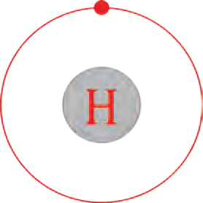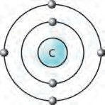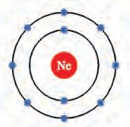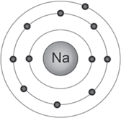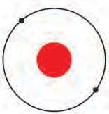

**He**

Hydrogen

Helium

Carbon

Neon

Sodium

Molecular formulae - H2, HCl, H2O, H2S, NH3, CH4 HBr, HI, NaH .

* 1. **Skeleton of Electronic configuration**



**Use your brain power**



1. What are the symbols used for the shells which accommodate the electrons in various atoms?
2. What is the symbol and ordinal number of the inner most shell ?
3. Write symbol of electron distribution in shell of fluorine atom?
4. Which is the outermost shell of fluorine atom ?
5. Which is the outermost shell of sodium atom ?
6. Which is the outermost shell of hydrogen atom ?

The concepts regarding valency of an element chemical bonds in compounds get clarified from the electronic configuration. Atom forms chemical bonds by using electron of its outermost shell. Valency of an atom is determined by the configuration of its outermost shell. Therefore the outermost shell is called valence shell. Also, the electrons in the outermost shell are called **valence electrons.**

It can be seen that the valency of an atom is related to the number of valence electrons in that atom. Let us first look at the elements helium and neon. Atoms of both these gaseous element do not combine with any other atom. These elements are chemically inert. It means that their valency is ‘Zero’.

Helium atom contains two electrons which are accommodated in the first shell ‘K’.

(See the table 5.7) Helium has only one ‘K’ shell that contains electron and the same is also the outermost shell. The electron capacity (2n2) of ‘K’ shell is ‘two’. This indicates that the outermost shell of helium is completely filled. It is said that helium has an electron duplet. The electronic configuration of the inert gas neon contain two shell ‘K’ and ‘L’. ‘L’ is valence shell of neon. The electron capacity of ‘L’ shell is ‘eight’ and the table 5.7 shows that the valence shell of neon is completely filled. It is said that neon has an electron octet. Argon is an inert gas having electron in the shells ‘K’, ‘L’ and ‘M’. The electron capacity of the ‘M’ shell is 2 x 32 = 18. However in argon there are only 8 electron in the valence shell ‘M’. (See table 5.7) It means that there are eight electron in the valence shell of inert gases, that is an electron octet. From this it is understood that the valency is ‘Zero’ when electron octet (or duplet) is complete.

The electronic configurations of elements other than inert gases (table 5.7) show that they do not have electron octet or their electron octet are incomplete. Regarding hydrogen, it can be said that its electron duplet is incomplete.

Atom of all the elements except inert gases have tendency to combine with other atoms, meaning that they have a non zero valency. You have seen from the formulae of the molecules formed by combination with hydrogen (for example H2, HCl) that valency of hydrogen is ‘one’. The electronic configuration of hydrogen shows that there is ‘one’ electron less than the complete duplet state.

This number ‘one’ matches with the valency of hydrogen which is also ‘one’. Moreover it is learnt that the electronic configuration of sodium (2, 8, 1) has ‘one’ electron in the valence shell and the valency

of sodium is also ‘one’ as seen from the molecular formulae NaCl, NaH, etc. It means that there is some relation between the valency of an element and the number of electron in its valence shell.



**Use your brain power**

The following table (5.9) shows molecular formulae of compounds formed by some elements. Write the valency of the respective element obtained from them and also their electronic configuration and the number of their valence electrons in the empty spaces.



|  |  |  |  |  |  |  |
| --- | --- | --- | --- | --- | --- | --- |
| **Sr.**  **No.** | **Symbol of element** | **Molecular formula of compound** | **Valency of the element** | **Electronic configuration of the element** | **Number of valence electrons x** | **8 - x (For x**  **4)** |
| 1 | H | HCl | 1 | 1 | 1 | -------- |
| 2 | Cl | HCl | 1 | 2, 8, 7 | 7 | 8-7 = 1 |
| 3 | Ne | No compound | 0 |  |  |  |
| 4 | F | HF |  |  |  |  |
| 5 | Na | NaH |  |  |  |  |
| 6 | Mg | MgCl2 |  |  |  |  |
| 7 | C | CH4 |  |  |  |  |
| 8 | Al | AlCl3 |  |  |  |  |

* 1. **Relationship between valency and electronic configuration**



**Use your brain power**

In table 5.9 column you have written identified valency from its molecular formulae.

1. When the number of the valence electrons in an element ‘x’ is 4 or less than 4, does ‘x’ match with the valency of that element ?



**Always remember**

‘‘Valency of an element is same as the number of its valence electrons if this number is four or less than four. On the other hand, when an element has four or more valence electrons, the number of electron by which the octet is short of completion is the valency of that element.

1. When the number of the valence electrons in an element ‘x’ is 4 or more than 4, does ‘(8-x)’ match with the valency of that element? How many electrons are used to complete the octet ?

From this you will learn that there is a general relationship between the valency of an element and its electronic configuration as shown below.

* 1. What is meant by the atomic number (Z) of an element ?



**Use your brain power**

* 1. Atomic numbers (Z) of some elements are given here.

Write down the number of electron present in the outermost shell of each of them.

|  |  |  |  |  |  |
| --- | --- | --- | --- | --- | --- |
| **Element** | **H** | **C** | **Na** | **Cl** | **N** |
| Z | 1 | 6 | 11 | 17 | 7 |
| Number of electrons in the outermost shell |  |  |  |  |  |

* 1. The number of electrons of some elements is given here. By using it write the electronic configuration, number of valence electron and valency of the respective elements.

|  |  |  |  |  |
| --- | --- | --- | --- | --- |
| **Element** | **Li** | **C** | **Mg** | **O** |
| Number of electrons | 3 | 6 | 12 | 8 |
| Electronic configuration |  |  |  |  |
| Number of valence electrons |  |  |  |  |
| Valency |  |  |  |  |

* 1. Why are the atomic numbers and atomic mass numbers always in whole numbers ?
  2. Sulphur contains 16 proton and 16 neutrons. What would be its atomic number and mass number?

**Isotopes :** The atomic number is a fundamental property of an element and its chemical identity. Some elements in nature have atoms with same atomic number but different mass number. Such atom of the same element having different mass number are called isotopes. For example, carbon has three isotopes, namely, C - 12, C - 13, C - 14. The mass number of

isotopes is also represented by another method as 12C , 13C and 14C. The isotopes have same

proton number but different neutron number.

|  |  |  |
| --- | --- | --- |
| **Isotopes** | **Proton number** | **Neutron number** |
| 1H  1 | 1  1 | 1  2 |
| 35Cl  17  37Cl  17 |  |  |

|  |  |  |  |
| --- | --- | --- | --- |
| **Isotope** | **Mass number A** | **Proton number (Atomic number) Z** | **Neutron number n = A - Z** |
| 12C | 12 | 6 | 6 |
| 13C | 13 | 6 | 7 |
| 14C | 14 | 6 | 8 |



**Collect information**



**Complete the table**

Hydrogen has three isotopes. They have separate names hydrogen, deuterium and tritium. Find out their mass numbers. Collect the information about what is heavy water from internet.

**Uses of isotopes :** Isotopes of some elements are radioactive. They are used in various fields such as industry, agriculture, medicine, research field.

1. Uranium - 235 is used for nuclear fission and production of electricity.
2. Some radioactive isotopes like Cobalt - 60 are used in the medical treatment of fatal diseases like cancer.
3. Iodine -131 is used in the treatment of goiter, disease of thyroid gland.
4. The radioactive isotopes are used for detection of cracks (leakage) in the underground pipes. eg. Sodium -24.
5. Radioactive isotopes are used for food preservation from microbes.
6. The radioactive isotope C-14 is used for determining the age of archeological objects.

**Nuclear Reactor :** Nuclear reactor is a machine that generates electricity on large scale by using atomic energy (See fig. 5.10). In a nuclear reactor, the nuclear energy in atom is released by bringing about nuclear reactions on the nuclear fuel. Let us understand a nuclear reaction with example of a nuclear fuel, namely, Uranium - 235. On bombardment with slow speed of neutrons, the nucleus of the isotope Uranium - 235 undergoes nuclear fission to form nuclei of two different elements Krypton - 92 and Barium - 141 and 2 to 3 neutrons. On decreasing the speed these neutrons bring about fission of more U-235 nuclei. In this way a chain reaction of nuclear fission takes place. (See the figure 5.11) A large amount of nuclear energy is released during a chain reaction of fission. The chain reaction is kept under control to prevent the probable explosion.

To control the chain reaction in the nuclear reactor it is necessary to decrease the speed and number of neutrons. For this purpose the following provision is made in a

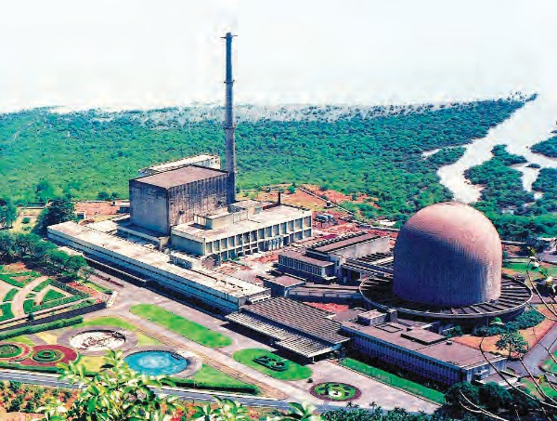

* 1. **Nucleur reactor: Bhabha Atomic Research centre, Mumbai**

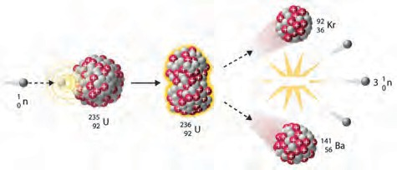

nuclear reactor. **5.11 Uranium - 235 Disintegration**

* + 1. **Moderator :** Graphite or heavy water is used as moderator for reducing the speed of neutrons.
    2. **Controller :** To reduce the number of neutron by absorbing them rods of boron, cadmium, beryllium etc. are used as controller.

The heat produced in the fission process is taken out by using water as coolent. Water is transformed into steam. By means of this steam, turbines are driven and electricity is generated.

In India, total twenty two nuclear reactors in eight places are functioning. ‘Apsara’ at Bhabha Atomic Research Centre in Mumbai is the first nuclear reactor in India which went critical on 4th August 1956. India has large reseves of the element Thorium -232. Therefore Indian scientists have developed a future plan for nuclear reactors based on production of the isotope U - 233 from Th - 232.

**Use of ICT :**

Collect detailed working information of atomic reactor from [www.youtube.com](http://www.youtube.com/) and show video in the class.



**Exercises**

1. **Answer the following.**
   1. What is the difference in the atomic models of Thomson and Rutherford?
   2. What is meant by valency of an element? What is the relationship between the number of valence electron and valency?
   3. What is meant by atomic mass number ? Explain how the atomic number and mass number of carbon are 6 and 12 respectively.
   4. What is meant by subatomic particle ? Give brief information of three subatomic particles with reference to electrical charge, mass and location.
2. **Give scientific reasons.**
   1. All the mass of an atom is concentrated in the nucleus.
   2. Atom is electrically neutral.
   3. Atomic mass number is a whole number.
   4. Atoms are stable though negatively charged electron are revolving within it.
3. **Define the following terms**

a. Atom b. Isotope c. Atomic number

d. Atomic mass number e. Moderator in nuclear reactor

1. **Draw a neat labelled diagram.**
   1. Ruthrford's scattering experiment
   2. Thomson's atomic model
   3. Diagramatic sketch of electronic configuration of Magnesium (Atomic number 12)
   4. Diagramatic sketch of electronic configuration of Argon (Atomic number 18)
2. **Fill in the blanks.**
   1. Electron, proton, neutron are the types of

in an atom.

* 1. An electron carries a charge.
  2. The electron shell is nearest to the nucleus.
  3. The electronic configuration of magnesium is 2, 8, 2. From this it is understood that the valence shell of Magnesium is .
  4. The valency of hydrogen is 'one' as per the molecular formula H2O. Therefore valency of 'Fe' turns out to be

as per the formula Fe2O3.

1. **Match the pairs.**

**Group ‘A’ Group ‘B’**

* 1. Proton i. Negatively charged
  2. Electron ii. Neutral
  3. Neutron iii. Positively Charged

1. **Deduce from the datum provided.**

|  |  |
| --- | --- |
| **Datum** | **To deduce** |
| 23Na  11 | Neutron number |
| 14  6 C | Mass number |
| 37Cl  17 | Proton number |

**Project :**

Explain the atomic models using the material such as old C.D., balloon, thread, marbles, etc .





**6. Composition of matter**

1. What are the various states of matter?



**Can you recall?**

1. What is the difference in ice, water and steam?
2. What are the smallest particles of matter called?
3. What are the types of matter ?

We saw in the previous standards that all the objects that we see around us and also those which cannot be seen are made of same or the other matter.

1. Classify the following matter into three groups. Cold drink, air, sherbat, soil, water, wood, cement.



**Can you tell?**

1. What are the states of matter that you used as criteria for the above classification ?



**Try this**

Take some mustard seeds in a transparent plastic jar. Thread a long thread at the centre of a big ballon by means of a needle and tie it tight.

Stretch this rubber diaphragm and fix it on the mouth of the jar by means of a rubber band. Pull the diagphragm up and down with the help of the thread first slowly, then with moderate force and then vigorously. Record your observation in the following table.

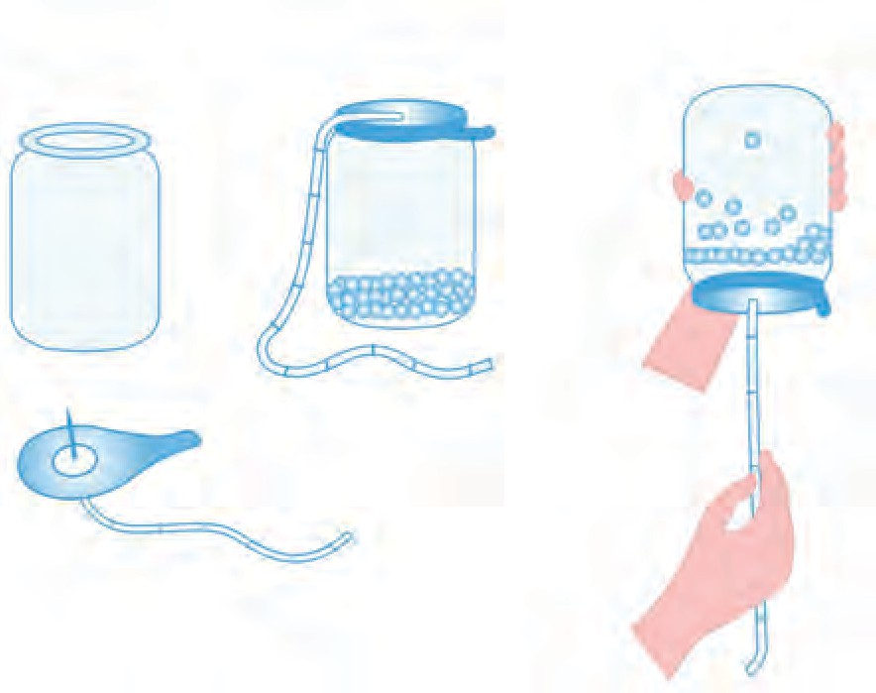

Mustard seeds

Big ballon

Pull thread slowly, moderately, vigorously

|  |  |
| --- | --- |
| **Mode of pulling the diaphragm up and down** | **Movement of the mustard seeds** |
| Slow | Vibration in the  same place |
| with moderate force | ...... |
| vigorous | ...... |

On the above experiment we give energy, less or more, to the mustard seeds by pulling the diaphragm up and down, making them move differently. The particles in the solid, liquid and gaseous states of matter have movement some what similar to that.

An intermolecular force of attraction acts between the particles (atom or molecules) of matter. The extent of the particle movement is determined by the strength of this force. The particles of solid are very close to each other and vibrate at their fixed positions. Due to this, solids get properties like definite shape and volume and also high density and non-compressibility. The strength of intermolecular force is moderate in the liquid state. Though it is not strong enough to fix the particles in definite position, it is strong enough to hold them together. As a result, liquids have definite volume. However they have fludity and their shape is not definite but changes in accordancewiththecontainer. Theintermolecular

* 1. **Movement of mustard seeds**

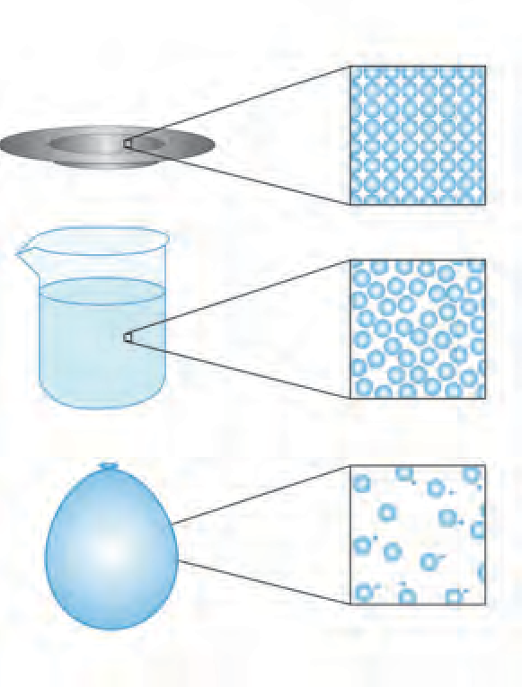Inter Particle distance

Solid

Very less

Liquid

Medium

Gas

Large

* 1. **Physical state of matter : submicroscopic picture**

force is very weak in gases. Therefore the constituent particles of gases move freely and occupy all the available space. Consequently gases have neither definite shape nor definite volume. Figure 6.2 shows schematic representation of submicroscopic picture of the physical states of matter and the table 6.3 shows the characteristics of the states of matter.

|  |  |  |  |  |  |  |
| --- | --- | --- | --- | --- | --- | --- |
| **Physical state of matter** | **Fluidity/ Rigidity/ Plasticity/ Elasticity** | **Volume** | **Shapes** | **Compressibility** | **Intermolecular force** | **Distance between particles** |
| Solid | Rigid/plastic/ elastic | Definite | Definite | Negligible | Strong | Minimum |
| Liquid | Fluid | Definite | Indefinite | Very small | Moderate | Moderate |
| Gaseous | Fluid | Indefinite | Indefinite | Very high | Very weak | Very large |

* 1. : Characteristics of States of matter



**Can you tell?**

Write the composition of the following materials by means of chemical formulae and classify them accordingly.

|  |  |  |
| --- | --- | --- |
| **Name of the material** | **Chemical formula/composition** | **Type of matter** |
| Water |  |  |
| Carbon |  |  |
| Oxygen |  |  |
| Air |  |  |
| Aluminium |  |  |
| Brass |  |  |
| Carbon dioxide |  |  |

This is the second method of classification of matter. In this method the criterion used for classification of matter is chemical composition of matter. We have seen in the previous standard that matter is classified into three types **‘element’, ‘compound’ and ‘mixture’** by considering whether the smallest particles of matter are similar or different and what are they made of. All the smallest particles (atoms/ molecules) in an element or a compound are alike, however, the smallest particles in a mixture are of two or more types.

The smallest particles of an element contain identical atoms. For example, each molecule of oxygen contains two oxygen atoms in bonded state. The smallest particles (molecules) of a compound are formed by joining two or more types of atoms to each

other. For example, each molecule of water contain two hydrogen atoms joined to one atom of oxygen. The smallest particles of a mixture are atoms/molecules of two or more elements/compounds. For example, the main constituent molecules of the mixture namely, air are N2, O2, Ar, H2O, CO2. Similarly, the mixture (an alloy) brass contain atoms of copper (Cu) and zinc (Zn), while bronze contain atoms of the elements copper (Cu) and tin (Sn).

The figure 6.4 shows a schematic submicroscopic picture of the types of matter, namely, element, compound and mixture and also their characteristics.

|  |  |  |
| --- | --- | --- |
| **Element** | **Compound** | **Mixture** |
| Nitrogen molecules (N2) | Nitrogen dioxide molecules (NO2) | Mixture of N2 and NO2 |
| Oxygen molecules (O2) | Nitric oxide molecules (NO) | Mixture of N2 and O2 |
| Constituent substance of element is only one, and it is that element itself | Constituent substance of a compound is only one and it is that compound itself | Constituent substances of a mixture are two or more elements and/or compounds |
| All the atoms/molecules of an element are alike | All the molecules of a compound are alike | Atoms\molecules of a mixture are of two or more types |
| All the atoms in a molecule of an element are alike and are joined to each other by chemical bonds. | The constituent atoms of a molecule of a compound are of two or more types and are joined to each other by chemical bonds. | The constituent molecules of mixture are different from each other and are not joined by chemical bonds. |
| Atoms/molecules of different elements are different | The proportion of constituent elements in a compound is constant. | The proportion of constituent substances in a mixture can change. |
| - | Properties of a compound are different than those of the constituent elements | The proporties of constituent substances are retained in the mixture. |

* 1. **: Element, Compound, Mixture - a schematic submicroscopic picture and characteristics**



**Do you know?**

**Water : A compound** Pure water is a compound formed by chemical combination of the elements hydrogen and oxygen. Whatever may be the source of water, the proportion of its constituent elements oxygen and hydrogen by weight is always 8:1. Hydrogen is an inflammable gas while oxygen gas supports combustion. However, the compound water formed by chemical combination of the gaseous elements hydrogen and oxygen is a liquid. It is neither inflammable nor does it support combustion. On the contrary it helps to extinguish fire.

**Milk : A mixture** Milk is a mixture of water, lactose, fats, protein and a few more natural substances. The proportion of various ingredients of milk is different as per its source. The proportion of fats in cow milk is 3-5 %, while it is 6-9 % in buffalo milk. The ingredient water is naturally present in large proportion in milk. Therefore milk exists in liquid state. The sweetness of milk is due to the ingredient called lactose. In other words, the proporties of the constituent substances are retained in milk.

Types of element

Take the following objects : iron nail/sheet, copper wire, aluminium wire, a piece of coal. Rub each object on a fresh surface of sandpaper and observe. Hammer each object with force. (Take care not to hurt



**Try this**

yourself.) Record your observations in the following table.

|  |  |  |
| --- | --- | --- |
| **Object** | **Is the surface shining? yes/ no** | **Does the shape flatten/break into small pieces on hammering ?** |
| Iron nail |  |  |
| Copper wire |  |  |
| Aluminium wire |  |  |
| Coal piece |  |  |

The objects in the above activity are made of the elements iron (Fe), copper (Cu), aluminium (Al) and carbon (C) respectively. Fill the following table on the basis of the observations obtained on doing the above two tests on each of the objects.

|  |  |
| --- | --- |
| Elements having a shiny surface |  |
| Elements that flatten on hammering |  |
| Elements with a dull surface |  |
| Elements that break on hammering |  |

You noticed that element has different physical properties like lustre/paleness, malleability/ brittleness. According to that elements are classified. In early times, elements were classified into 'Metals' and 'Non metals'. After invention of new elements a new type 'Metalloid' is discovered. The detail study of these type elements will be made in chapter Metals and Non metals.

Types of compound



**Try this**

**Apparatus :** Evaporating dish, tripod stand, burner, etc.

**Chemicals :** Camphor, washing soda, blue vitriol, sugar, glucose, urea.

Keep the evaporating dish on the tripod stand (fig 6.4).

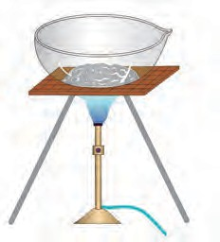

Take some camphor in the evaporating dish. Heat the camphor in the dish strongly with the help of a burner. Find out what remains behind in the evaporating dish. Repeat the above procedure using limestone, washing soda, blue vitriol, sugar, glucose and urea instead of camphor. Record your observation in the following table. (Do this activity carefully under the supervision of your

Camphor

Evaporating dish

Stand

Burner

teacher, as some of the powders may catch fire.) **6.4 Experimental figure**

|  |  |  |
| --- | --- | --- |
| **Powder in the evaporating dish** | **Whether there was a residue / no residue in the evaporating dish** | **Colour of the residue** |
| Camphor |  |  |
| Limestone |  |  |
| ...... |  |  |

You saw in the above activity that on heating strongly some compounds give residue while others do not give any residue or give a blackish residue. The black residue is mainly made of carbon. Moreover, when such compounds are strongly heated in air, combine with oxygen to form some gaseous substances. In case their combustion is not complete, black coloured carbon remain behind as residue. These compounds are

called **organic compounds or carbon compounds**. For example materials like, carbohydrates, proteins, hydrocarbons (for example, petrol, cooking gas) are made of organic compounds. The comphor, sugar, glucose and urea used in the above activity are organic compounds. On the other hand the compounds that decompose on strong heating to leave a residue behind are **inorganic compounds**. Comman salt, soda,

rust, blue vitriol, limestone are inorganic compounds. In addition there is one more type of compounds, namely **complex compounds**. The molecules of compounds have a complex structure formed by many atoms and in the centre of this structure metal atoms are also included. Chlorophyll that contains magnesium, hemoglobin that contain iron, cyanocobalamine (vitamin B-12) that contain cobalt are some examples of complex compounds.

Various atoms in the molecules of compounds are joined by **chemical bonds**. We are going to look at that later.

Types of mixtures



**Try this**

Take three beakers. Take a little sand and water in the first beaker. Take some crystals of blue vitriol and water in the second beaker. Take some blue vitriol and sand in the third beaker. Stir the materials in all the three beakers and observe. Record your observation in the following table.

|  |  |  |  |  |
| --- | --- | --- | --- | --- |
| **Beaker Number** | **Materials taken** | **What change seen on stirring** | **Number of phases in the mixture** | **Types of mixture** |
| **1** |  |  |  |  |
| **2** |  |  |  |  |
| **3** |  |  |  |  |

The part of matter having uniform composition is called **phase**. Write the third column of the table the number of phases seen in each of the beakers ofter stirring. When all the components of a mixture form one phase, it is called **homogeneous mixture**. When the components of a mixture are distributed into two or more phases it is called a **heterogeneous mixture**.



In the above activity after stirring a homogeneous mixture is

**Can you tell?**

formed in only one beaker. Which is that ?

**Always remember**

All the particles of a solid that stay together (or are in the same container) constitute a single phase. (eg., a heap of stones.) A liquid substance along with all the soluble substances dissolved in it together constitute a single phase. (eg., sea water) A liquid or all its drops present together or in the same container constitute a single phase. (eg., rain drops) The liquids present together or in the same container, but not mixed with each other, constitute separate phase. (eg., oil and water) All the gases present together constitute a single phase. (eg., air)

**Try this**

Take three beakers. Take 10 g common salt in the first beaker, 10 g saw dust in the second beaker and 10 ml milk in the third beaker. Add 100 ml water to all the three beakers and stir. which of the mixtures shows separate water phase? Place the three beakers in front of a vertically held paper and pass a laser beam through the beakers from the opposite side. (use the laser beam under the guidance of teacher.) At the same time observe what appears on the paper in front of the beaker. Also look at the beaker from the side. Arrange three filtration assemblies using conical flask, funnel and filter paper for doing filtration. Stir the mixtures in the three beakers and carry out filtration. Record all the observations in the following table.

|  |  |  |  |  |
| --- | --- | --- | --- | --- |
| **Beaker** | **Components of the mixture** | **Separate aqueous phase seen/not seen** | **Transperent/ opaque** | **Components are separated/ not separated by filtration** |

**Solution :** A homogeneous mixture of two or more substances is called **solution**. In the first beaker in the above activity a homogeneous mixture of water and salt is formed. It is called a salt solution. That component of a solution which is present in the largest proportion is called **solvent.** The other components which are in less proportion than the solvent are called **solutes**. The process of forming a solution by mixing solutes in a solvent is called dissolution. According to the states of the components solution can be of many types. The solution such as sea water, blue vitriol dissolved in water, salt dissolved in water, sugar syrup are of the type solid in liquid. In addition to this, the solution can also be of the types **liquid in liquid** (for example, vinegar, dilute sulphuric acid), **gas in gas** (for example, air) **solid in solid’** (for example, alloys like brass, steel, stainless steel, etc), **gas in liquid** (for example, chlorinated water, hydrochloric acid). The composition of a homogeneous mixture, that is to say solution, is uniform throughout the bulk. If solvent is a transparent liquid, the solution is also transparent and it passes through a filter paper.

**Suspension :** In the second beaker in the above activity a heterogeneous mixture of water and saw dust was formed. It is a mixture of a liquid and a solid. Heterogeneous mixture of a liquid and a solid is called a **suspension**. The diameter of the solid particles in a suspension is larger than 10-4

m. Therefore light cannot transmit through

it. More over these solid particles remain on an ordinary filter paper as residue and therefore the liquid and solid components of a suspension get separated by filtration.

**Colloid :** The mixture of water and milk in the third beaker in the above activity is transluscent. It means that, when light is incident on the surface of this mixture, it is partly transmitted and partly scattered. This is because the tiny particles of milk phase in this heterogeneous mixture are dispered evenly in water phase, and the diameter of these particles is around 10-5m. Such a heterogeneous mixture is called a **colloid**. However as the pores of an ordinary filter paper are larger than colloid, the heterogeneous mixture, cannot be separated by filtration. Milk is itself a colloid. In it, the solid and liquid particles of proteins, fats, etc. having a diameter around 10-5m are dispersed in the aqueous medium. Apart from this, there are some more types of colloids such as ‘solid in gas’ (for example, smoke), ‘liquid in gas’ (for example, fog, cloud), etc.

**Let us understand compounds :** while studying matter we have seen that element is a type of matter having the simplest composition. On inspection of the composition of the types compound and mixture it is learnt that they are formed from two or more units. Whether these units are in a joined state with each other or separate decides whether the matter is a compound or a mixture.

**Try this** Take two evaporating dishes. Take 7 g iron filings in the first dish and 4 g sulphur in the second. Take a horse shoe magnet near the matter



in both the dishes and observe. Transfer the entire iron filings from the first dish to the second, stir with a glass rod and observe by taking the horseshoe magnet near the matter. Also observe the colour of the matter. Now heat the matter in the second dish for a while and let it cool. Observe the colour change, if any in the matter and observe whether there is any effect of the horse shoe magnet on it. Record all the observation in the following table.

|  |  |  |
| --- | --- | --- |
| **Action** | **Colour of matter** | **Effect of horse shoe magnet** |
| Iron filings and sulphur were mixed in the dish |  |  |
| Iron filings and sulphur in the dish were heated together |  |  |

In the above activity, on testing the matter obtained by mixing iron filings and sulphur with horse shoe magnet (step 3) it was found that the resulting matter was a mixture of iron and sulphur and possessed properties of both the components. Some particles were yellow. They were of sulphur. Some particles were black. They were iron particles. The property of iron particles to get attracted towards magnet was unchanged. In other words the components iron and sulphur were in free state in that matter. On the contary when iron filings and sulphur were heated together and cooled there was no effect of magnet and the characteristic yellow colour of sulphur also disappeared.

From this we understand that the matter formed in the above activity is different from

the original components. A chemical combination took place between iron and sulphur due to heating in the above activity. The atom of iron and sulphur became joined by chemical bond to form molecules of a new compound.

**Molecular formula and valency :** There is a definite proportion of the constituent elements in a compound. Certain number of the atom of the constituent elements are joined to each other in a molecule of a compound. Molecular formula indicates the number of atom of each of the constituent elements present in one molecule of a compound. A molecular formula includes the information regarding the symbols of the all the constituent elements and their respective number as subscripts.

Molecular formulae of some compounds are given in the following table. Use these to fill in the gaps in the table.



**Can you tell?**

|  |  |  |  |  |
| --- | --- | --- | --- | --- |
| **Sr.**  **No.** | **Name of the compound** | **molecular formula** | **Constituent elements** | **Number of atoms of constituent elements** |
| 1. | Water | H2O | H O | 2  1 |
| 2. | Hydrogen chloride | HCl | ...  ... | ...  ... |
| 3. | Methane | CH4 | ...  ... | ...  ... |
| 4. | Magnesium chloride | MgCl2 | ...  ... | ...  ... |

We have seen the relationship between a molecular formula and the number of atom of various elements in molecule. The ability of joining to another atom with a chemical bond is a chemical property of each atom. This ability is indicated by a number and this number is called valency of that atom. An atom forms as many chemical bonds with other atom as its valency. Generally valency of an element remain constant in its various compounds.



**Complete the table**



**Do you know?**

Scientists performed many experiments regarding composition of compounds during 18th and 19th contury and from that they deduced the valencies of elements.

Molecular formulae of various compounds formed by hydrogen with other elements are given in the following table. From that, deduce the valencies of the concerned elements.

|  |  |  |  |  |  |  |
| --- | --- | --- | --- | --- | --- | --- |
| **Sr.**  **No.** | **Molecular formula of a compound** | **Constituent Elements** | | **Valency of ‘H’** | **Number of bonds formed by ‘X’ with ‘H’** | **Valency ‘X’** |
| **H** | **X** |
| 1 | HCl | H | Cl | 1 | 1 | 1 |
| 2 | H2O | H | O | 1 | 2 | 2 |
| 3 | H2S |  |  | 1 |  |  |
| 4 | NH3 |  |  | 1 |  |  |
| 5 | HBr |  |  | 1 |  |  |
| 6 | HI |  |  | 1 |  |  |
| 7 | NaH |  |  | 1 |  |  |
| 8 | CH4 |  |  | 1 |  |  |

Valencies of the constituent elements can be deduced from the known molecular formula of a compound. The basis for this is the univalency of hydrogen. On the other hand the molecular formula of a compound can be written from the known valencies of the constituent elements by the method of cross multiplication.

**Cross multiplication method for writing the molecular formula of simple compounds Step 1 :** To write symbols of constituent elements.

Pairs of elements and their valencies are given in the following table. Use them logically to deduce the molecular formulae of the compounds formed from the pairs and write them in the last column.

C O

|  |  |  |
| --- | --- | --- |
| **Element** | **Valency** | **Molecular formula of the corresponding compound** |
| C | 4 |  |
| H | 1 |
| N | 3 |  |
| H | 1 |
| Fe | 2 |  |
| S | 2 |
| C | 4 |  |
| O | 2 |

**Step 2 :** To write the valency below the respective element.

C O

4 2

**Step 3 :** To cross multiply to obtain the number of atom of the constituent elements in the molecule of the compound

C O

4 2

**Step 4 :** To write the formula of the compound obtained by cross multiplication.

C2O4

**Step 5 :** To write the final molecular

formula of the compound. The number of constituent atoms in the final molecular formula should be the smallest possible whole numbers. For getting this, divide the formula obtaind in step 4 by a suitable number.

Formula obtained by cross multiplication : C2O4



**Use your brain power**

1. Deduce the molecular formulae of the compounds formed from the following pairs of elements.
   1. H (valency 1) and O (valency 2)
   2. N (valency 3) and H (valency 1)
   3. Fe (valency 2) and S (valency 2)
2. The valencies of the atom H, O and N are 1, 2 and 3 respectively. The molecular formulae of these gaseous elements are H2, O2, and N2 respectively.

Final molecular formula obtained by dividing by ‘2’ : CO2

How many chemical bonds are there in

each of these molecules?



**Exercises**

1. **Choose the appropriate option and rewrite the following statements.**
2. The intermolecular force is ........ in the particles of solid.
   1. minimum ii. moderate iii. maximum

iv. indefinite

1. Solids retain their volume even when external pressure is applied. This property is called ........ .
   1. plasticity ii. incompressibility

iii. fluidity iv. elasticity

* 1. Matter is classified into the types mixture, compound and element, by applying the criterion ........ .

i. states of matter ii. phases of matters

iii. chemical composition of matter

iv. all of these

1. Matter that contain two or more constituent substances is called ........ .
   1. mixture ii. compound

iii. element iv. metalloid

1. Milk is an example of type of matter called ........ .
   1. solution ii. homogeneous mixture

iii. heterogeneous mixture iv. suspension

1. Water, mercury and bromine are similar to each other, because three are ........ .
   1. liquids ii. compounds iii. nonmetals

iv. elements

1. Valency of carbon is 4 and that of oxygen is 2. From this, we understand that there are ...... chemical bond/bonds between the carbon atom and one oxygen atom in the compound-carbon dioxide.
   1. 1 ii. 2 iii. 3 iv. 4
2. **Identify the odd term out and explain.**
3. Gold, silver, copper, brass
4. Hydrogen, hydrogen peroxide, carbon dioxide, water vapour.
5. Milk, lemon juice, carbon, steel.
6. Water, mercury, bromine, petrol.
7. Sugar, salt, baking soda, blue vitriol.
8. Hydrogen, sodium, potassium, carbon.
9. **Answer the following question.**
10. Plants synthesize glucose in sunlight with the help of chlorophyll from carbon dioxide and water and give away oxygen. Identify the four compounds in this process and name their types.
11. In one sample of brass, the following ingredients were found : copper (70%) and zinc (30%). Identify the solvent, solute and solution from these.
12. Sea water tastes salty due to the dissolved salt. The salinity (the proportion of salts in water) of some water bodies Lonar lake - 7.9 %, Pacific Ocean 3.5 % , Mediterranean sea - 3.8 %, Dead sea -

33.7 %. Explain two characteristics of mixtures from the above information.

1. **Give two examples each**
2. Liquid element
3. Gaseous element
4. Solid element
5. Homogeneous mixture
6. Colloid
7. Organic compound
8. Complex compound
9. Inorganic compound
10. Metalloid
11. Element with valency 1
12. Element with valency 2
13. **Write the names and symbols of the constituent elements and identify their valencies from the molecular formulae given below.**

KCl, HBr, MgBr2, K2O, NaH, CaCl2, CCl4, HI, H2S, Na2S, FeS, BaCl2

1. **Chemical composition of some matter is given in the following table. Identify the main type of matter from their.**

|  |  |  |
| --- | --- | --- |
| **Name of matter** | **Chemical composition** | **Main type of matter** |
| Sea water | H2O + NaCl + MgCl2+... |  |
| Distilled water | H2O |  |
| Hydrogen gas filled in a ballon | H2 |  |
| The gas in LPG cylinder | C4H10 + C3H8 |  |
| Baking soda | NaHCO3 |  |
| Pure gold | Au |  |
| The gas in oxygen cylinder | O2 |  |
| Bronze | Cu + Sn |  |
| Diamond | C |  |
| Heated white powder of blue  vitriol | CuSO4 |  |
| Lime stone | CaCO3 |  |
| Dilute hydrochloric acid | HCl + H2O |  |

1. **Write scientific reason.**
2. Hydrogen is combustible, oxygen helps combustion, but water helps to extinguish fire.
3. Constituent substances of a colloid cannot be separated by ordinary filtration.
4. Lemon sherbat has sweet, sour and salty taste and it can be poured in a glass.
5. A solid matter has the properties of definite shape and volume.
6. **Deduce the molecular formulae of the compound obtained from the following pairs of elements by the cross multiplication method.**
7. C (Valency 4) & Cl (Valency1)
8. N (Valency 3) & H (Valency 1)
9. C (Valency 4) & O (Valency 2)
10. Ca (Valency 2) & O (Valency 2)

Collect the wrappers of readymade food stuff. Use the information given and prepare a chart of foodstuff and the ingredients in it. Procure the ingredients available. Discuss with friends and teacher, test the procured ingredients with combustion test under the supervision of your teacher. Thereby identify the ingredients as organic or inorganic.

**Project :**





**7. Metals and Nonmetals**

1. What are the three types in which the elements are generally classified?



**Can you recall?**

1. What are the metals and nonmetals that we use in everyday life?

All the objects or materials in the world are made from elements, compounds or their mixtures. Scientists classified all the elements into three general types which are metals, nonmetals and metalloids.

**Metals :** Gold, silver, iron, copper, aluminium, magnesium, calcium, sodium, platinum are a few metals. Metals have lustre. The metals are hard. Wire or sheet can be from them made metal. Metals are good conductors of heat and electricity. Metals lose their valence electrons to produce positively charged ions, that is, cations.

Physical Properties of Metals

1. **Physical State :** Under ordinary temperature metals stay in solid state. However metals like mercury and gallium are exception, which are in liquid state even at room temperature.



**Can you recall?**

You might have seen a doctor’s pressure gauge to measure blood pressure, during your visit to a dispensary, accompanying your relative. In that, you might have seen a grey coloured liquid in a glass tube. What is that metal?

1. **Lustre :** Take copper vessels at your home. Scrub them with lemon and rinse with water. Observe the lustre before and after cleaning. Light gets reflected from the cleaned or freshly cut surface of metal and the metal looks lustrous.
2. **Hardness :** Generally metals are hard, not soft. Exception : Sodium and potassium are soft and can be easily cut by a knife.
3. **Ductility :** Have you ever gone to a goldsmith’s shop ? Have you seen the goldsmith making a wire of gold or silver? When a metal is pulled through a hole its wire is formed. This property of metal is called ductility.
4. **Malleability :** Take an iron nail. Place it on a platform and keep on hammering it. After sometime you will see a thin sheet forming. This property is called malleability of metals.
5. **Conduction of Heat :** Take a copper plate. Fix some wax at one of its ends. Heat the other end and observe what happens. Discuss with teacher.

Metals are good conductors of heat. Silver, copper and aluminium are the best conductors of heat.

1. **Conduction of Electricity :** Which metals are used to make electrical wires? Metals are good conductors of electricity. Lead is an exception, which is neither a good conductor of heat nor a good conductor of elctricity.
2. **Density :** Metals have high density Sodium, potassium and lithium are exception, having lower density then water. The density of lithium is only 0.53 g/cc.
3. **Melting point & Boiling Point :** Generally metals have high melting points and boiling points. Exceptions : Hg, Ga, Na, K.
4. **Sonority :** What is the metal that your school bell is made of ? How does a bell is function? Metals are sonorous. They produce sound on striking.

**Nonmetals :** Carbon, Sulphur, Phosphorus are a few nonmetals. Generally nonmetals are brittle and nonlustrous.

Physical Properties of nonmetals :

1. **Physical State :** At ordinary temperature nonmetals occur as solids, liquids and gases. For example : Solids : C, S, P; Liquids : Br2; Gases : H2, N2, O2
2. **Lustre :** Nonmetals do not have lustre, except diamond and iodine crystals. Some nonmetals are colourless while others have different colours. What is the colour of carbon in the form of coal ? Sulphur is

yellow and bromine is brown.

1. **Brittleness :** Take coal and hammer it. See what happens to it. Solid nonmetals are brittle. Some nonmetals are soft. Diamond (an allotrope of carbon) is an exception,

which is the hardest natural substance.

1. **Ductility & Malleability :** Non metals are neither ductile nor malleable.
2. **Conduction of Heat & Electricity :** Non metals are bad conductors of heat and electricity, except graphite (an allotrope of carbon) which is a very good conductor of electricity.
3. **Density :** Nonmetals have low densities.
4. **Melting & Boiling Point :** Nonmetals have low melting and boiling points. Exceptions : the solid nonmetals carbon and boron melt at high temperature.

**Metalloids :** Some elements such as arsenic (As), Silicon (Si), Germanium (Ge), Antimony (Sb) have properties which are intermediate between metals and nonmetals. Such elements are called metalloids.

Chemical properties of Metals

* 1. **Electronic configuration :** Electronic configuration is the basis of chemical behaviour of elements. Majority of metals have upto three electrons in their outermost shell.

|  |  |  |
| --- | --- | --- |
| **Metal** | **Atomic number** | **Electronic configuration** |
| 11Na | 11 | 2, 8, 1 |
| 12Mg | 12 | 2, 8, 2 |
| 13 Al | 13 | 2, 8, 3 |

* 1. **Formation of ions :** Metals have a tendency to lose their valence electrons to form positively charged ions, that is, cations. Na  Na+ + le-

##### (2,8,1) (2,8)

Sodium Sodium ion

Mg  Mg++ + 2e-

##### (2,8,2) (2,8)

Magnesium Magnesium ion

Al  Al+++ + 3e-

##### (2,8,3) (2,8)

Aluminium Aluminium ion

* 1. **Reaction with oxygen :** Metals combine with oxygen to form their oxides.



**Always remember**

1. Gold, Silver, Aluminium are highly malleable metals.
2. A sheet with thickness 1/10,000 mm and a wire with diameter 1/5000 mm can be made from gold.

Metal + Oxygen  Metal oxide

The metal oxides are basic in nature. Metal oxides react with an acid to form salt and water.

Metal oxide + Acid  Salt + Water

* 1. **Reaction with acid :** Take dilute hydrochloric acid in a test tube. Then add zinc dust to it. Take a glowing splinter near the mouth of the tube. Observe the glowing splinter. You will notice some sound coming out from it.

Most of the metals react with dilute acids to form metal salts while hydrogen gas is released.

Metal + dilute Acid  Salt + Hydrogen gas.

* 1. **Reaction with water :** Most metals do not show any observable and fast reaction with cold water. But some metals like sodium and potassium react with cold water to produce their hydroxides and hydrogen gas. magnesium metal requires steam to give

Cl + e-  Cl

(2, 8, 7) (2, 8, 8)

Chlorine Chloride ion

O + 2e-  O 

(2, 6) (2, 8)

Oxygen Oxide ion

N + 3e-  N  

(2, 5) (2, 8)

Nitrogen Nitride ion

1. **Reaction with oxygen :** Nonmetals combine with oxygen to form their oxides.

Nonmetal + oxygen  Nonmetal oxide

The oxides of nonmetals are acidic in nature. They react with bases to form soluble salt and water.



similar reactions.

Chemical properties of nonmetals

C + O2

CO2

* 1. **Electronic configuration :** Most of the nonmetals have 4 to 7 electrons in their valence shells.

CO2 + 2NaOH  Na2CO3 + H2O

The oxides of nonmetals react with water to form an acid.

CO2 + H2O  H2 CO3 Carbonic acid

SO + H O  H SO Sulphurous acid

|  |  |  |
| --- | --- | --- |
| **Nonmetal** | **Atomic number** | **Electronic con- figuration** |
| 7N | 7 | 2, 5 |
| 8O | 8 | 2, 6 |
| 17Cl | 17 | 2, 8, 7 |

2 2 2 3

* 1. **Formation of ions :** Non metals have a tendency to accept electrons in their valence shell to form negatively charged ions called anions.

SO3 + H2O  H2 SO4 Sulphuric acid

1. **Nonmetals do not react with dilute acids.**

**Uses of metals and nonmetals**

**Prepare a list of the uses of metals and nonmetals in our everyday life.**



**Make a list and discuss**

|  |  |  |  |
| --- | --- | --- | --- |
| **Name of metal** | **Use** | **Name of nonmetal** | **Use** |
|  |  |  |  |
|  |  |  |  |

While studying chemical properties of metals it is found that gold or silver do not react readily.



**Can you recall?**

**Noble Metal :** Some metals like gold, silver, platinum, paladium and rhodium are noble metals. They occur in nature in the elemental state. Gold which is100 percent pure is called 24 carat gold. Pure gold is soft. As a result the ornaments made from pure gold bend or break due to pressure. Therefore goldsmiths mix it with certain proportion of copper or silver. Ornaments are made from 22 carat gold or gold with still smaller carat value.

Uses of Noble metals :

1. Gold, silver and platinum are used to prepare ornaments.
2. Silver used in medicines. (It has antibacterial property).
3. Gold and silver also use to make medals.
4. Gold and silver also used to make few electronic devices.
5. Platinum, palladium metals are used as catalyst.

Purity of Gold :

When we ask rate of gold in gold shop, it always differ ? Why is it ? Gold is a noble metal, in nature it occurs in element form. 100% pure gold is 24 carat. Pure gold is soft. Therefore gold ornaments prepared by pure gold may break or bend due to pressure. Hence gold-smith add specific amount of copper or silver in pure gold. To prepare ornaments 22 carat gold is used.

|  |  |
| --- | --- |
| **Carat** | **Percentage** |
| 24 | 100 |
| 22 | 91.66 |
| 18 | 75.00 |
| 14 | 58.33 |
| 12 | 50.00 |
| 10 | 41.66 |

**Corrosion :** Gases in the air react with metals in presence of moisture to form metal compounds. The metals get affected by this

process and undergo what is called corrosion.



**Do you know?**

There is a statue of Liberty in the sea near New york city in America. The original surface of their statues was made of copper. But now it, looks green. This is because green coloured

copper formed copper

carbonate has been by a reaction of

with

the

carbon

dioxide and moisture in the air. This is an example of corrosion.



**Make a list and discuss**

Prepare a list of the examples of corrosion in your everyday life.

A reddish coloured deposit is formed on iron by reaction with oxygen gas. A greenish coloured deposit is formed on copper by reaction with carbondioxide gas. A blackish coloured deposit is formed on silver by reaction with hydrogen sulphide gas. To prevent corrosion of metals, layers of oil, grease, varnish and paint are applied on them. Also plating with another noncorroding metal is done. Iron is arrested by zinc plating. Due to these processes the contact of metal surface with air is lost and corrosion cannot occur as the chemical reaction cannot occur.

**Alloy :** A homogeneous mixture of two or more metals or a homogeneous mixture metal with nonmetals is called alloy. Alloys are made by mixing the constituent elements in as per the requirement. For example, the stainless steel utensils used at home are made of an alloy of iron with carbon, chromium and nickel. The alloy bronze is formed from copper and tin.



**Exercises**

* 1. **Complete the table**

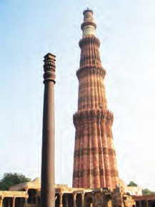

**Do you know?**

There is an iron pillar in the premices of Kutubminar in Delhi, made about 1500 year ago. The pillar is lustrous even after so many years. This is becasuse our ansestors had made it from an alloy.

It contains small proportion of carbon, silicon and phosphorus mixed in iron.



**Discuss**

You might be knowing scrap dealers. What do they do with the scrap ? Why is this needed ?

|  |  |
| --- | --- |
| **Property of metal** | **Use in everyday life** |
| 1. Ductility 2. Malleability 3. Conduction of heat 4. Conduction of electricity 5. Sonority |  |

**5. Three experiments to study the process of rusting are given below. Observe the three test tubes and answer the following questions.**

* 1. **Identify the odd term**
     1. Gold, silver, iron, diamond
     2. Ductility, brittelness, sonority, malleability
     3. Carbon, bromine, sulphur, phosphorus

**Test tube 1**

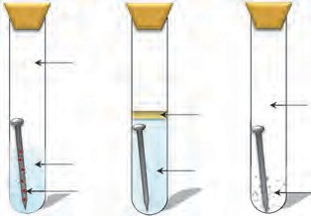

air

oil

water rusted nail

boiled water

dry air

calcium chloride

**Test tube 2 Test tube 3**

* + 1. Brass, bronze, iron, steel



**Do you know?**

A cheap variety of stainless steel is made sometimes by using copper instead of costly nickel. You might have seen the vertical cracks in stainless steel vessels. The reason is as above.

* 1. **Write scientific reasons.**
     1. The stainless steel vessels in kitchen have copper coating on the bottom.
     2. Copper and brass vessels are cleaned with lemon.
     3. Sodium metal is kept in kerosene.
  2. **Answer the following.**
     1. What is done to prevent corrosion of metals?
     2. What are the metals that make the alloys brass and bronze?
     3. What are the adverse effects of corrosion?
     4. What are uses of Noble metals?

1. Why the nail in the test tube 2 is not rusted ?
2. Why is the nail in the test tube 1 is rusted highly?
3. Would the nail in the test tube 3 get rusted ?

**Project :**

How is the 'Varkha' or sliver foil used in sweets made ? Collect the information about which metals are used to make 'Varkha'.

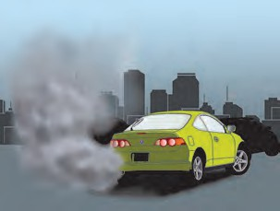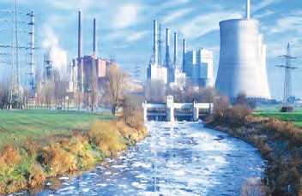

**8. Pollution**

**Observe**

* 1. 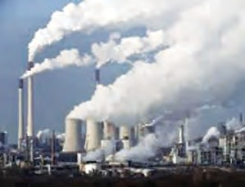**Various problems of environment**

1. Why these problems in environment may have been arised?
2. What should be done to overcome these problems?

Many problems have been arisen on the earth due to human interference in the nature. Industrialization, increasing population, mining, transportation, indiscriminate use of pesticides and fertilizers are causing pollution on the earth. It is affecting human beings.

**Pollution :** Contamination of natural environment that will be harmful to ecosystems is called as pollution.



**Can you tell?**

Pollutants :

1. Where do you see the pollution around you?
2. 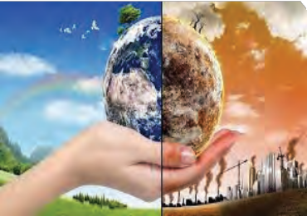How does the pollution occur?

Factors affecting natural functions of ecosystem and causing harmful effects on abiotic and biotic factors are called as pollutants. Pollutants make the environment poisonous and unhealthy.

Pollutants may be natural or man made. Natural pollutants are destroyed in due course of time by nature’s rule; however, man made pollutants are not.

* 1. **Save me my children !**

If natural materials are pollutants, why do we not perceive their adverse effects during their use? When such materials are referred as pollutants?



**Think about it.**

**Activity :** You yourself survey your residential area and identify the polluted locations. Try to identify the pollutant at each polluted location.



**Try this**

* + 1. Which types of pollutant are observed?



**Use your brain power**

* + 1. Whether the pollutants are degradable or non-degradable?
  1. **Air Pollution :** 1. Plot a graph showing the proportion of various gases in earth’s atmosphere.



**Can you recall?**

* + 1. Why is it said that air is homogenous mixture of different gases?
    2. Which different hazardous gases are released through fuel combustion?

Contamination of air by harmful substances like poisonous gases, smoke, particulate matter, microbes, etc. is called as air pollution.

Reasons of air pollution

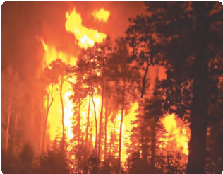

Which factors are responsible for pollution shown in the following

**Can you tell?**

pictures?

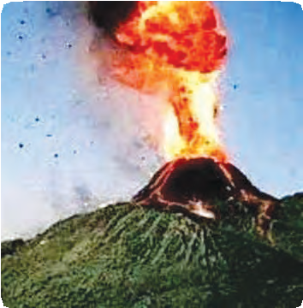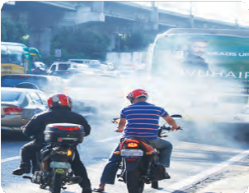

* 1. **Air pollution due to different factors**

**Natural reasons**

**Manmade reasons**

**Reasons of air pollution**

1. Volcanic eruption: Solid, gaseous and liquid materials emerge out through eruption. Ex. Hydrogen sulphide, sulphur dioxide, carbon dioxide, ammonium chloride, hydrogen, vapors, dust, etc.
2. Earthquake: Poisonous gases and water vapors from inside of earth are released into air.
3. Cyclones and dust storms: Dust, soil, garbage, pollens, microbes are mixed with air.
4. Forest fires: Forest fires release carbon dioxide, sulphur dioxide, hydrogen sulfide, smoke in air.
5. Microbes in air: spores of bacteria, fungi are mixed with air
6. Fuel: I. Burning of fuel like coal, timber, LPG, kerosene, diesel, petrol releases carbon dioxide, carbon monoxide, nitrogen oxide, sulphur dioxide, lead compounds, etc. are released in air.

II. Burning of solid waste, agricultural waste, etc. in open space causes air pollution.

1. Industrialization: Smoke is released in large quantity from various factories. sulphur powder, nitrogen oxide, Cotten seed powder in air.
2. Atomic energy plants and blasts: Use of elements like uranium, thorium, graphite, plutonium release radiations in air and thus pollution occurs.
   * 1. What are reasons other than above mentioned responsible for air pollution?
     2. Whether the vehicles with two stroke engine cause more pollution than four stroke engine?



**Think about it.**

**Internet My Friend**

1. Collect information about larger volcanoes of the world.
2. Collect information about effect of air pollution on human health from large cities and villages from Maharashtra.

**Peeping in the history**

1. There had been thick fog in London due to air pollution during 5th – 9th Dec.1952. Smoke due to burning of coal had been mixed. Dark shadow of this SMOG remained on the city for consecutive 5 days. Same situation occurred again during 3rd – 6th Dec.1962.
2. In 1948, Petersburg was named as 'BLACK CITY' when smoke and soot casued night like situation during day time.

|  |  |  |  |
| --- | --- | --- | --- |
| **S r .**  **No.** | **Air Pollutants** | **Source** | **Effects** |
| 1. | Sulphur dioxide (SO2) | Factories (where coal and mineral oil used as fuel) | Irritation of eyes, respiratory tract, excess mucus, cough, breath. |
| 2. | Carbon monoxide (CO) | Vehicular and industrial smoke | Lowered O2 carrying capacity of blood. |
| 3. | Oxides of nitrogen | Vehicular smoke | Irritation of respiratory tract and lungs |
| 4. | Particulate matter | Vehicular and industrial smoke | Respiratory diseases |
| 5. | Dust | Vehicular and industrial smoke | Silicosis |
| 6. | Pesticides | Production and use of pesticides | Mental weakness, death due to prolonged exposure |
| 7. | Methane (CH4) | Industrial leakage | Poisoning, skin cancer, asthma, respiratory diseases. |

* 1. **Air pollutants: Sources and effects**



**Do you know?**

Worst ever industrial accident had been occurred in Bhopal on the night of 2nd Dec.1984. Eight thousand people had been died due to accidental gas leakage.

Collect more information about Bhopal gas accident discuss the nature of accident, reasons, aftereffects, preventive measures.

**Animals**

1. Respiration is adversely affected.
2. Irritation of eyes.

**Plants**

1. Stomata get closed.
2. Slowing down of rate of photosynthesis.
3. Growth is retarded. Leaves fall off or become yellow.

**Effect of air pollution on plants and animals**

1. What is importance of ozone layer?
2. What are reasons for depletion in ozone layer?



**Can you recall?**

Effect of air pollution on plants and animals

**Depletion in Ozone layer :** Earlier, we have studied that ozone layer is present below the stratosphere, at the height of 48 kilometres from earth’s surface. It protects the living world of the earth from ultraviolet rays (UV-B) radiating from the Sun. However, nowadays, ozone layer is getting depleted due to following reasons.

**Green house effect and Global warming :** Though CO2 is present in very less quantity in atmosphere, it plays very important role of absorption of solar heat. Over the last 100 years, proportion of CO2 has been increased due to industrialization. Effect of this CO2 on the earth’s temperature is nothing but green house effect. Similar to CO2 , nitrous oxide, methane and CFC also trap the heat. Collectively, these are called as green house gases.

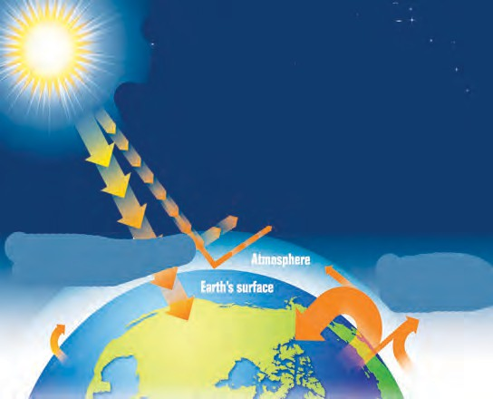

Earth

Infrared radiation

Atmosphere

Energy emitted by Sun is absorbed by earth surface

Energy emitted by Sun is absorbed in atmosphere

* 1. **Green House effect**

Global temperature is gradually increasing due to green house effect. Due to this, atmosphere is changing, causing disturbances in agricultural yield, distribution of wild animals. Icebergs and glaciers are melting causing increase in sea level.

**Acid Rain :** Oxides of sulphur and nitrogen are released into atmosphere through burning of coal, timber and fuel oils. Those oxides mix with rain water and form acids like sulphuric acid, nitric acid, nitrous acid, etc. These acids mix with rain drops and snowflakes and come down as rain, called as acid rain.

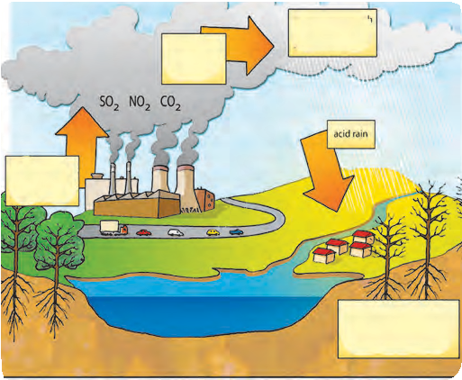

Oxides

Acid rain

Damage of animals and plants

Burning fuels

Acid

Effects of acid rain:

1. Acidity of soil and water bodies increases due to acid rain. It harms the aquatic organisms, plants and entire forest life. Total ecosystems are
   1. **Acid rain**

adversely affected.

1. Erosion of buildings, busts, historical monuments, bridges, metal idols, wire fences, etc. occurs due to acid rain.
2. Heavy metals like mercury and cadmium are absorbed up by plants and thereby enter the food chain indirectly due to acid rain.
3. Due to acidification of water in water bodies and pipes, leaching of metal and plastic material occurs in water and thereby serious health problems arise.

Preventive measures of air pollution



**Do you know?**

**Air Quality Index**

It is important for citizens to know the extent of air pollution in their city. So as to define the air quality index, proportion of SO2, CO, NO2, ozone, particulate matter, etc. is measured every day.

Boards indicating the air quality index are displayed in busy squares in metro cities.

1. Smoke emerging from factories contains harmful particles. Hence, pollution controlling machinery should be used. Ex. Arresters, filters.
2. Proper disposal of stinking waste generated in cities.
3. Control on atomic tests, chemical weapons, etc.
4. 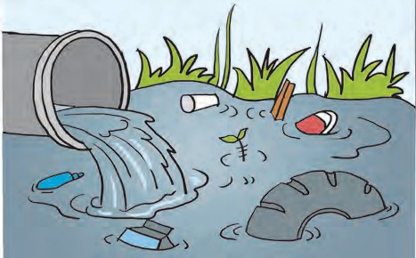Control / ban over CFC production.



**Do you know?**

Air pollutants with sulphur cause colour change in paints, oil paintings, nylon, cotton fabrics, leather articles and papers etc.

* 1. Water Pollution :



**Can you tell?**

1. From which water sources do we get the water suitable to use?
2. For which different purposes do we use the water?
3. How much percent of the earth’s area is occupied by water?
4. What are the reasons of water pollution?
5. Why does water is referred as ‘molecule of life’?

Water is said to be polluted when it becomes unclean and poisonous due to mixing of natural or artificial unwanted material, when it becomes harmful to living organisms due to decreased oxygen content, when epidemic diseases are spread through the water.

Fresh water or marine water pollution includes physical, chemical and biological changes.



**Do you know?**

* 1. **Water pollution**

Water Pollutants

* 1. Biological pollutants : Water does not remain potable due to algae, bacteria, viruses, parasites, etc. Diseases are spread due to biological pollution.
  2. Inorganic pollutants : Suspended particles like fine sand, dust, soil, precipitates of salt, compounds of arsenic, cadmium, lead, mercury, and traces of radioactive material.
  3. Organic pollutants : Weedicides, insecticides, fertilizers, sewage, industrial effluents, etc.

Large number of tanning centers are present in Tamilnadu. Waste water from those centers is released into Palar river. Hence that river is referred as Puzzar (Gutter river).

**B. Manmade reasons**

**A. Natural reasons**

**Reasons of water pollution**

1. **Aquatic weeds**
   * Depletion in O2 level
   * Changes in natural qualities of water

**2. Decomposing matter**

* Decomposing bodies of plant, animals

**3. Mud/sludge**

* River current and its diversion

**4. Soil erosion**

* Many biotic and abiotic factors are added to water due to soil erosion.

1. **Microbes like fungi and bacteria**
   * grow on organic matter decaying in water.
2. **Algae**
   * Excessive algal growth pollutes water

**7. Nematodes :**

* Soil nematodes flow in with rain water

1. **Domestic sewage**
   * Domestic sewage from villages and cities is disposed off in river water
2. **Industrial effluent**
   * Various pigments, bleaching chemicals, leather pieces, fibres, mercury, lead, etc. are released in to water.
3. **Oil spillage**
   * While transportation, cleaning of tankers oil spills in to water
4. **Use of fertilizers and pesticides**
   * N, P, K containing chemical fertilizers
   * Pesticides like endrin, chlorine, carbonate containing pesticides, flow and mix with water.
5. **Other reasons :**
   * Disposal of human wastes, washing of clothes, decomposing hemp and flax in water, disposal of ashes, floral offerings to god, water from thermal power plant, etc.
     1. Effects on human being

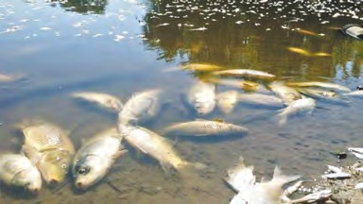

**Effects of water pollution**

* + - * Diseases like hepatitis, typhoid, diseases of skin and alimentary canal.
      * Ailments of liver, kidneys, brain, deformities in bones, hypertension.
    1. Effects on ecosystem
       - Retarded plant growth
       - Loss of plant species
       - Increase in salt content of water
       - Decreased dissolved oxygen level
       - Disturbance in aquatic ecosystem
       - Death of aquatic animals
       - Adverse effects on sea birds
    2. Other effects
       - Changes in physical and chemical properties of water
       - Changes in natural color and taste
       - Useful aquatic fauna is destroyed
       - Soil fertility is affected
       - Toxic materials are added to crops
  1. Soil Pollution :



**Can you recall?**

1. What is meant by soil erosion?
2. What are reasons for depletion in soil fertility?

Out of the total land area of the soil, some is covered by ice; some is desert, whereas some is occupied by mountains and hills. Very less area of land is available for human use.

Soil is said to be polluted when there are changes in its physical biological and chemical properties and its fertility decreases due to either natural or manmade reasons.



**Compare this**

Compare two neighbouring photographs.

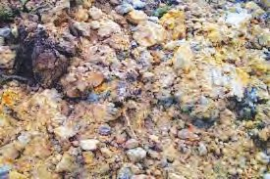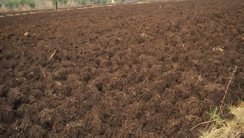Effects of soil pollution

Give 5 examples of each of domestic waste, biological waste, and agricultural waste and write in your own words about soil pollution due to those wastes.

* 1. Soil fertility decreases due to mixing of salty, acidic water from industry.
  2. Radioactive and other pollutants enter and pass through food chain like the soil, crop, water and human body.
  3. Problem of water pollution increases due to soil pollution. Toxic substances leach into water. Similarly, diseases spread through various pathogens.

**Discuss the issues like ‘dry waste- wet waste’ and ‘toilet in each home’ and write information in your own words.**

Relationship of soil pollution with air and water pollution

If wet waste is dumped at wrong places instead of composting, pathogens grow upon it, which are then mixed with water causing water pollution.

Insecticides, chemical fertilizers, weedicides are used in agriculture, which causes soil pollution. Excessively sprayed insecticides and weedicides are mixed with air causing air pollution. Similarly, excessive use of chemical fertilizers causes water pollution.

Soil pollution occurs due to mixing of human wastes, birds and animals waste. This releases various stinking gases causing air pollution. Same waste may cause water pollution if mixed with water.

**Pollution - Prevention and control :** Government of India has enacted some laws for control, regulation and prevention of pollution. Following are laws regarding pollution control.

1. Water pollution and prevention act, 1974. 2. Air pollution and prevention act, 1981.

**3. Environmental Protection Act, 1986.**

Various laws and rules are in force in relation to biomedical waste, harmful effluents, solid waste and sound pollution. Government statutory bodies like Maharashtra Pollution Control Board and Central Pollution Control Board supervise about whether the industries, industrial areas, local governing bodies like municipalities, district councils, panchayat samiti, gram panchayat, etc. follow the laws about pollution control.



**Exercises**

1. **Following are some statements about**

**pollution. Which type of pollution do those express?**

* 1. Fog seems to be appearing in Delhi during day hours.
  2. Many times, vomiting and dysentery occurs after eating ‘pani puri’.
  3. Problem of sneezing occurs sometimes during visit to garden.
  4. Crop does not grow up in some areas.
  5. People living in the busy squares face the problems like short breathing and other respiratory problems.

1. **Read the passage and identify the sen- tences expressing types of pollution.** Nilesh is a student of std. VIII and lives in urban area. It takes about an hour to go to the school by bus. He faces the heavy traffic of two wheelers, four wheelers, rickshaws, buses while going to school. He is facing the problem of asthma since last few days. Doctors recommended him to stay away from urban area. Since then, his mother sent him to the village of his maternal uncle. Nilesh saw the heaps of garbage at many places in village. Foul smell of human and animal wastes was present at many places. Blackish water with foul smell was flowing in a stream. He developed some abdominal disease within few days.
2. **Match the pairs from ‘A’ and ‘B’ col- umns and explain the effect of pollution on human health.**

**Column ‘A’ Column ‘B’**

1. Water a. Mental containing cobalt retardedness
2. Methane gas b. Paralysis.
3. Water containing c. Inflammation lead of lungs.
4. Sulphur dioxide d. Skin cancer
5. Nitrogen dioxide e. Irritation of

eyes

1. **Answer the following.**
   1. What is pollution?
   2. What are pollutants?
   3. What is acid rain?
   4. What is green house effect?
   5. Which are visible pollutants known to you?
   6. Which are invisible pollutants?
2. **Answer the following**
   1. Give two examples of each of water, soil and air pollution from your residential area.
   2. How does the pollution occur due to vehicles? Give the names of vehicles causing least pollution.
   3. What are natural reasons for water pollution?
   4. Suggest four preventive measures for air pollution.
   5. Explain relation between green house effect and global warming.
   6. Construct two slogans each on air, water and soil pollution.
3. **Classify the following pollutants into natural and manmade categories.** Sewage, dust, pollen grains, chemical fertilizers, vehicular smoke, algae, pesticides, waste of animals and birds.

**Project :**

1. Visit the water testing laboratory in your area and collect the information about tests for checking the purity of water.
2. Visit the square having heavy traffic in your area and report the pollution at different times of day and find out the duration of maximum pollution.



1. **True or false**
   1. Water does not get polluted by washing the cloths in running water of river.
   2. More the use of electric appliances, more will be the pollution.



**9. Disaster Management**

* + 1. What do you mean by disaster ?



**Can you recall?**

* + 1. What are the different types of disaster?

Last year we have introduced various natural calamities/disasters. This year we are going to study about earthquake and some other natural calamities.

What is an earthquake ? what are the effects of earthquake ?



**Can you tell?**

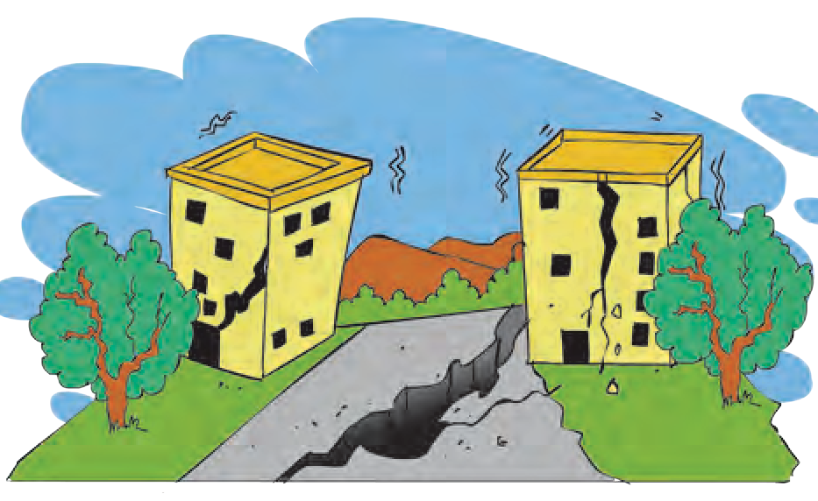Earthquake

Sudden vibrations on the earth and shaking of the earth surface /ground is called an earthquake. These cause seismic waves leading to movements of the earth’s surface like tremors, shaking or it goes up-down.

The shocks and waves formed in the interior of the earth spread on the surface in all directions. The central point of earthquake is the point above the epicenter on the earth surface. Strong convulse or waves at first reach to the epicenter, therefore major loss occurs near to that area.

Shocks occurred due to an earthquake can be mild or intensified (acute). On the earth mild earthquakes occur in a larger number than the intensified or Runners .

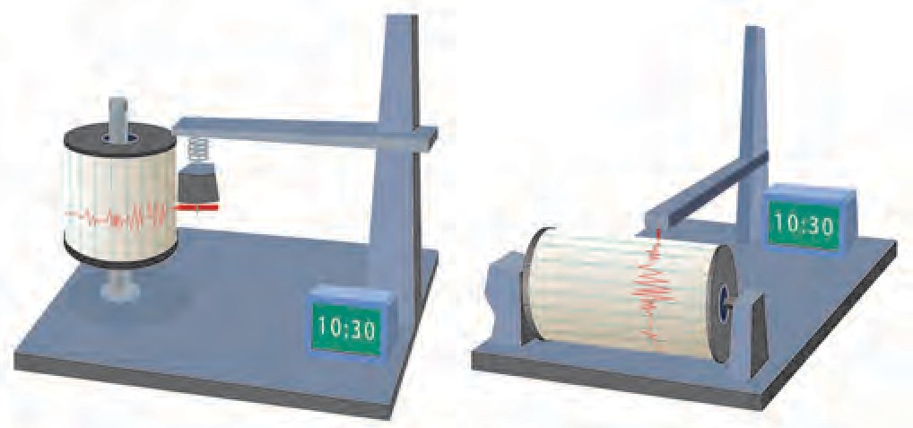Everyday, earthquakes are noticed at some or the other places on the earth. According to the observation of ‘National Earthquakes information center’ every year nearly 12,400 to 14,000 earthquakes occur on the earth. ( Ref:- [www.tris.edu.)](http://www.tris.edu/) From this it is noticed that earth is continuously vibrating.

Vertical seismometer Horizontal seismometer

**9.3 Seismometer**

* 1. **Cracks to the buildings**

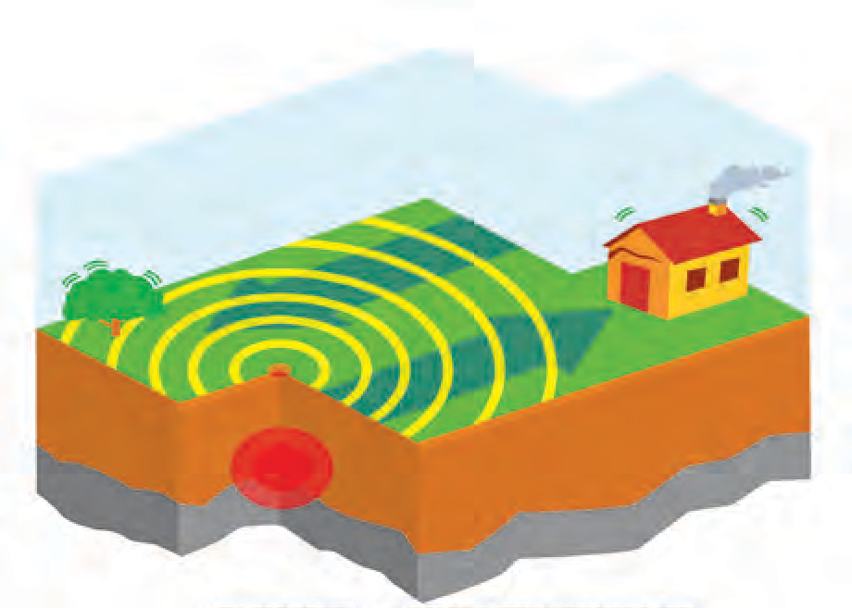

Plate movement

Epicentre

Focal point

Seismic waves

* 1. **Focal point and epicentre of earthquake**

The machine / Instrument which records the earthquakes is called ‘Seismograph’ or ‘Seismometer’, and the accentuation (intensity) is measured in ‘Richter Scale’. This is one of the mathematical measuring unit.

Effects of earthquakes are mentioned below. Study them carefully.

**Internet My Friend** Collect the information about Richter Scale and effects of earthquake

|  |  |
| --- | --- |
| **Causes of an earthquake** | **Effects of an earthquake** |
| 1. Volcanic eruption. 2. Stress of big dams on the earth. 3. Mining. 4. Underground atomic tests. 5. Water percolates through the cracks of the earth. Due to tremendous heat, the water converts into steam. The steam formed tries to come out from the loosened earth surface causing earthquakes. | 1. Loss of human beings, wild animals and pets. 2. Economic loss at large scale ( Electric poles, pipelines, houses, buildings, roads, railway tracks are destroyed.) 3. Ecosystem destruction due to the loss of Biodiversity. 4. Direction of flow of rivers, streams changes. 5. Possibility of fire in cities increases. 6. If there is earthquake at the bottom of ocean, it may create tsunami waves and thereby large scale destruction of costal region. 7. Level of water-table changes. |

Precautions to be taken at the time of Earthquake

* + 1. **If you are at home,** then, do not get scared and instead of running here and there, stand still at one place. Either sit on the floor or below the bed or any other furniture and cover yourself until the movement of earth stops. If there is no table or any other shelter then sit in any corner of the room and cover your head by folding your hands around it.
    2. **If you are in the vehicle or outside the house,** then park your vehicle at a safe place and sit inside it. Do not wait near or below tall building, trees or electric pole.

Avoid doing following things during earthquake

1. Avoid using lift in the multistoried building, instead use staircase.
2. Do not sit in discomfort for long. Do some physical movements.
3. After the earthquake there is a possibility of fire, hence, to avoid it carefully switch off the main electric supply. Do not use candles, lantern, or matchbox, instead use torch or battery.

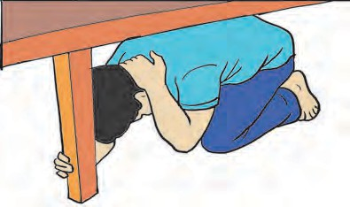

**(a)**

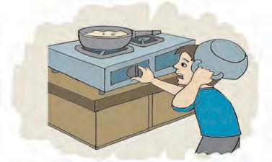

**(b)**

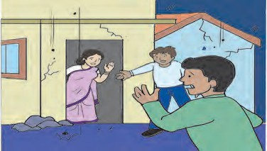

**(c)**

**9.4 Precautions to be taken**

**Earthquake Resistant / Proof Buildings :** The constructions which do not get damaged due to earth movements upto a certain limit, are called earthquake resistant buildings. To construct tall buildings, ‘Indian Standard Institute’ has made some code of conduct . Buildings are constructed as per I.S. 456 and earthquake resistant constructions are performed as per IS 1893 (Criteria for earthquake resistant design of structure) and IS 13920 (Ductile detailing of reinforced concrete structures subjected to seismic forces). Advanced technology is used for earthquake resistant construction.

To get prior intimation about earthquake, modern equipments like laser ranging very long baseline, geiger counter, creep meter, strain meter, tide gauge, tilt meter, volumetric strain gauge etc. are used.

Fire

Fire is a natural calamity or man made calamity ?



**Can you recall?**

Types Of Fire

**Methods of Fire Extinction :** There are 3 main methods to stop the spreads of fire or to control the fire.

1. **Cool Out (Use of Water) :** To extinguish fire water is most common and effective solution which is easily available everywhere. If you spray water on the fire or around the fire it creates cooling effect and helps to control the fire.
2. **Suppress the Fire :** To control the fire which is caused due to electricity or oil, sand or soil can be used. If we spread a froth like substance on the fire, it cuts off the contact between air and fire. This method is more useful to extinguish the fire spread due to oil.
3. **Keep away Flammable Substances :** In this method, all flammable substances are kept away from the fire. Any wooden article or flammable substances must be kept away so that no source is left for the fire to spread. Stirr up pump is the best device to put off small fires. It sprays water in all directions around the fire.
4. **Class A Fire (Solid substances) :** Commonly flammable materials are their fuel source. (wood, clothes, coal, papers etc.) This fire can be put out with water.
5. **Class B Fire (Liquid substances) :** Fires caused due to flammable liquid substances (petrol, oil, varnish, solvents, cooking oil, paints etc.) All these substances are lighter than water, therefore, fire extinguishers can be used to extinguish fire.
6. **Class C Fire (Gaseous Substances) :** Fires caused due to acetylene, household gas (L.P.G.)
7. **Class D Fire (Chemical substances) :** Fires caused due to combustible metals like potassium, sodium and calcium, which react with water at normal room temperature. Magnesium, aluminum and zinc react with water at high temperature. When both these groups combine with water, it explodes.
8. **Class E Fire ( Electrical) :** A fire caused due to electrical components is class E fire. To extinguish such fire, power is cut off and non-conductive fire extinguishers like carbon dioxide are used.

**Precautions and Safety Measures**

1. Develop the habit of switching off the gas regulator when not in use specially during night. Switch off the electrical appliances when you are going out of the house.
2. To make others alert and call them for help, shout loudly.
3. Call fire brigade.
4. Provide information how to use fire extinguishers.

**First Aid**

Let the patient sit / sleep in a comfortable position and call the doctor immediately.

Landslides- Rift collapse

* 1. What are the reasons for ‘Malin’ mishap in Pune district? What are its effects?



**Can you recall?**

* 1. What is the landslide ?

Natural cracks and fissures present in hard rocks cause their breaking. Especially, at the time of heavy rains, water entering these cracks causes weathering of these rocks. Weight increases, these rocks slide on the sloppy region and settle at the lower side. This is called collapse of rift.



**Make a list and discuss**

In Maharashtra where do the traffic jams occur due to landslides? Make a list of such places. Why do the landslide occur at those places only? Discuss in the classroom and suggest preventive measures.

Causes of landslide

1. After effects of natural disasters like earthquake, tsunami, heavy rains, storms, floods cause landslide.
2. Unlimited cutting of trees causes soil erosion.
3. While building roads in mountains, there is a lot of digging, that makes the mountain weak.

Effects of landslide

1. Rivers get flooded and change their paths.
2. Displacement of waterfalls, formation of artificial water reservoirs.
3. There is live and financial loss on a large scale, as trees, buildings, rocks on sloppy area collapse on low-lying land.
4. Landslide affects the traffic.
5. Landslide destroys plant life on it.

**Disaster relief – planning :** If the plan is prepared, it will help any disaster relief in the school. For that prepare a chart as given below.

|  |  |
| --- | --- |
| **Main points** | **The things to be noted** |
| **Primary information of the school** | 1. Name and address of the school 2. Name and residential address of the Head Master with contact number. 3. Names and contact numbers of school management members. 4. Total number of staff. |
| **School Disaster Management Committee** | a. Fire extinguisher b. Awareness c. Instructions d. Traffic Management e. Safety f. communication committee (2-3 members/ sub committee) |
| **Detailed information about school building** | a. Total number of rooms. b. Number of classroom. c. Classes. d. Type of roof (wooden/cement/sheets) e. Age of the building, building year. |
| **Information about school ground** | 1. Type of the play ground – prayers space, kho-kho, kabaddi and other grounds etc. 2. Distance of the ground from main road. |
| **Daily routine of the school** | 1. Time to start, school breaks and time to leave the school. 2. Daily activities taking place in the school. |
| **Possible hazards in the school** | 1. Name and type ( normal/ medium/ acute) of the danger. 2. Destruction in the past and current planning. |
| **Disaster management map of the school** | The map must have following contents –  All buildings of the school, their structure, grounds, entrances, place of probable dangers in the school, safe places at the time of disaster, nearest road. This map must be at the entrance of the school and all students must be given detailed knowledge about it. |

|  |  |
| --- | --- |
| **Mock drill in the school** | Every month a mock drill must be conducted in the school.  It should include possible hazards and the measures taken against them. The date, time, number of students and shortfalls must be noted down. |

**Work of the institutes**

1. The government of India in collaboration with Indian Mountaineering Institute and International center for Integrated Mountain Development has launched a program to forecast the landslides and its effects.
2. Institute of geology and world geological forum also help for this forecast.



**Exercises**

1. **Answer the following in your own words.**
   1. Explain the relation between continuous rains and landslide. Give reasons.
   2. Prepare a chart showing ‘Do’s’ and ‘don’ts’ at the time of earthquake.
   3. What are the specifications of an earthquake –proof building ?
   4. Explain the effects of landslide.
   5. Is there any relation between dam and earthquake ? Explain.
2. **Give Scientific reasons.**
   1. It is safer to find shelter under things like a bed, table at the time of earthquake.
   2. In monsoon, don’t take shelter near hillside.
   3. Don’t use lifts at the time of earthquake.
   4. The foundation of earthquake-proof building is separated from other land.
3. **If a crowd gathers at the place of earthquake, what would be the difficulties in relief work ?**
4. **Make a list of the institutes and organizations who provide help for disaster management. Collect more information about their work.**
5. **Make a survey of your school according to the plan of disaster management and write the pointwise information.**
6. **Are there any possible places of landslide in your area ? Collect information from experts.**
7. **With the help of following picture, explain your role in the disaster management.**

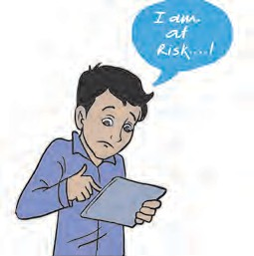

**Project :**

1. Make a collection of news, photos, and cuttings about landslides and rift collapse.
2. With the help of internet, collect information about the latest gadgets and technology to forecast earthquake .
3. Collect information about NDRF, RPF, CRPF, NCC from internet.
4. Discuss- Need of CCTV.





**10. Cell and Cell Organelles**

* 1. How many types of cells are found in living organisms ?



**Can you recall?**

* 1. Which instrument had you used to observe cells ?

Last year, we studied that cell is the structural and functional unit of living organisms. According to the functions, cells of different sizes and structures are found in different organs. **Structure of the cell**

Observe the following figures, write the names and complete the chart.



**Observe**

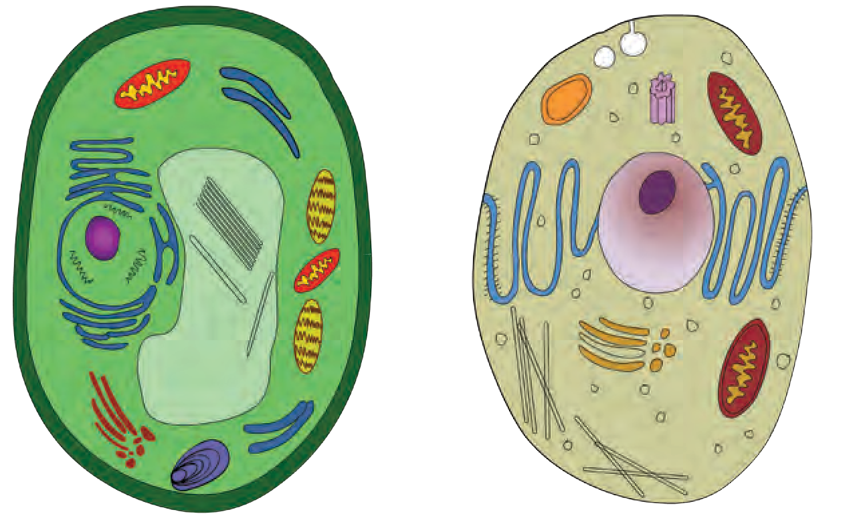

* 1. **: Plant cell and Animal cell**

We must study each and every part of the cell to understand the processes

|  |  |  |
| --- | --- | --- |
| **Component** | **Animal cell** | **Plant cell** |
| Cell membrane | Present | Present |
| Cell wall | . . . . . | . . . . .. |
| . . . . . | Present | Absent |
| Plastids | . . . . . | . . . . . |
| . . . . . | Present | Present |
| Vacuole | . . . . . | . . . . . |
| Golgi complex | . . . . . | . . . . . |
| Mitochondria | . . . . . | . . . . . |

occuring within the cell.

Components of a cell

1. **Cell wall :** It is found around cells of algae, fungi and plants. Animal cells lack cell wall. Cell wall is an elastic and strong coat around cell membrane. It is mainly composed of carbohydrates like cellulose and pectin. Afterwards, polymers like lignin, suberin, cutin are added in cell wall as per need. Functions of cell wall are to support and to protect the cell by

preventing entry of excess water in the cell.

1. **Plasma membrane/cell membrane** : It is a thin, fragile and elastic covering that separates the cell components from outer environment.

Structure of plasma membrane - Protein molecules are embedded in two layers of phospholipids.

Plasma membrane is said to be a selectively permeable membrane as it allows some substances to enter the cell, while prevents other substances.

Due to this property, useful molecules

of water, salt and oxygen enter the cell and

Middle lamella

Primary cell wall

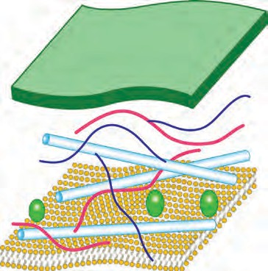

Hemicelluose

Pectin

Cellulose microfibre

CO2

exits the cell.

If any changes occur outside the cell,

Plasma

Soluble

proteins

the celllular environment does not change due to plasma membrane. This condition is called homeostasis.

mebrane

* 1. **Structure of cell wall**



**Can you tell?**

How do substances travel in the cell ?

###### Activities that consume cellular energy

1. **Endocytosis -** To gulp/engulf food and other substanes from outer environment.
2. **Exocytosis -** To excrete waste materials out of cell.

###### Processes those that don’t consume cellular energy

* 1. **Structure of Plasma membrane**

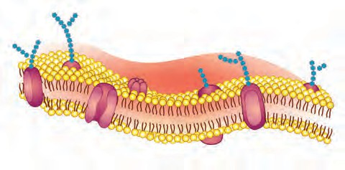

Carbohydrate chain

Protein

Lipid bilayer

1. **Diffusion -** Entry or exit of small molecules like O2, CO2
2. **Osmosis -** The travelling of water from a part with more water to a part with less water, through a selctively permeable membrane is osmosis. It is a physical process with 3 possibilities.

hypertonic Isotonic Hypotonic

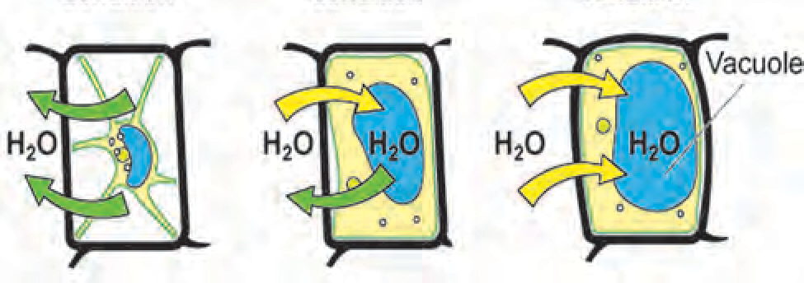

Vacuole

Osmosis in plant cell

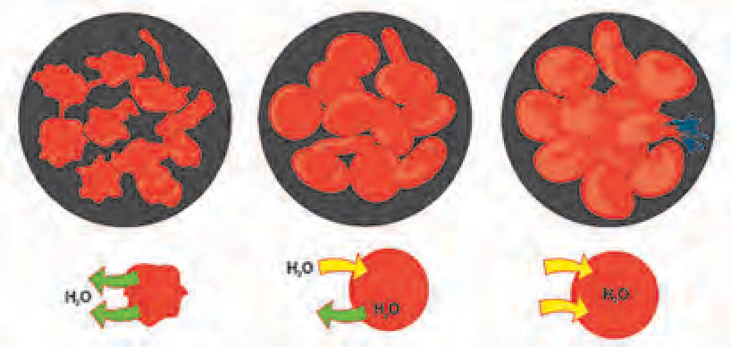

H2O

H2O

Osmosis in animal cell

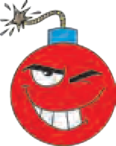

**10.4 Osmosis**

**Research**

1. Keep 4-5 raisins in water and observe after an hour. Afterwards, keep the same raisins in sugar solution and observe after an hour. Note down the observations and discuss in the classroom.
2. Wooden doors fit very tightly in rainy season. Why does it happen ?
   1. **Isotonic solution -** Medium outside and inside the cell has same proportion of water, water doesn’t go in or out.
   2. **Hypotonic solution -** The cell has less water than outside medium, so water enters the cell.

This is called endomosis. Eg. If raisins are kept in water, after sometime they swell and become turgid.

###### Hypertonic solution -

The cell has more water than the outside medium so water comes out of the cell.

Eg. If fruit pieces are kept in thick saturated sugar solution, the water from fruit pieces enter the sugar solution. So the fruit pieces shrink after a while. If plant cell or animal cell is kept in hypertonic solution, water comes out of the cell by the process of exosmosis and there is

contraction of cytoplasm. This process is called plasmolysis.

###### Cytoplasm -

Have you seen the fully turgid, rectangular cells of onion peelings ?



**Can you recall?**

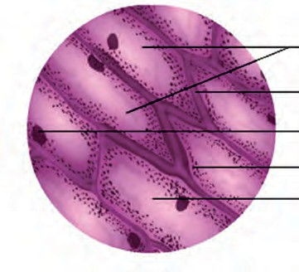Cytoplasm is the fluid between plasma

membrane and nucleus. It is a moving, sticky substance. Many cell organelles are suspended in cytoplasm. Cytoplasm is the medium for cellular chemical reactions. The part of cytoplasm other than organelles is the cytosol. Cytosol stores vital substances like amino acids, glucose, vitamins, etc. In animal cells, cytoplasm is more granular and dense while in plant cells, it is thin and mostly pushed to the periphery due to a larger central vacuole.

**Cell organelles :** An organelle is a specialized subunit having specific function within the cell. They are ‘organs of the cell.’ Each organelle has its own lipoprotein membrane. Except nucleus and chloroplast, all other organelles can be seen only with electron

microscope.

###### Nucleus

* 1. **Onion peeling**

Cells of onion peeling

Cell wall

Nucleus Cytoplasm Vacuole

* 1. 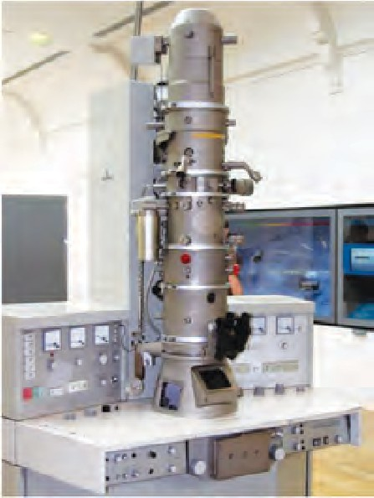**Electron microscope**



**Try this**

**Activity -** Take a drop of water on a clean glass slide. Using an ice-cream spoon, gently scrape the inner surface of your cheek. With a needle, transfer a little material from spoon to the water drop on the slide and spread it evenly. Put a drop of methylene blue stain on the smear. Put a cover slip and observe under microscope. Did you observe the cells with blue nucleus?

The dark round spot seen under the microscope while observing the onion peeling stained

with iodine is the nucleus of the cell.

Chromatin

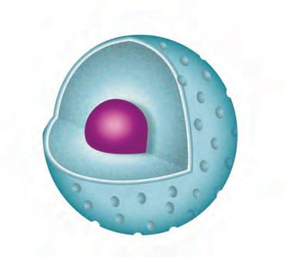

Nuclear

Nucleolus pore

Nuclear

membrane

* 1. **Nucleus**

When observed under electron microscope, we can see nucleus covered by a double layered membrane with small pores. These pores allow the passage of material in and out of the nucleus. Nucleus has one round nucleolus and a network of chromatin fibres. Chromatin fibres are thin thread like structures, which condense to form short thick chromosomes at the time of cell division. Functional segments on chromosomes

are called genes.

###### Functions of nucleus

1. It controlls all metabolic activities of the cell and also the cell division.
2. It is involved in the transmission of hereditary characters from parents to offsprings.



**Do you know?**

* Due to loss of nucleus, large quantity of haemoglobin can be accomodated in the RBC and thereby large amount of oxygen can be transported.
* Due to the loss of nucleus of sieve tubes of the plant phloem, they become hollow and thereby transportation of food becomes easy.

###### Endoplasmic Reticulum (ER)



**Think about it.**

How many types of pipelines are there in your building/home ? What are their functions ? What will happen if they weren’t there ?

The organelle which conducts various substances inside the cell is called endoplasmic reticulum. E.R. has a net like structure consisting of interconnected miniature tubes and sheets filled with fluid.

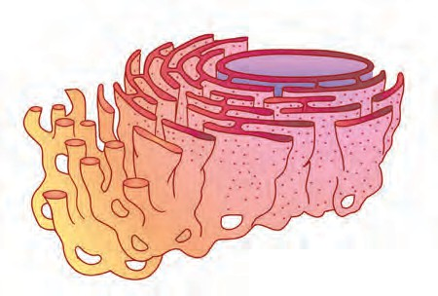

Nucleus

Ribosome

E.R. is connected to nucleus from innerside to plasma membrane from outer side.

Rough ER has ribosome grannules on its outer surface.

###### Functions of ER

1. It is the framework that supports cell.
2. Conduction of proteins.
   1. **Endoplasmic Reticulum**
3. Toxins that have entered the body through food, air and water are made water soluble by ER and then flushed out of the body.
   * What materials are used to pack your favorite biscuits and



**Think about it.**

chocolates?

* + What is the function of ‘Packing department’ of any factory?

**Golgi Complex :** It is made up of 5-8 hollow and flat sacs placed parallel to each other. These sacs are called ‘cisternae’ and are filled with different enzymes. The proteins coming from ER are enclosed in vesicles, which come towards golgi complex via cytoplasm. They fuse with the formation face of the golgi membranes and empty their contents in the cisternae.

As they pass through the cisternae, they are chemically modified with the help of enzymes. They are again packed in the vesicles. These vesicles exit from the maturation face. Thus, cisternae work like like a packing department that packs and distributes

substances.

###### Functions

1. Golgi complex is the secretory organ of the cell.
2. It modifies, sorts and packs materials synthesized in the cell (enzymes, mucus, proteins, pigments etc.) and dispatches them to various targets like plasma membrane, lysosome etc.
3. It produces vacuoles and secretory vesicles.
4. It helps in the formation of cell wall, plasma membrane and lysosomes.

###### Lysosomes

* 1. **Golgi Complex**

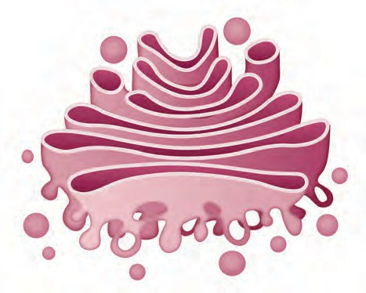

Cis face

Fusing vesicles

Cisternae Lumen

new vesicle

Secretory vesicle

What happens to the agricultural waste after a few days when it is dumped in a compost pit ?



**Can you tell?**

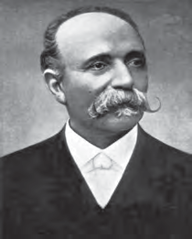

**Introduction to scientists**

Camilio Golgi described the Golgi complex for the first time. He developed the staining technique called 'Black reaction' and with the help of it, he studied nervous system.

He won the Nobel prize of 1906 along with Santiago Cajal for the study of structure of nervous system.

Due to various metabolic activities in the cell, organic waste is generated. Lysosomes digest the waste.

Lysosomes are simple, single membrane bound sacs, filled with digestive enzymes.

###### Functions

1. Immune system - It destroys viruses and bacteria that attack the cell.
2. Demolition squads - It is destroys worn out cellular organelles and organic debris. (Autolysis)
3. Suicide Bags - When a cell becomes old or is damaged, lysosomes burst and enzymes digest their own cells.
4. During starvation, lysosomes digest stored proteins, fats.

Single membrane

Enzyme complex

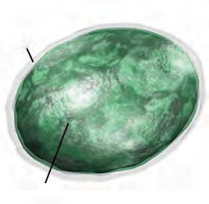

* 1. **Lysosomes**

###### Mitochondria



**Can you tell?**

Which type of energy is required to run the fans, computers and electric bulbs ? Where is this energy produced ?

Each cell requires energy and this energy is produced in the mitochondria. Under the electron microscope, a mitochondrion is seen as a double membrane structure.

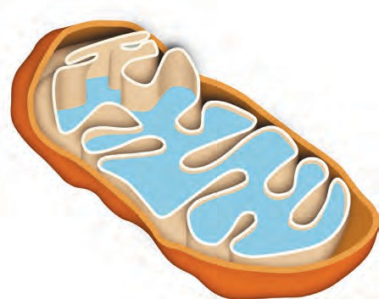

The outer membrane is porous and the inner membrane is deeply folded. These folds are called ‘cristae’. The inner cavity is filled with proteinaceous gel like matrix containing ribosomes, phosphate granules and DNA. Therefore it can produce its own proteins. With the help of enzymes, mitochondria oxidise carbohydrates and fats in the cell. The energy released in this process is stored in the mitochondria in th form of ATP (Adenosine Tri Phosphate). Plant cells

have less mitochondria than animal cells.

###### Functions

1. To produce energy-rich compound- ATP.
2. Synthesis of proteins, carbohydrates, lipids etc. by using the energy in ATP.

Cristae Matrix

* 1. **Mitochondria**



**Do you know?**

Mitochondria are absent in RBCs. Due to this, the oxygen which is carried by them is not used for themselves.

Innner membrane Outer membrane

###### Vacuoles



**Use your brain power**

What is the benefit of foldings of inner membrane in mitochondria ?

Vacuoles are the storage sacs for solid or liquid contents. They don’t have any typical shape or size. The structure of the vacuole changes according to the need of the cell. Vacuole

is bound by single membrane.

###### Functions

1. To maintain the osmotic pressure of the cell.
2. To store metabolic byproducts and end products. (Glycogen, proteins, water etc).
3. In animal cell, they store waste products and food, while in amoeba it stores food before digestion.
4. In plant cell, vacuoles are full of cell sap and provide turgidity, rigidity to them.

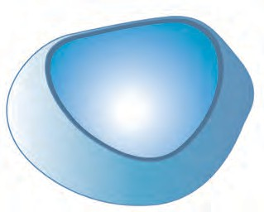

* 1. **Vacuoles**

**Plastids :** Why are plant leaves green and flowers red, yellow, orange or blue ? The organelle which gives such colours is present only in the plant cells - it is called plastid. Plastids have double membrane and are of two types

|  |  |
| --- | --- |
| **Colour of the plant part** | **Pigment** |
| Green (ex. Leaves) Orange (ex. Carrot) Yellow  Purple, blue  Dark pink (ex. Beet)  . . . . . . . . . . . . . . . | Chlorophyll Carotene Xanthophyll Anthocyanin Betalains  . . . . . . . . . . . . . . . |

1. Leucoplasts - White or colourless plastids
2. Chromoplasts - Coloured plastids Chloroplast can get converted into other

types of chromoplasts. Eg. Raw green tomatoes turn red due to breakdown of chlorophyll and synthesis of lycopene.

Chloroplast

**Activity -** Take out a thin peel of Rheo or Croton leaf and observe the chromoplasts under the compound microscope.

Chloroplasts are important for the photosynthesis process that takes place in the leaves. Chlorophyll in chloroplast traps

Intermembranous space

Outer membrane Inner

**Internet my friend**

Collect the information about more colors observed in flowers and fruit and the responsible pigments and complete the above chart.

membrane

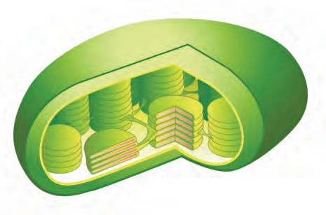

Granum

solar energy and converts it to chemical energy. Stroma in the chloroplast contains enzymes, DNA, ribosomes and carbohydrates that are necessary for photosynthesis.

###### Functions

Thylakoid Stroma

* 1. **Chloroplast**

1. Chloroplasts convert solar energy to chemical energy (food).
2. Chromoplasts give different colours to flowers and fruits.
3. Leucoplasts are involved in the synthesis and storage of food like starch, oils and proteins.

Mitochondria and plastids can produce proteins as well as replicate themselves, as they have their own DNA and ribosomes.

After studying the cell and cell organelles, you must have come to know that all the functions in plant and animal cells are taking place smoothly due to the cell organelles. Such developed cells are called eukaryotic cells. Last year, you have studied prokaryotic cells of bacteria. Let’s now compare them.

**Work of institue :** National Centre for Cell Science - NCCS is an independent institute working under biotechnology department of Government of India. It is located in the campus of Savitribai Phule Pune University, Pune and involved in research in cytology. It provides services for National Animal cell repository. It is mainly working on research about cancer treatment.

|  |  |
| --- | --- |
| Eukaryotic cell | Prokaryotic cell |
| * Size - 5-100 micrometer * Number of chromosomes - More than one * Nucleus - with nuclear membrane, nucleolus and nucleoplasm * Mitochondria and plastids - present * Examples - Present in highly evolved unicellular and multicellular plants and animals. | * 1-10 micrometer. * Only one. * Nucleoid resembling nucleus * They don’t have membrane bound cell organelles * Bacteria |



**Exercises**

1. **Who am I ?**
   1. I am ATP producing factory.
   2. I am single layered, but maintain cellular osmotic pressure.
   3. I support the cell, but I am not cell wall. I have a body resembling net.
   4. I am chemical factory of the cell.
   5. Leaves are green because of me.
2. **What would have happened ? If.......**
   1. RBCs had mitochondria.
   2. There had been no difference between mitochondria and plastids.
   3. Genes had been absent on the chromosomes.
   4. Plasma membrane had not been selectively permeable.
   5. Plants lacked anthocyanin.
3. **Who is odd man among us? Give reason.**
   1. Nucleolus, mitochondria, plastids, endoplasmic reticulum
   2. DNA, Ribosomes, Chlorophyll
4. **Give functions.**
   1. Plasma membrane
   2. Cytoplasm
   3. Lysosome
   4. Vacuole
   5. Nucleus
5. **Who gives me the colour? (Select the correct option.**
   1. Red tomato 1. Chlorophyll
   2. Green leaf 2. Carotene
   3. Carrot 3. Anthocyanin
   4. Violet 4. Lycopene

**Project :**

1. Prepare model of a cell using different ecofriendly materials.
2. Study osmosis using parchment paper or a similar membrane.
3. Form a friends' group in your class. Give each one role of a cell organelle. Present a skit accordingly.



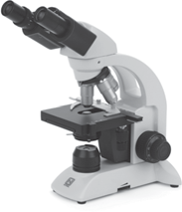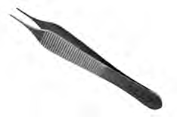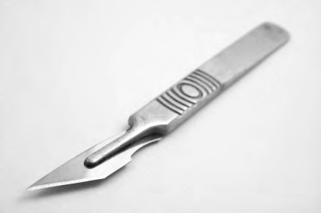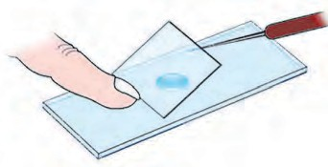

**Useful apparatus for studying cells**



**11. Human Body and Organ System**

* 1. From what the organs and organ systems are made up of?



**Can you recall?**

* 1. Which organ systems are present in human body?

In the last class, we have studied some characters of living organisms. All the vital processes which are essential properties of living beings, are collectively called as life processes.

1. Which processes occur in our body during sound sleep?



**Can you tell?**

1. Which life processes occur continuously in our body?

Different organs in our body are working in group so as to smoothly carry out various life processes. These life processes takes place in various steps. Specific organs carry out the specific steps. Group of organs working together to perform a specific function is called as organ system. Various organ systems like digestive, respiratory, circulatory, nervous, excretory, reproductive, skeletal, muscular, etc. are functioning in our body.

Which different organs perform the function of breathing in the body of animals?



**Can you recall?**

Energy is essential to operate all the life processes in human body. Energy production occurs within the cells. Cells need the supply of soluble nutrients and oxygen for this purpose. This supply takes place with the help of respiratory and circulatory systems. Respiration is carried out through following three steps.



**Use your brain power**

How do the

organisms like

amoeba, earthworm, cockroach, plants, various aquatic animals, birds respire? Prepare a chart.

1. External Respiration:
   1. **Inspiration / Inhalation :** Air is taken in through nose and sent towards the lungs through trachea (wind pipe).
   2. **Expiration / Exhalation :** Oxygen from the inspired air goes into blood. Blood carries the CO2 from various parts of body towards lungs. This air is given out by exhalation.

Both of these processes occurring with the help of lungs are collectively called as external respiration.



**Think about it.**

1. **Internal Respiration :** Exchange of gases between cells and tissue fluid is called as internal respiration. Oxygen moves from blood into tissue fluid and carbon dioxide moves from tissue fluid into blood.
2. **Cellular Respiration :** Dissolved nutrients like glucose are slowly burnt (oxidized) with the help of oxygen and energy is released in the form of ATP. Waste materials like CO2 and water vapours are produced during this process. Cellular respiration can be summarized as follows.

C6H12O6+6O26CO2+6H2O+ Energy (38ATP)

Along with the heat; sound and light are also produced during burning of fuel. Similarly, whether the sound and light are produced during oxidation of nutrients in cell?



**Can you tell?**

1. Which organs are present in the respiratory system?
2. One should not talk while eating. Why is it so?

**Respiratory system : Structure and function**

1. **Nose :** Respiratory system and respiration begins with nose. Air is filtered with the help of hair and mucus present in the nose.
2. **Pharynx :** Food pipe and wind pipe originate in the pharynx. Wind pipe is present in front of the food pipe. There is a lid at the beginning of wind pipe. This lid closes the wind pipe during passing of food into food pipe and thereby normally prevents the entry of food particles into wind pipe. Otherwise, wind pipe remains open. Hence air passes through pharynx into wind pipe.
3. **Wind pipe :** Wind pipe is swollen at the beginning due to sound box. Wind pipe bifurcates in the thorax. One branch enters the right lung and the other into left lung.
4. **Lungs :** A lung is present on either sides of heart in thoracic cavity. Maximum area of thoracic cavity is occupied by lungs and they cover the maximum part of heart. Each lung has double layered covering. It is called as pleura. Lungs are elastic like a sponge. Lungs are made up of many small compartments, called as alveoli. Rich network of capillaries is present around each alveolus.

Walls of alveoli and capillaries are extremely thin. Gaseous exchange can easily take place across these thin walls. As large

Transport

**Respiratory system**

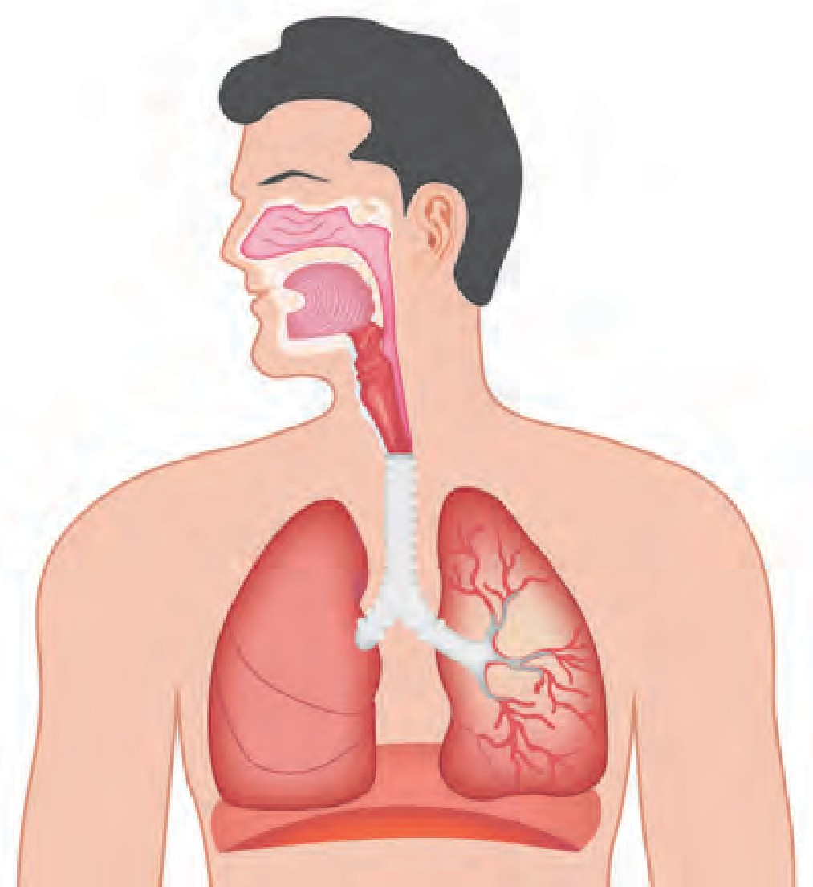

Nasal cavity

Pharynx

Larynx

Trachea

Bronchioles

Lungs

Alveoli

Diaphragm

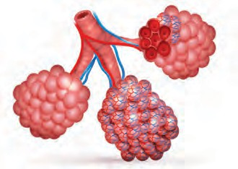**Alveoli**

In and out air passage

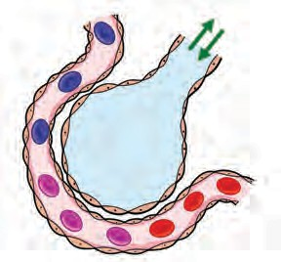

Alveoli

number of alveoli is present in lungs, larger surface is available for gaseous exchange.

into

capillaries

RBCs

* 1. **Human Respiratory System and Alveoli**

**Exchange of gases in lungs :** Gaseous exchange occurs continuously while blood is circulating around the alveoli. An iron containing protein- hemoglobin is present in the RBCs of blood. Hemoglobin absorbs the oxygen from air within alveoli. Simultaneously, CO2 and water vapours move from blood into the alveoli. Thus, oxygen is taken into the blood and CO2 and water vapours are removed from the blood and given out by exhalation.

1. **Diaphragm :** A muscular partition is present at the base of thoracic cage. This partition is called as diaphragm. It is present between the thoracic cavity and abdominal cavity. Simultaneous rising up of ribs and lowering of diaphragm causes the decrease in pressure on lungs. Due to this, air moves into the lungs through nose. When ribs return to their original position and diaphragm rises up, pressure on the lungs increases. Due to this, air moves out from it through nose. Continuous upward and downward movement of diaphragm is necessary to bring about the breathing.



**Observe and discuss.**

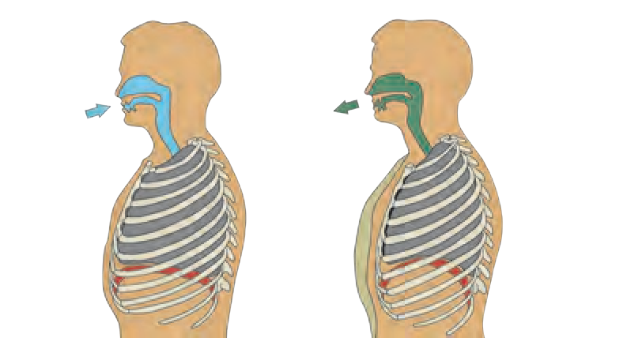Observe the movements in the region below the thoracic cage, occurring during breathing and discuss in the class.

* 1. **Breathing movements**



**Can you recall?**

1. What is meant by blood circulation?
2. Which organs are present in blood circulatory system?

Blood circulatory system

Circulatory system performs the function of transport of various substances like water, hormones, oxygen, soluble nutrients, and waste materials through different organs. An independent system for blood circulation is present in humans and higher animals. It consists of heart, blood vessels and capillaries.

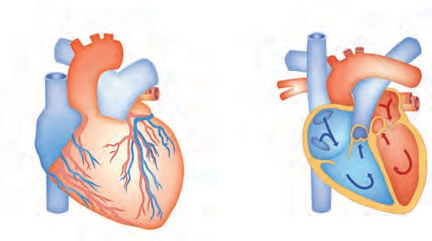Right pulmonary artery

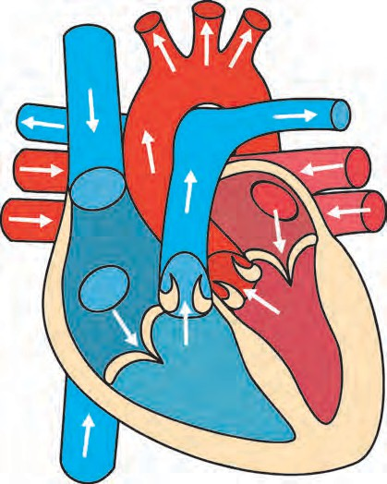

Superior Vena

cava

Right pulmonary veins

Right atrium

Systemic aorta

Left pulmonary artery

Left atrium

Bicuspid

Valve

Left

ventricle

Heart: Structure and Functions

Heart is present almost at centre in thoracic cage. It is present behind the ribs, between two lungs and slightly inclined on left side.

Size of our heart is equal to one's own fist and its weight is about 360 gram. It is covered by a double layered peritoneal membrane. A fluid is present between two membranes due to which heart is protected from friction and mechanical shocks.

Human heart is a muscular organ. It is made up of involuntary cardiac muscles. They contract and relax with a definite rhythm. This is called as beating of heart.

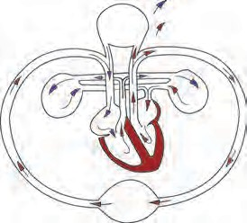Internally, heart is divided into left and right compartments by a vertical partition. Each of those compartments is again divided into two chambers. Thus, in all, heart consists of four chambers. Upper chambers are called as atria (singular - atrium) and lower chambers as ventricles.

Inferior Vena cava

Tricuspid valve

Right ventricle

Semilunar valve of systemic aorta

* 1. **Structure of heart and blood circulation**

**Blood vessels - Structure and functions :** Heart is beating continuously. Due to this, blood continuously circulates through blood vessels. There are two main types of blood vessels.

**Arteries :** Blood vessels which carry the blood away from heart are called as arteries. Except the one carrying blood towards lungs, all carry oxygenated blood. These are deeply located in the body and their walls are thick. These vessels do not have valves.

**Veins :** Vessels carrying the blood towards the heart from various parts of body are called as veins. All veins except the one carrying blood from lungs transport deoxygenated blood. Most of the veins are superficially located in the body. Their walls are thin and these are provided with valves.

**In History ...**

In 1628, William Harvey described the mechanism of circulation in the body. He proposed a theory that our heart is a muscular pump by which blood is circulated in the body. He discovered the working mechanism of valves of the heart.

Artery

Connective tissue

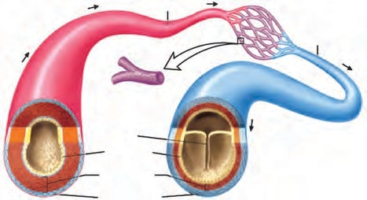

Vein

Capillary

Valve Intema

Muscle

* 1. **Structure of Artery and Vein**

From the heart Toward the heart

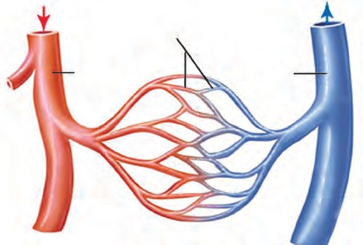

Capillaries

Artery

Vein

* 1. **Capillaries**



**Think about it.**

Why the veins are provided with valves? Why the arteries have thick wall?

**Capillaries :** Arteries gradually branch out with decrease in their diameter as they spread in the body and finally form fine hair- like vessels called as capillaries. Walls of capillaries are extremely thin and made up of single layer of cells. Due to this, exchange of materials between capillaries and cells becomes easy. During the exchange, the oxygen, nutrients, hormones, vitamins, etc. are sent towards the cells and waste materials of the cells move into blood.



**Do you know?**

In case of a healthy person, there are 72 beats of heart per minute. Rate of heart beat increases due to physical exercise and emotions. Similarly, it has been observed that it decreases during rest and sleep. Number of beats is more in case of infants.

Two types of sounds are heard during heart beat. One is described as 'lubb' and other as 'dub'. Heart pumps about 75 ml of blood during each beat.

Capillaries unite together to form the vessels of more diameter, called as veins. Capillary network is present in each organ.

Blood circulation through heart / Functioning of Heart

Process of pumping the blood towards various parts of the body and bringing it back towards the heart is called as blood circulation. So as to maintain the continuity in circulation, heart alternately contracts and relaxes. Consecutive single contraction and relaxation of heart constitutes a single heart beat.

**Material :** Two feet long rubber tube with small aperture, stop watch, funnel.



**Try this**

1. Fit a funnel at one end of rubber tube.
2. Keep the wide mouth of funnel on left side of thorax.
3. Bring the other end of tube near the ear to hear the sound.
4. Record the number of beats per minute using stop watch.



**Think about it.**

**Pulse :** Find correlation between heart beats & pulses felt at wrist.

Blood

1. We can feel the pulse behind the ears and near the heel of foot. How these pulses occur?
2. What flows out when we have an injury?



**Can you tell?**

Blood is a red colored fluid material. It is fluid connective tissue. The oxygenated blood is deep red colored, salty in taste and its pH is 7.4. Blood is composed of mainly two components.

|  |  |
| --- | --- |
| **Plasma** | **Blood cells** |
| A. Plasma is pale yellow, clear, and slightly alkaline fluid. It contains  90 -92 % water  6 - 8 % proteins  1 - 2 % inorganic salts and other components  B. Albumin - Distributes the water all over the body.  C. Globulins - Protection.  D. Fibrinogen & prothrombin help in blood clotting process.  Inorganic ions - Ca, Na, K - control the function of muscles and nerves. | 1. **Red Blood Corpuscles (RBCs)**   Small, circular, enucleated cells. These cells appear red due to hemoglobin. Oxygen dissolves in blood due to hemoglobin.  50 - 60 lakh RBCs are present in each cubic millimeter of blood. RBCs are produced in red bone marrow and live for about 100 - 127 days.   1. **White Blood Cells (WBCs)**   These are large, nucleated and colorless cells. 5000-10000 WBCs are present per mm3 of blood.   * + 5 types of WBCs are present - basophils, eosinophils, neutrophils, monocytes & lymphocytes.   + WBCs are produced in red bone marrow.   + WBCs act as soldiers in our body.   **Function -** These cells attack the pathogens entering our body. They protect us from the microbial diseases.   1. **Platelets**    * These are extremely small and disc-shaped.    * 2.5 - 4 lakh platelets are present per mm3 of blood.   **Function -** Platelets participate in blood clotting process. |

**Functions of Blood**

1. **Transport of gases :** Oxygen is carried via blood from lungs to cells in various parts of body and carbon dioxide from tissues to lungs.
2. **Transport of nutrients :** Simple nutrients like glucose, amino acids, fatty acids are taken up by blood from wall of alimentary canal and transported up to each cell in the body.
3. **Transport of waste materials :** Nitrogenous wastes like ammonia, urea, creatinine are released by tissues into blood which carries those to kidney for excretion.
4. **Protection :** Antibodies are produced in the blood and they protect the body from microbes and other harmful particles.
5. **Transport of enzymes and hormones :** Blood transports the enzymes and hormones from the site of their production to the site of their action.
6. **Thermoregulation :** Body temperature is maintained constant at 37 0C by vasodilation and vasoconstriction.
7. Maintaining the balance of minerals like Na, K in the body.
8. If bleeding occurs at the injury, platelets and a protein called fibrinogen of the blood form a clot and seal the injury.

Human Blood Groups

Depending upon the proteins like antigens and antibodies, different blood groups are formed. There are four main groups of human blood as A, B, AB and O. Besides, there are two types as 'Rh' negative and 'Rh' positive of each of those four groups. Thus, in all eight blood groups are formed. (Eg. A Rh +ve & A Rh -ve).

**Blood Donation :** If a person meets an accident, bleeding occurs through wounds. Many times, blood transfusion is necessary during the surgical operation. Similarly, blood is transfused in case of patients of anemia, thalassaemia, cancer too. Blood transfusion is carried out to compensate the blood shortage in body. This is called as blood transfusion.

From where the blood is supplied for blood transfusion?

**Blood banks :** Blood is collected in blood banks by specific method from the healthy persons and supplied to the needful persons. If the collected blood is not to be used immediately, it can be stored for some days in refrigerator.

**Blood donor :** Person who donates the blood is referred as blood donor.

**Blood recipient :** Person who receives the blood is referred as recipient.

Person of the blood group 'O' can donate the blood to the person having any other blood group where as the person with 'AB' blood group can receive the blood from the person with any other blood group. Hence, person of blood group 'O' is called as universal donor and the person with blood group 'AB' is called as universal recipient.

Blood groups are hereditary and depend upon the genes inherited from parents. Blood transfusion is performed only after the blood group matching. If it is done without matching, it may prove fatal for the patient. Person who donates the blood may be recipient in future. Blood donation without any expectation is always life saving. Blood is required in various situations like accidents, bleeding, parturition, surgical operations, etc. Blood donated by healthy person is used to save the life of needful person. Hence blood donation is considered as the best donation.



**Collect information**

Visit the blood bank in your area and collect more information about blood donation.

**Blood Pressure :** Blood is continuously kept flowing through blood vessels due to contraction- relaxation of the heart. Due to contraction of the heart, pressure is exerted on the wall of arteries and it is called as blood pressure. Proper blood pressure is necessary to supply the blood in all parts of the body. Pressure recorded during the contraction of heart is called as 'systolic pressure' and that one recorded during relaxation is called as 'diastolic pressure'. Blood pressure of a healthy person is about 120/80 mm to 139/89 mm of Hg. It is measured with the help of sphygmomanometer'.



**Always remember**

* Blood production occurs continuously in our body.
* About 350 ml of blood is collected from a person during donation and our body restores the fluid part of it within 24 hrs.
* Pregnant and breast feeding women cannot donate the blood.
* There is no trouble during or after the blood donation.
* 1st October is observed as National Voluntary Blood Donation Day.
* Healthy person of age more than 18 years can donate the blood for 3 - 4 times a year.

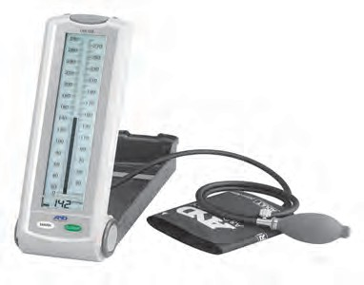

**11.6 Sphygmomanometer**

**Hypertension (High Blood Pressure) :** High blood pressure than the normal is referred as hypertension. In arteries of the person with hypertension, unnecessary tension develops. Heart needs to perform more function than the normal condition in case of hypertension. Both, systolic and diastolic pressures are high in hypertension.

|  |  |  |
| --- | --- | --- |
| Type | Systolic pressure | Diastolic pressure |
| Normal Blood Pressure Primary Hypertension Hypertension stage-I Hypertension stage-II | 90 - 119 mm  120 - 139 mm  140 - 159 mm  > 160 mm | 60 - 79 mm  80 - 89 min  90 - 99 mm  > 100 mm |

A, B, O blood groups were discovered by Carl Landsteiner in 1900. He won the Nobel Prize of 1930 for this discovery. Blood group AB was discovered by Decastello and Sturli in 1902.



**Do you know?**

**Hematology:** Branch of medical science that deals with the study of blood, hematopoietic organs and blood diseases is called as hematology. Research of diagnosis and remedies of blood diseases is also performed in this branch.



**Collect information**

Visit a clinic nearby your place and collect information about measurement of B.P. with the help of B.P. apparatus.



**Exercises**

1. **Find out my partner.**

**Group 'A' Group 'B'**

* 1. Heart beats a. 350 ml
  2. RBC b. 7.4
  3. WBC c. 37 0C
  4. Blood donation d. 72
  5. Normal body e. 50 - 60 Temperature lakh/mm3
  6. pH of oxygenated f. 5000-6000 per blood mm3

1. **Complete the following table.**

|  |  |  |
| --- | --- | --- |
| Organ systems | Organs | Functions |
| 1. Respiratory system 2. Circulatory system |  |  |

1. **Draw neat and labeled diagrams.**
2. Respiratory system
3. Internal structure of heart.
4. **Explain with reasons.**
5. Human blood is red coloured.
6. Upward and downward movement of diaphragm occurs consecutively.
7. Blood donation is considered to be superior of all donations.
8. Person with 'O' blood group is considered as 'universal donor'.
9. Food must have limited amount of salts.
10. **Answer the following questions in your own words.**
11. Explain the functional correlation of circulatory system with respiratory, digestive and excretory system.
12. Explain the structure and function of human blood.
13. Explain the importance and need of blood donation.
14. **Explain the differences.**
15. Arteries and veins.
16. External and internal respiration.
17. **Which health parameters of blood donor should be checked?**
18. **Fill in the blanks using appropriate words given in the bracket. (hemoglobin, alkaline, diaphragm, red bone marrow, acidic, voluntary, involuntary,)**

a. RBCs of the blood contain , an

iron compound.

b is present between thoracic and

abdominal cavity.

1. Cardiac muscles are --.
2. pH of oxygenated blood is --.
3. Production of RBCs occurs in --.
4. **Find odd one out.**
   1. A, O, K, AB, B.
   2. Blood plasma, platelets, blood transfusion, blood corpuscles.
   3. Trachea, alveoli, diaphragm, capillaries.
   4. Neutrophils, globulins, albumins, prothrombin.
5. **Read the following paragraph and identify the disease.**

Today, her child became one and half year old. However, that child does not seem to be healthy and happy. It was continuously crying and gradually becoming weak. It has shortness of breath. Its nails have become blue.

1. **Your neighboring uncle has been diagnosed with hypertension. What should he do to keep his blood pressure within normal range?**

**Project :**

Collect information about various modern treatments on heart diseases.



# Introduction to Acid & Base



Acid

**Can you tell?**

1. We consume many food items in our daily life e.g. lemon, tamarind, tomato, sugar, vinegar, salt etc. Do all items taste similar?
2. Write the taste of lemon, sugar, curd, lime, baking soda, amla, tamarind, raw mango, pomegranate, water (sour, astringent, sweet, bitter, tasteless)

Indicator :

You will notice that some substances have sweet taste, some are bitter, some are sour or astringent. Lemon, tamarind, vinegar or amla like substances acquire sour taste due to the presence of a typical compound in them. Such compounds imparting sour taste are called acids. Acids are soluble in water and they are corrosive in nature. Animals and plants also possess acids in them.

Acids present in food stuffs are called natural acids or organic acids. These acids being weak in nature are called weak acids. Some acids are strong in nature. They are caustic/inflammatory, e.g. sulphuric acid (H2SO4), hydrochloric acid (HCl) and nitric acid (HNO3). These acids are also called ‘mineral acids’. The skin gets burnt when their concentrated solution falls on skin, similarly their vapours if inhaled can be harmful to health. Strong concentrated acids are converted into their dilute acids by slowly adding them into water. Such dilute acids are less harmful than their corresponding strong acids.

If you taste dilute solution of baking soda, you will find it astringent/bitter. Substances having astringent/bitter taste and slippery to touch e.g. Lime water [(CaOH)2], baking soda (NaHCO3) caustic soda (NaOH) and soap are called bases. Bases are completely different from acids. Chemically they have properties opposite to that of acids. They are also inflammatory to skin in their concentrated form. We know that the distilled water is tasteless. Water is neither acidic nor basic.

The substances which are neither acidic nor basic and are chemically inert in nature. Touching or tasting of acid or base is very harmful and hence typical indicators are used to recognise them. The substances which change their colours in presence of acid or base are called ‘Indicators’.

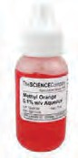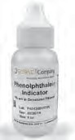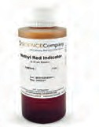

**Indicators in Laboratory :**

In the laboratory, litmus paper is mainly used to test alkali or base. This paper is made by an extract of licane plant. It is red or blue coloured. Blue litmus paper turns red on dipping in acid and red litmus turns blue by alkali. Similarly phenolphthalein, methyl orange and methyl red are used in laboratory in solution form. Methyl orange indicator becomes pink in acid and yellow in alkali. Phenolphthalein remains colourless in acid and becomes pink in alkali. Universal indicator which are in liquid state change their colour in the presence of acid and base.

Methyl orange Phenolphthalein Methyl red

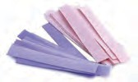Litmus papers

* 1. **Laboratory indicators**

|  |  |  |  |  |
| --- | --- | --- | --- | --- |
| **Sr.No.** | **Name of Indicator** | **Colour of the Indicator** | **Colour in Acid** | **Colour in alkali** |
| 1 | Litmus paper | Blue | Red | Blue (Remain same) |
| 2 | Litmus paper | Red | Red (Remain same) | Blue |
| 3 | Methyl orange | Orange | Pink | Yellow |
| 4 | Phenolphthalein | Colourless | Colourless | Pink |
| 5 | Methyl red | Red | Red | Yellow |

* 1. **: Indicators and their colours in acid and base**

Making of natural indicator :

**Domestic Indicator :** On non availability of laboratory indicator, ‘natural indicators’ can be made by using several domestic substances. You must have seen yellow food stain turning red after washing with soap. This colour change is a result of chemical reaction between turmeric and alkaline mateiral of soap. Here turmeric acts as on indicator. Natural indicators can also be prepared from red cabbage, radish, tomato and similarly from hibiscus and rose.



**Try this**

**Apparatus :** Hibiscus, rose, turmeric, red cabbage leaves, filter paper etc.

**Activity :** Rub red petals of hibiscus flower on the white filter paper, This gives hibiscus indicator paper. Similarly rub, rose petals on the white filter paper. Cut strips of this paper, it is a rose indicator paper. Take turmeric powder, add little water in it. Dip filter paper or ordinary paper in the turmeric water for some time. After drying make strips of that paper. Prepare turmeric indicator paper in this way. Put leaves of red cabbage in small quantity of water and heat it. Once solution of cabbage leaves cool down, dip papers in it and dry it. Make strips of dried paper. In this way prepare red cabbage indicator paper.

Put some drops of following substances on the indicator papers prepared by the above method and write the effect in the following table.

|  |  |  |  |
| --- | --- | --- | --- |
| **Sr.No.** | **Substance** | **Effect on turmeric paper** | **Acidic / basic** |
| 1 | Lime juice |  |  |
| 2 | Lime water (calcium hydroxide) |  |  |
| 3 | ............... |  |  |

Take baking powder. Add little water to it. Add this solution on to lime juice, vinegar, orange juice, apple juice, etc. and note the findings.



**Try this**

What do you observe on addition of baking soda solution in the fruit juice? Whether bubbles formed or effervescence came out of fruit juice?

From the above first activity we came to know that turmeric indicator paper’s turns red yellow colour in certain solutions. Similarly on addition of baking soda solution in the acidic solution bubbles come out or effervescence is produced.

By these simple and easy activity we can identify acidic or alkaline substance.

Under the guidance of teacher take vinegar, lime juice, ammonium hydroxide (NH4OH) and dil. hydrochloric acid (HCl) in different test- tubes. Add drops of following indicators in them. Also dip litmus papers in the solutions. Observe and record in the following table.



**Try this**

|  |  |  |  |  |  |
| --- | --- | --- | --- | --- | --- |
| **Sample solution** | **Red litmus** | **Blue litmus** | **Phenolphthalein** | **Methyl orange** | **nature of solution (Acidic/Basic)** |
| Lime juice |  |  |  |  |  |
| NH4OH |  |  |  |  |  |
| HCl |  |  |  |  |  |
| Vinegar |  |  |  |  |  |

* 1. 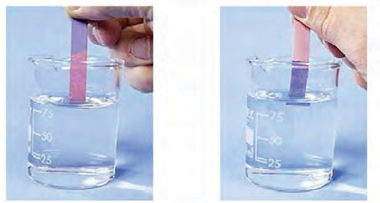**Effect of acid and base on litmus paper**

From above experiments it is seen that blue litmus turns red in acids and red litmus turns blue in alkali. Orange colour of methyl orange turns pink in acid while colourless phenolphthalein turns pink in alkali solution.



**Can you tell?**

1. What happens when sour substances like lime juice, tamarind water falls on shahabad stones or kitchen platform? Why?
2. Collect soil samples from your surroundings and find out whether it is acidic, alkaline or neutral?
3. Which substances are used to clean greenish stains on copper vessels and to shine blackish silver utensils?
4. Why tooth-paste is used for brushing teeth?

Acid

Acid is such a substance which gives H+ ions in solution state. e.g. HCl dissociates in water solution.

HCl (aq)  H+ + Cl

(Hydrochloric acid) (Hydrogen ion) (Chloride ion)

**Examples of some acids :** Hydrochloric acid (HCl), Nitric acid (HNO3), Sulphuric acid (H2SO4), Carbonic acid (H2CO3) (in cold aerated drinks), ascorbic acid, citric acid in lemon and other fruits, acetic acid in vinegar, etc.

Our daily diet contains a few natural (organic) acids. They are mild in nature and hence are not harmful like mineral acids.

|  |  |  |
| --- | --- | --- |
| **Sr.**  **No.** | **Substance / Source** | **Acids (Natural/organic)** |
| 1 | Vinegar | Acetic acid |
| 2 | Orange | Ascorbic acid |
| 3 | Tamarind | Tartaric acid |
| 4 | Tomato | Oxalic acid |
| 5 | Curd | Lactic acid |
| 6 | Lemon | Citric acid |

* 1. **Natural acids**

Properties of acid :

**Causticity of concentrated acid and base :** Dissolution of conc. H2SO4 in water generates large amout of heat. Therefore for dilution of concentrated acid, it is slowly added to water. Never add water in the concentrated sulphuric acid. It will produce enormous heat and cause explosion.

Bases like sodium hydroxide and potassium hydroxide are strong and caustic in nature. Their concentrated solution burns skin as it decomposes the proteins in skin.

1. Acids are sour in taste.
2. Acid molecules contain hydrogen ion (H+) as a main costituent.
3. Acid reacts with metal to form hydrogen gas.
4. Acid reacts with carbonates and liberates CO

2

gas.

1. Blue litmus turns red in acid.

Use of acids

1. Acids are used in the production of chemical fertilizers.
2. Acids are used in the production of explosives, oil purification, medicines, dyes and paints.
3. Hydrochloric acid is used for the preparation of different types of chloride salts.
4. Dil. H2SO4 acid is used in the batteries. (electric cell)
5. Dil. HCl is used for sterilization of water.
6. Acid is used for making of white paper from wood pulp.



**Use your brain power**

The iron knife shines better after cutting the sour fruits like lemon, raw mangoes. Why?

* + We have seen that mineral acids are harmful to body. However serveral organic acids are present in our body and in plants which are useful to us.
  + DNA (Deoxyribo Nucleic Acid) is an acid present in our body decides heredity property.
  + Proteins which are part of our body cell are made up of amino acids.
  + Fat of our body is formed by fatty acids.

Base

Base is a substance whose water solution gives hydroxide (OH-) ion e.g.

NaOH (aq)  Na+(aq) + OH- (aq)

(Sodium Hydroxide) (Sodium ion) (Hydroxide ion)

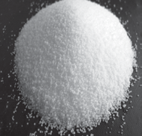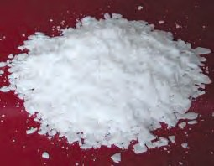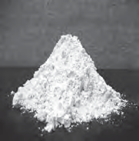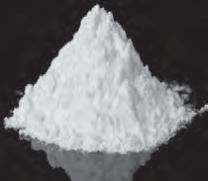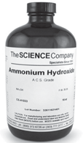

Sodium Hydoxide Potassium Hydroxide Calcium Hydroxide Magnesium Hydroxide Ammonium Hydroxide

* 1. **Some examples of Base**

|  |  |  |  |
| --- | --- | --- | --- |
| **Sr.No.** | **Name of Base** | **Formula** | **Use** |
| 1 | Sodium hydroxide/Caustic soda | NaOH | Washing soap |
| 2 | Potassium hydroxide / Potash | KOH | Soap//shampoo |
| 3 | Calcium hydroxide/lime water | Ca(OH)2 | lime/white washing |
| 4 | Magnesium hydroxide / milk of magnesia | Mg(OH)2 | Acidity resistant medicines (Antacids) |
| 5 | Ammonium hydroxide | NH4OH | for production of fertilizers |

* 1. **Table : Formulae of bases and their uses.**



**Always remember**

Properties of alkalies :

1. Bases has bitter taste.
2. They are slippery.

Remember for identification of any substance it is dangerous to taste, inhale or touch them.

1. Bases contains hydroxide (OH-) as a main constituent.
2. Metal oxides are generally basic in nature.

Neutralization

We have seen that acid contains (H+) hydrogen ions and base contains(OH-) hydroxide ions. Salt and water are formed by combination of acid and base.

Acid + Base  Salt + Water HCl + NaOH  NaCl + H2O

(Hydrochloric acid) (Sodium hydroxide) (Sodium chloride) (Water)

This chemical reaction is called neutralization.



**Do you know?**

Hydrochloric acid is present in our stomach. It helps to ease digestion process. However excessive acid leads to indigestion. Antacids are used to control this hyper acidity. This medicine contains milk of magnesia [Mg(OH)2]. Such alkaline medicine neutralises excess acid present in stomach.

The acidity of soil increases due to excessive use of chemical fertilizers. Under the guidance of agriculturist lime stone or lime water is mixed in the acidic soil. Such alkaline substances neutralizes excess acid present in the soil.



**Exercises**

1. **Identify the following solutions, whether they are acid or base.**

|  |  |  |  |  |
| --- | --- | --- | --- | --- |
| **Solution** | **Change in Indicator** | | | **Acid / Base** |
| **Litmus** | **Phenolphthalein** | **Methyl orange** |
| 1. | -- | No change | -- |  |
| 2. | -- | -- | Orange colour turns red |  |
| 3. | Red litmus turns blue | -- | -- |  |

1. **Write chemical names from given formulae.**

H SO , Ca(OH) , HCl, NaOH, KOH,

1. **Match the pairs.**

Group A Group B

1. Tamarind a. Acetic acid

2 4 2

NH4OH

1. **Sulphuric acid has highest importance in chemical Industry. Why?**
2. **Give answers.**
   1. Which acid is used for getting chloride salt?
   2. By squizzing lemon on a piece of rock the gas liberated turned lime water milky. which compound is present in the rock?
   3. The label on the bottle of chemical is spoiled. How will you find whether the chemical is acidic or not?
3. **Answer the following questions.**
   1. Explain the difference between acid and base.
   2. Why indicator does not get affected by salt?
   3. Which substances are produced by neutralization process ?
   4. Which are the industrial uses of acids?
4. **Select proper word given in bracket and fill in the blanks.**
   1. Main constituent of acid is...........
   2. Main constituent of base is.......
   3. Tartaric acid is a acid.
5. Curd b. Citric acid
6. Lemon c. Tartaric acid
7. Vinegar d. Lactic acid
8. **State true or false.**
9. Oxides of metals are acidic in nature.
10. Table salt is acidic.
11. Metal corrodes due to salts
12. Salts are neutral.
13. **Classify following substances into acidic, basic and neutral group -**

HCl, NaCl, MgO, KCl, CaO, H2SO4, HNO3, H2O, Na2CO3

**Project :**

Write in your own language the uses and importance of neutralization reaction in daily life.





**13. Chemical Change and Chemical Bond**

1. What are the methods of classification of changes ?



**Can you recall?**

1. What is the difference between physical and chemical change ?
2. Classify the follwing changes into physical and chemical change.

Ripening of mango, melting of ice, boiling of water, dissolution of salt in water, Ripening of banana, fragrance on ripening fruit, darkening of a cut potato, bursting of an inflated balloon, sound of bursting fire cracker, foul smell from a spoiled food.

During any chemical change, composition of original substance changes to form new substance with a different composition and properties. How to identify a chemical change?



**Try this**

****Take the lemon juice in a clean glass. Take two drops of the lemon juice in a spoon and taste. Add a pinch of baking soda in the glass of lemon juice. Did you notice bubbling around the particles of soda? Did you hear a sound on taking your ear near the glass? Now again taste it. Did it taste as sour as it was in the beginning?**(Above activity is to be done using clean apparatus and edible material. Then only it is possible to test the 'taste', otherwise keep in mind that the testing of 'taste' cannot be done.)**

Many perceivable observations are noticed during the above activity. A gas is seen to be liberating in the form of bubbles. A low sound is heard. The white solid particles of the baking soda disappear. The original sour taste becomes mild or diminishes. From this, it is understood that a new substance having a different taste is formed. At the end of the above change, the taste of the substance was different means its composition was different. Thus, during the above change, the composition of the original substance changed to form a new substance with different properties. Thus, the change that takes place on adding baking soda to lemon juice is a chemical change. Sometimes some characteristic observations are perceived during a chemical change. These enable us to know that a chemical change has taken place. Some of these observations are enlisted in the table 13.1

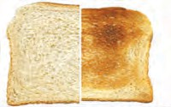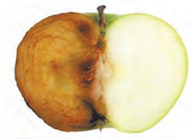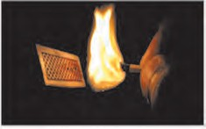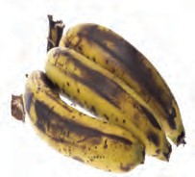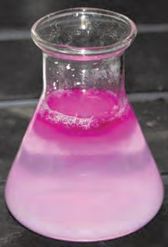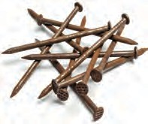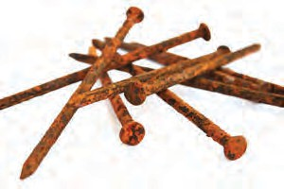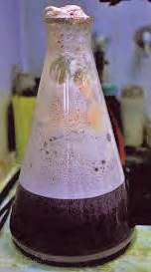

Change in colour, taste, release of gases, etc

* 1. **Some observations of chemical change**

**Chemical change and word equation :** During a chemical change the chemical composition of the original matter changes and new substances having different properties and different chemical compositon are formed. A chemical equation can be written for a chemical change, if the exact change in chemical composition is known. Names and chemical formulae of the original substance and newly formed substance are used while writing a chemical equation. For example, when baking soda is added to lemon juice a chemical change takes place in the citric acid present in the lemon juice and the gas formed is carbon dioxide. The word equation can be written for this chemical reaction as follows

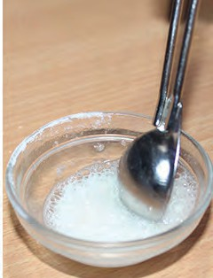

Formation of CO2 with effervescence

* 1. **Experiment figure**

Citric acid + Sodium bicarbonate  Carbon dioxide + Sodium citrate

Acid + Alkali  CO2 + Salt This is neutralization reaction.



**Always remember**

First step of writing a chemical equation is to write a word equation by using the names of the concerned substances. When the chemical formula is written in place of each of the names, it becomes a chemical equation. While writing a chemical equation, original substances are written on the left side and newly formed substances are written on right side and an arrow is drawn in between. Arrow head points towards the substances formed. Arrow indicates the direction of the reaction. Substances written on the left side of the arrow are original substances that take part in the reaction. They are called reactants. New substances formed as a result of the reaction are called products. Place for the products of a reaction is on the right side of the arrow.

**Chemical changes in everyday life :** We find many examples of chemical changes in our surrounding, body, home and laboratory. Let us see some chemical changes for which word and chemical equation can be written easily.

Natural chemical changes



**Try this**

1. **Respiration :** Respiration is a continuously

occuring biological process. In this process, we inhale the air and exhale carbon dioxide and water vapour. After an in depth study it is learnt that glucose in the cells reacts with oxygen in the inhaled air to form carbon dioxide and water. The word equation and the chemical equation of this chemical reaction are as follows. (Here, the chemical equation is not balanced.)

Word equation :

Take some freshly prepared lime water (solution of calcium hydroxide) in a test tube. Keep on blowing in it with a blow tube. What is seen after some time? Did the colourless lime water turn milky? After some more time you will find that a white insoluble solid settles at the bottom of the test tube. This is a precipitate of calcium carbonate. The turning milky millgot lime water means that the blown gas mixed in it was carbon dioxide.

Glucose + Oxygen respiration Carbon dioxide + Water



**Chemical equation :**

**Carbon dioxide**

**+ Calcium Calcium hydroxide carbonate + Water**

C6H12O6 + O2

respiration



CO2 + H2O

Write a chemical equation for the above word equation.

1. **Photosynthesis :** You know that green plants perform photosynthesis in sunlight. A word equation and a chemical equation (unbalanced) can be written for this natural chemical change as follows.

**Word equation :** Carbon dioxide + Water Sunlight



green plant

Glucose + Oxygen

Sunlight

**Chemical equation :** CO2 + H2O green plant C6H12O6 + O2



**Man made chemical changes :** We bring about many chemical changes for our use in everyday life. Let us see some of them. The chemical change that we saw in the first activity is used in the cold drink called 'soda-lemon'. It means that it is an useful man made chemical change.

1. **Combustion of fuels :** Wood, coal, petrol or cooking gas are burnt for getting energy. The common substance that burns in all these fuels is 'Carbon'. During the combustion process carbon combine with oxygen in air and the product carbon dioxide is formed. A common equation can be written for all these combustion processes as follows.

**Word equation :** Carbon + Oxygen  Carbon dioxide

**Chemical equation :** C + O2  CO2

Combustion of fuel is a fast and irreversible chemical change.

1. **Cleaning Shahabad tile with dilute hydrochloric acid :** The chemical composition of Shahabad tile is mainly calcium carbonate. During its cleaning with hydrochloric acid the upper layer of the tile reacts with hydrochloric acid and three products are formed. One of them is calcium chloride, which being soluble in water, gets washed away with water. The second product is carbon dioxide; its bubbles mix up in air. The third product, water mixes with water. The following equation can be written for this chemical change.

Word equation :

Calcium cabonate + Hydrochloric acid  Calcium chloride + Carbon dioxide + water Write a chemical equation (unbalanced) for the above reaction.

1. **Softening of hard water :** Some wells or tube wells have hard water. It is brackish to taste and does not form lather with soap. This is because of hard water contains the chloride and sulphate salts of calcium and magnesium in dissolved state. To soften the hard water, a solution of washing soda is added to it. This results in a chemical reaction to form a precipitate of insoluble carbonate salts of calcium and magnesium. As the dissolved salts of calcium and magnesium go out in the form of precipitate of the carbonate salts, the water is softened. The following equation can be written for this chemical change.

Word equation :

Calcium chloride + Sodium carbonate  Calcuim carbonate+ Sodium chloride

Chemical equation (unbalanced) :

CaCl2 + Na2CO3  CaCO3 + NaCl

Write word and chemical equations for the chemical change taking place in magnesium

salts during the softening of hard water.

We saw that composition of matter changes during a chemical change and new substances having different properties are formed. When this happens, some chemical bonds in the reactants break and new substances called products are formed by formation of new chemical bonds. We have also seen in the chapter 'Composition of Matter' that the number of chemical bonds formed by one atom is its valency. Now let us see what is a chemical bond.

**Chemical bond :** We have seen the relationship between electronic configuration and valency of an element in the chapter 'Inside the Atom'. Noble gases do not form any chemical bond as their electron octet/duplet is complete while the atoms with incomplete electron octet/duplet form chemical bonds. Reason for this is that an atom uses its valence electrons during formation of a chemical bond. Moreover on forming chemical bonds equal to its valency the atom attains the electronic configuration of complete octet/duplet.

1. **Ionic bond :** Let us first see how the compound sodium chloride is formed from the atoms of the constituent elements sodium and chlorine. For this purpose let us see the electronic configuration of sodium and chlorine.

11Na : 2,8,1; 17Cl : 2,8,7

We have seen the correlation that the

valency of sodium is one as it has one electron in its valence shell and the valency of chlorine is one as its valence shell is short of one electron to have a complete octet. On loss of a valence electron from ‘M’shell, the penultimate shell ‘L’ of sodium atom becomes outermost shell. It has eight electrons in it. Effectively, sodium attains an electron octet state. However, the electron number, becomes 10. Hence the positive charge +11 on the sodium nucleus is imbalanced and a Na+ cation, carrying net positive charge +1 is formed. On the other hand valence shell of chlorine atom contains an electron less to the octet state. On accepting an electron from outside, octet of chlorine is completed. However the charge balance is disturbed due to additon of an electron to the neutral chlorine atom. This

results in the formation of an anion Cl,

carrying a net negative charge -1.

When the elements sodium and chlorine combine, an atom of sodium gives its valence electron to a chlorine atom, whereby the

cations Na+ and anions Cl are formed. Due

to the electrostatic force of attraction between opposite charges the oppositely charged ions get attracted to each other and a chemical bond is formed between them.

The chemical bond formed due to an elctrostatic force of attraction between the oppositely charged cation and anion is called an **ionic bond or an electrovalent bond**. The compound formed by means of one or more ionic bonds is called **ionic compound**. Formation of an ionic compound sodium chloride from the elements sodium and chlorine is shown with the help of diagramatic representation of electronic configuration in

the fig 13.3.

One ionic bond is formed due to the electrical charge +1 or -1 on an ion. The valency of an ion is equal to the magnitude of postive or negative charge on it. An ion forms the same number of ionic bonds as its valency.

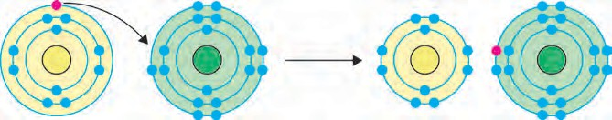

11Na

+

17Cl

Na Cl

+ -

* 1. **Formation of Ionic bond of NaCl**

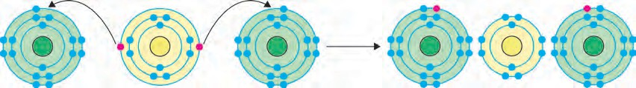

|  |  |  |  |
| --- | --- | --- | --- |
| 17Cl | + 12Mg | + 17Cl | Cl- Mg2+ Cl- |
| 2,8,7 | 2,8,2 | 2,8,7 | 2,8,8 2,8 2,8,8 |

* 1. **Formation of Ionic bond in MgCl2 molecule**

The figure 13.4 shows how the ionic compound magnesium chloride is formed from the elements magnesium and chlorine.

Show the formation of the following ionic compounds from the corressponding elements

using two methods namely, numerical and diagramatic representation of electronic

configuration. (a) K+F, from K and F (b) Ca2+O2- from Ca and O

9

19 20 8

1. **Covalent bond :** Generally a covalent bond is formed when atoms of two elements having similar properties combine. Such atoms cannot exchange electrons. Instead, these atoms share electrons with each other. The shared electrons become a common property of both the atoms and thereby the electron octet/duplet of both the atoms becomes complete. Let us first consider an example of the hydrogen molecule (H2).

We have seen in the chapter 'Inside an Atom' that a hydrogen atom contains one electron, its duplet is short of one electron and therefore the valency of hydrogen is one. The two atoms of hydrogen are identical and

have similar tendency and therefore they share their electrons with each other. As a result, the electron duplet of both the hydrogen atoms is complete and a chemical bond is formed between them.

The chemical bond formed by sharing of valence electrons of two atoms with each other is called a covalent bond. One covalent bond is formed by sharing of two valence electron. The figure 13.5 shows formation of the H2 molecule from two hydrogen atoms, using diagramatic representation of elctronic configuration. A covalent bond between two atoms is also represented by dash joining their symbols.

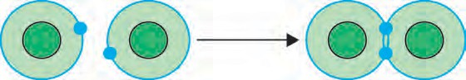

H H H2

* 1. **Formation of Covalent bond in H2 molecule**

Now let us see how an H2O molecule of a covalent compound is formed from hydrogen and oxygen atoms. (See fig. 13.6) There are six electrons in the valence shell of oxygen atom. It means that the electron octet in oxygen is short of two electrons and the valency of oxygen is ‘2’. In the H2O molecule the oxygen atom completes its octet by forming two covalent bonds, one each with the two hydrogen atoms. While this happens, the duplets of the two hydrogen atoms also are completed.

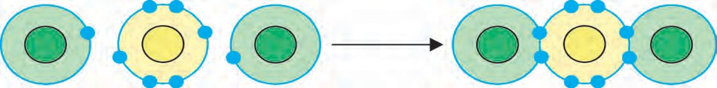

H o H H2O

* 1. **Formation of Covalent bond in H2O molecule**

There is one covalent bond between the component atoms H and Cl of the molecule HCl. Use this information to represent the formation of HCl molecule from H and Cl atoms diagramatically.



**Use your brain power**



**Exercises**

1. ** Complete the statement by filling the gaps using appropriate term from the terms given in the bracket.**

**(slow, coloured, arrow, fast, smell, milky, physical, product, chemical, reactant, covalent, ionic, octet, duplet, exchange, sharing, equality sign)**

* 1. An ................ is drawn in between the reactants and products while writing the equation for a chemical reaction.
  2. Rusting of iron is a ..................... chemical change.
  3. The spoiling of food is a chemical change which is recognized from the generation of certain ............ due to it.
  4. A colourless solution of calcium hydroxide in a test tube turns on

blowing in it through a blow tube for some time.

* 1. The white particles of baking soda disappear when put in lemon juice. This means that it is a change.
  2. Oxygen is a in respiration.
  3. Sodium chloride is compound

while hydrogen chloride is ......... compound.

* 1. Electron ......... is complete in each hydrogen in a hydrogn molecule.
  2. Chlorine (Cl2) molecule is formed by

............... of electrons between two chlorine atoms.

1. **Explain by writing a word equation.**
   1. Respiration is a chemical change.
   2. Hard water gets softened on mixing with a solution of washing soda.
   3. Lime stone powder disappears on adding to dilute hydrochloric acids.
   4. Bubbles are seen on adding lemon juice to baking soda.
2. **Match the pairs.**
   1. Photosynthesis i. Tendency to

lose electrons

* 1. Water ii. Reactant in combustion process
  2. Sodium chloride iii. Chemical

change

* 1. Dissolution iv. Covalent bond of salt in water
  2. Carbon v. Ionic bond
  3. Fluorine vi. Physical change
  4. Magnesium vii. Tendency to

form anion

1. **Show with the help of diagram of electronic configuration how the following compound are formed from the constituent atoms.**
   1. Sodium chloride b. Potassium fluoride

c. Water d. Hydrogen chloride

**Project :**

Prepare a list of the chemical changes that occur in your house and surroundings and discuss these in the class.





**14. Measurement and Effects of Heat**

**Can you recall?**

1. Which sources do we get heat from?
2. How is heat transferred?
3. Which effects of heat do you know? Some effects of heat are shown in figure 14.1 What are they?

We have seen in previous standards that heat is a form of energy which flows from an object at high temperature to an object at low temperature. Temperature of an object tells us how hot or cold that object is. The temperature of a cold object is lower than the temperature of a hot object. Thus, the temperature of ice cream is less than the temperature of tea.

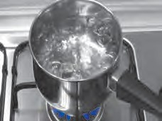 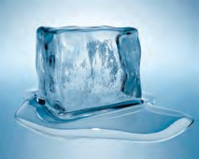

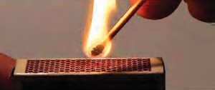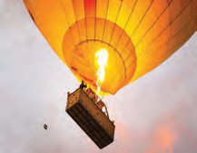

* 1. Various effects of heat

We have also seen that when we give heat to an object it expands and it contracts on cooling. Also, the state of matter changes due to heat.

The unit of heat in SI system is Joule while that in CGS units is calorie. One calorie is equivalent to 4.18 Joule. One calorie heat is the heat required to increase the temperature of 1 gm of water through 10C.

Solved examples

1. How much heat will be needed to raise the temperature of 1.5 kg of water from 15 0C to 45 0C ? Give the answer in calories as well as in Joule.

**Given :** mass of water = 1.5 kg = 1500 gm. Change in temperature = 45 0C - 15 0C

= 30 0C.

Heat required for temperature change = ? Heat required for temperature change = mass of water (gm) x change in temperature (0C) cal.

= 1500  30 cal = 45000 cal

= 45000  4.18 J = 188100 J

1. If the temperature of water changes by 10 0C on giving 300 cal of heat, what is the mass of water?

**Given :** Amount of heat given to water = 300 cal, change in temperature = 10 0C, mass of water = m = ?

Amount of heat given (cal) = mass of water (gm) x change in temperature (0C)

300 = m  10

m = 300 / 10 = 30 gm.

Sources of heat

1. **Sun :** The Sun is the biggest source of heat received by the earth. A large amount of heat is generated due to the nuclear fusion taking place in its centre. In this process hydrogen nuclei fuse together to form helium nuclei, generating heat in the process. Some of it reaches the earth in the form of light and heat.
2. **Earth :** As the temperature at the centre of the earth is high, the earth is also a source of heat. This heat is called geothermal energy.
3. **Chemical energy :** When fuels like wood, coal, petrol etc, burn, there is chemical reaction between the fuel and oxygen. Heat is generated in these reactions.
4. **Electrical Energy :** In your daily life, you have seen several equipments which produce heat with the help of electricity e.g. electric press, electric heater etc. Thus, electricity is a source of heat.
5. **Atomic energy :** A huge amount of heat is produced in a very short time when the nuclei of some elements like uranium, thorium etc undergo fission. This is used in atomic energy projects.
6. **Air :** A large amount of heat is present in the air around us.

**Temperature :** We can find out how hot or cold an object is by touching the object. However, our sense of ‘hot’ or ‘cold’ is relative. This can be understood from the following experiment.



**Try this**

1. Take three similar vessels. Let us call them ‘A’, ‘B’and ‘C’(see figure 14.2 )
2. Fill A with hot water and B with cold water. Put some water from A and B in C.
3. Dip your right hand in A and left hand in B, and keep them immersed for 2 to 3 minutes.
4. Now dip both the hands in C. What do you feel?
   1. **Relative sensation**

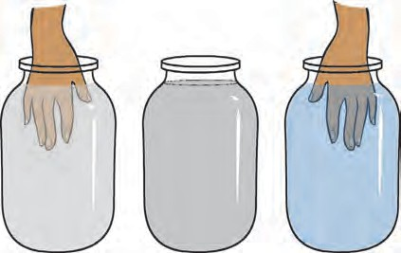

Vessel A

Vessel C

Vessel B

Even though, both the hands are dipped in water in the same vessel i.e. water at the same temperature, your right hand will find the water to be cold while the left hand will find it to be hot. What is the reason for this? Think about it.

You must have understood from the above activity that we cannot determine the temperature of an object accurately by simply touching it. Also you may hurt yourself by touching very hot or cold objects. So we feel the need of some device for measuring temperature. Thermometer is a device for measuring temperature. You have read about thermometer in the previous class. In this lesson you are going to learn about the construction of a thermometer.



**Can you recall?**

What are potential and kinetic energies?

**Heat and Temperature :** What is the difference between heat and temperature? We know that a substance is made of atoms. The atoms in a substance are always in motion. The total kinetic energy of the atoms in a substance is a measure of the heat contained in that substance, while the temperature of a substance is related to the average kinetic energy of atoms. If the average kinetic energy of atoms in two objects is equal then their temperatures will also be equal.

Figure 14.3 ‘a’and ‘b’ show the velocities of atoms in a gas at high and low temperature, respectively. The direction and the length of the arrows attached to the atoms show the direction and magnitude of the velocity of the atoms. The velocity of atoms in the gas at higher temperature is larger than the velocity of atoms in the

**Hot gas Cooler gas**

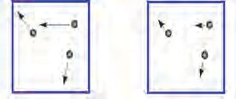

(a) (b)

Atom

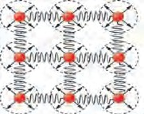

**Solid**

(c)

gas at lower temperature. **14.3 Motion of atoms in gas and solid**

The velocities of atoms in a solid object are shown by arrows in figure 14.3(c). The atoms in a solid object are tied to one another because of the forces acting between them. So they cannot be displaced from their places. Because of heat, they oscillate around their fixed position. Higher the temperature of the solid, faster is their velocity of oscillation.

Suppose A and B are two objects made from the same substance. The mass of A is twice the mass of B which means that the number of atoms in A is twice the number of atoms in B. Even if the temperatures of A and B are equal, i.e. the average kinetic energy of atoms in A is same as that in B, the total kinetic energy of atoms in A is twice that in B. Thus, the heat content of A is twice that of B even though, they both have the same temperature.



**Try this**

1. Take two steel vessels A and B of the same size.
2. Fill some water in A and double that amount in B. Make sure that the water in both vessels are at the same temperature.
3. Raise the temperatures of water in both vessels by 10 0 C using a spirit lamp. Did it take the same time to increase the temperature in the two vessels?

You must have required more time to raise the temperature of water in B. This means that for the same increase in temperature, you had to give more amount of heat to B. Thus, even though the water in A and B have the same temperature, the amount of heat in B is more than that in A.

Temperature is measured in units of Celsius (0C), Fahrenheit (0F) and Kelvin (K). Kelvin is used in scientific experiments, while the other two are used in daily life. The relation between

the three units is shown by the following formulae.

#### (F-32) 9

= C (1)

5

|  |  |  |  |
| --- | --- | --- | --- |
| **Description** | **0F** | **0C** | **K** |
| Boiling point of water | 212 | 100 | 373.15 |
| Freezing point of water | 32 | 0 | 273 |
| Room temperature | 72 | 23 | 296 |
| Boiling point of mercury |  | 356.7 |  |
| Freezing point of mercury |  | -38.8 |  |

#### K = C + 273.15 (2)

Some specific temperatures are given in the three scales in the following table. Verify that they satisfy the above relations and fill appropriate numbers in the blanks.

Sloved examples

1. How much will the temperature of 68 0F be in Celsius and Kelvin?

**Given :** Temperature in Fahrenheit = F = 68, Temperature in Celsius = C= ?, Temperature in Kelvin = K = ?

According to formula (1), (F-32) = C

##### 9 5

(68-32)

9

C = 5 x 36

9

= C

##### 5

= 20 0C According to formula (2)

K = C + 273.15 = 20 + 273.15 = 293.15

Thus, the temperature in Celsius = 20 0C and in Kelvin = 293.15 K

1. At what temperature will its value be same in Celsius and in Fahrenheit?

**Given :** If the temperature in Celsius is C, then the temperature in Fahrenheit (F) will be same,

i.e. F= C.

Using formula (1), (F-32) = C

9 5

or, (C-32) = C

9 5

(C-32)  5 = C  9 5C - 160 = 9 C

4 C = - 160

C = F = - 40 The temperatures in Celsius and in Fahrenheit will be same at - 400

**Thermometer :** You must have seen the thermometer that is used when someone at home has fever. That thermometer is called clinical thermometer. Different thermometers are used for different purposes. Let us first learn about the working of a thermometer.

A thermometer is shown in figure 14.4

1. It has a narrow glass tube which has a bulb at one end. The bulb and part of the tube is filled with a liquid. Earlier, mercury was used but, as it is harmful for us, it has been replaced with alcohol. The rest of the volume of the tube has vacuum and its other end is closed. The bulb is kept in contact with the object whose temperature is to be measured so that its temperature becomes same as that of the object. Because of the increased temperature the alcohol inside it expands and its level in the tube rises. Using the properties of the expansion of alcohol (to be discussed below), the temperature can be obtained from the level of the alcohol. The tube of the thermometer is marked accordingly.

Figure 14.4 (b) shows a clinical thermometer. As the body temperature of a healthy person is 37 0C, clinical thermometers are designed to measure temperatures between 35 0C and 42 0C. These days, instead of the above type, digital thermometers are used for clinical puroses. One such thermometer is shown in figure 14.4 c.

This does not use the expansion of liquid due to heat. Instead, it has a sensor which can measure the heat coming out from the body directly and from that can measure the temperature of the body.

The thermometers used in laboratory are similar to the one shown in figure 14.4 a except that the range of temperatures that it can measure is large spanning 40 0C to

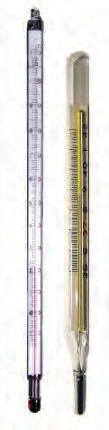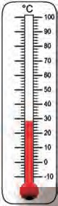110 0C or even larger. A special type of thermometer is used to measure the minimum and maximum temperatures in a day. It is called the maximum minimum thermometer. It is shown in figure 14.4 d.

1. Clinical thermometer

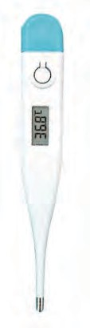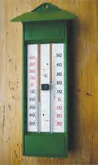a. A thermometer

1. Digital thermometer
2. Maximum

- minimum thermometer

* 1. **: Different thermometers**

When a hot object is kept in contact with a cold object they both exchange heat. The hot object gives away heat while the cold object absorbs heat. Thus, temperature of the hot object decreases, while that of the cold object increases. This means that the kinetic energy of atoms in the cold object goes on incresing while that in the hot object goes on decreasing. A time comes when the average kinetic energies of atoms in both objects become equal, which means that the temperatures of both objects become equal.

**Specific heat :** The specific heat of an object is the amount of heat required to increase the temperature of unit mass of that substance through one degree. This is represented by the symbol ‘c’. Its unit in SI is Joule /(kg 0C) and in CGS is cal/(gm 0C). Suppose Q amount of heat is required to increase the temperature of an object of mass m and specific heat c, from T**i** to T**f** This amount depends on the mass and specific heat of the object as well as on the

increase in temperature and can be written as.

Q = m x c x (T**f** - T**i**). (3)

|  |  |  |  |
| --- | --- | --- | --- |
| **Substances** | **Specific heat cal/(gm 0C)** | **Substance** | **Specific heat cal/(gm 0C)** |
| Aluminium | 0.21 | Iron | 0.11 |
| Alcohol | 0.58 | Copper | 0.09 |
| Gold | 0.03 | Mercury | 0.03 |
| Hydrogen | 3.42 | Water | 1.0 |

Different substances have different specific heats. We are going to learn more about it in future classes. The specific heats of a few substance are given in the following table.

**Calorimeter :** We have seen that a thermometer is used to measure the temperature of an object. A calorimeter is used to measure the heat content of an object. Using this equipment, we can measure the heat produced or absorbed in a physical or chemical process.

A calorimeter is shown in figure 14.5 Similar to a thermosflask, a calorimeter has two vessels, an inner and an outer one. This way, no heat can be transferred from the inner to the outer vessel or from the outer to the inner vessel. Thus, the inner vessel is thermally isolated from the surroundings. The inner vessel is made of copper. A thermometer for measuring the temperature and a stirrer for stirring the liquid in the calorimeter are fitted in it.



**Use your brain power**

1. Why does your mother put folded cloth strips soaked in cold water on your forehead when you have high fever?
2. Why is the calorimeter made of copper?

Water at a fixed temperature is placed inside the calorimeter. This means that the temperature of the inner vessel and that of the water in it are the same. When a hot object is placed in water, heat is exchanged between the hot object, water and the calorimeter and all three reach the same temperature. As the calorimeter is thermally isolated from the surroundings, the total heat lost by the hot object is equal to the total heat absorbed by the calorimeter and water inside it.

Similarly if we put a cold object in the calorimeter, the cold object will receive heat from the water and its temperature will increase, while water and calorimeter will lose heat and their temperature will decrease.

Suppose the mass of the inner vessel in the calorimeter is ‘mc’ and its initial temperature is ‘Ti’and the mass of the water

in the calorimeter is ‘mw’. The temperature

of water will also be ‘Ti’ . Suppose we place an object of mass ‘mO’ and temperature ‘To’ in the calorimeter. If ‘To’ is higher than Ti the object will give away heat to the calorimeter

and water. Soon the temperature of all three will become the same.

Heat resistant lid Heat

resistant ring

Thermometer

Stirrer

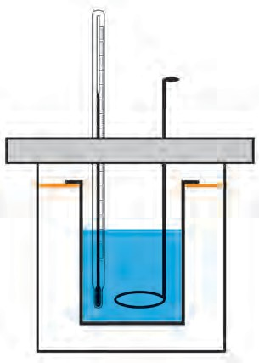

Let us call this final temperature ‘Tf’ . The total heat given away by the object (‘Qo’) will be equal to the sum of the heat gained by the calorimeter (‘Qc’) and by water (‘Qw’). We can write this as.

Qo = QC + QW (4)

Inner vessel

Air cavity

Outer vessel

As seen above Qo, Qc and Qw depend on mass, specific heat and change in temperature

T. If the specific heats of the material of calorimeter, water and the object are cc , cw and co respectively, we can write using

* 1. **Caloriemeter**

formula (3),

QO = mO  T  CO, T = TO – Tf

O

O

##### Q = m  T  C , T = T – T

W

##### Q = m

W W

* T  C

W W

#### , T = T

f i

#### – T = T

C C C C C f i W

Using (4), mo  T  c = mw  T  c + mc  T  c (5)

o

w

c

o

w

c

We can measure all the masses and temperatures. If we know the specific heats of the material of the calorimeter i.e. copper and that of water, we can calculate the value of the specific heat of the object using formula (5). We will learn about this in more details in higher standards.

Solved Examples

**1.** Suppose the masses of the calorimeter, the water in it and the hot object made up of copper which is put in the calorimeter are the same. The initial temperature of the calorimeter and water is 30 0C and that of the hot object is 60 0C. The specific heats of copper and water are

0.09 cal / (gm 0C) and 1 cal / (gm 0C) respectively. What will be the final temperature of water?

Given : m = m = m = m, T = 30 oC, T = 60 oC T = ?

w o c i o , i

Using formula (5), m  (60 - T )  0.09 = m  (T - 30)  1 + m  (T - 30)  0.09

(60 - T )  0.09 = (T

f f f

- 30)  1.09

f f

60  0.9 + 30  1.09 = (0.09 + 1.09) T

i

T = 32.29 0C

1

The final temperature of water wil be 32.29 0C.

Effects of heat

In previous standards, we have studied two effects of heat on matter : 1. expansion and contraction and 2. change of state. In this lesson, we are going to learn more about expansion. You will learn about change of state of matter in higher standards.

Expansion

When heat is given to any substance, its temperature increases and it expands. Its expansion depends on the increase in its temperature. Solids, liquids and gases, all expand on receiving heat.

Expansion of solids

**Linear expansion :** The linear expansion of a solid is the increase in length of a wire or a rod of a solid due to increase in its temperature.

When we increase the temperature of a rod of length *l*1 from T1 to T2, its length becomes *l*2. The change in length is proportional to the original length and the increase in temperature, ( T=T - T ). So we can write the change in length as follows.

2 1

The expansion coefficients of different substances are different. From the above formula we can see that if we take two rods of different substances, both having the same length, and increase their temperatures by the same amount, the rod of the substance having higher expansion coefficient will expand more. Thus, the increase in its length will be larger.

From formula (6), we can write the expansion coefficient as

Change in length  original length x change in temperature

*l* - *l*  *l*  T

2 1 1

*l* - *l* =   *l*  T (6)

2 1 1

*l* = *l* (1+ T) (7)

2 1

###### Here  (lambda) is the constant of proportionality and it is called the coefficient of linear expansion of the solid substance.

● = (*l* - *l* ) / (*l* T) (8)

Thus, the expansion coefficient is the change in length of a rod of unit length when its temperature is increased by 1 degree. From formula (8) we can see that the unit of expansion coefficient is the inverse of the unit of temperature, i.e. 1/0C. The expansion coefficients of some substances are given in the following table.

2

1 1



|  |  |  |  |  |  |
| --- | --- | --- | --- | --- | --- |
| **Solid** | **Coefficient of linear expansion x 106 (1/0C)** | **Liquid** | **Coefficient of volume expansion x 103 (1/0C)** | **Gas** | **Expansion coefficient x 103 (1/0C)** |
| Copper | 17 | Alcohol | 1.0 | Hydrogen | 3.66 |
| Aluminium | 23.1 | Water | 0.2 | Helium | 3.66 |
| Iron | 11.5 | Mercury | 0.2 | Nitrogen | 3.67 |
| Silver | 18 | Chloroform | 1.3 | Sulphur dioxide | 3.90 |

* 1. **: Coefficient of expansion of some substances**

Solved Examples

**Example :** What will be the increase in length of a steel rod of length 0.5 m, when its temperature is increased by 60 0C? The coefficient of linear expansion of steel is 0.000013 (1/0C).

**Given :** Initial length of the rod = 0.5 m, change in temperature = 60 0C, change in length =

*l* = ?

Using formula (6), *l* =   *l*  T = 0.000013  0.5  60 = 0.00039 m Increase in length = 0.039 cm

1

**Areal expansion of solids :** Similar to linear expansion, the area of a sheet of a solid material also increaes on heating. This is called the areal expansion of solids. This is given by the following formula.

A2 = A1 (1 +  T) (9)

Here, T is the change in temperature and A and A are the initial and final areas of the

1

2

sheet.  is the coefficient of areal expansion of the solid.

**Volumetric expansion of solids :** Similar to a sheet, a three dimensional piece of solid expands on all sides when heated and its volume increases. This is called the volumetric expansion of a solid. This is given by the following formula.

V2 = V1 (1 +  T) (10) Here, T is the change in temperature and and V

1

and V2 are the initial and final volumes of the solid.  **is the volumetric expansion coefficient**

of the solid.

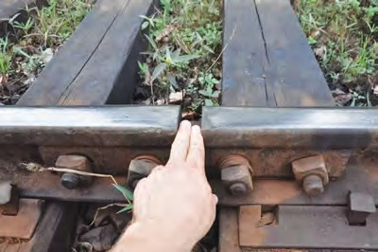

**Do you know?**

Have you seen rails? They are not continuous. A small gap is kept between them at regular intervals. This is shown in the figure. This is kept to accommodate the change in the length of the rails with change in temperature. If this gap is not kept, then the rails will get distroted due to expansion in summer which may lead to accidents.

Similar to rails, the length of bridges can also increase due to expansion in summer. The length of the 18 km long great belt bridge in Denmark increases by 4.7 m in summer. Therefore, provision is made in the construction of the bridges to accommodate this expansion.

**Expansion of liquids**

A liquid does not have a definite shape but it has a definite volume. So we can define a volumetric expansion coefficient for a liquid as follows.

Fixed Piston

Motion of air molecule

Movable Piston

V2 = V1 (1 +  T) (11)

Here, T is the change in temperature and V1 and V2 are the initial and final volumes of

the liquid.  is the volumetric expansion Burner

coefficient of the liquid.



**Use your brain power**

Which use of the expansion of liquids in daily life do you know?

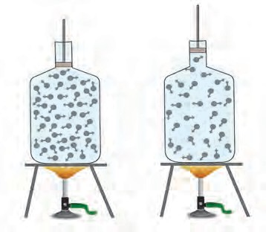

The effect if heat on water is somewhat different from that for other liquids. This is called anomalous behaviour of water. We are going to learn about it in higher standard.

Expansion of gases

A gas does not even have a fixed volume. Gas expands on heating but if the gas is kept in a closed box, its volume cannot increase but its pressure increases. This is shown in figure 14.7

Observe figure 14.7 and find out answers to the questions.

* 1. **Effect of heat on a gas**

1. Using the formula density = mass / volume, explain what will be the effect of heat on the gas kept in a closed bottle.
2. If the bottle is not closed but has a movable piston attached to its open end (see the figure), what will be the effect of heating the gas in the bottle?

Therefore, the expansion of a gas is measured by keeping its pressure constant. This volumetric expansion coeffcient is called the constant pressure expansion coefficient and is given by the following formula.

V = V (1 +  T) (12)

2 1

Here, T is the change in temperature and V1 and V2 are the initial and final volumes of the gas at costant pressure.  is the constant pressure expansion coefficient of the gas.

**Use your brain power**

The density of a gas decreases on heating. Which of the pictures in figure 14.1 makes use of this?

## Exercises



* 1. **A. Whom should I pair with?**

**Group A Group B**

* + 1. Temperature of a i. 296 K healthy human body
    2. Boiling point of water ii. 98.6 0F
    3. Room temperature iii. 0 0C
    4. Freezing point of water iv. 212 0F

**B. Who is telling the truth?**

1. The temperature of a substance is measured in Joules.
2. Heat flows from an object at higher temperature to an object at lower temperature.
3. Joule is the unit of heat.
4. Objects contract on heating.
5. Atoms of a solid are free.
6. The average kinetic energy of atoms in a hot object is less than the average kinetic energy of atoms in a cold object.

**C. You will find if you search.**

1. A thermometer is used to measure..........
2. The apparatus used to measure heat is called a .............

c Temperature is the measure of the ........... kinetic energy of the atoms in a substance.

d. The heat contained in a substance is the measure of the .............. kinetic energy of atoms in the substance.

* 1. **Nishigandha kept a vessel containing all the ingredients for making tea in a solar cooker. Shivani kept a similar vessel on a stove. Whose tea will be ready first and why?**
  2. **Write brief answers.**
     1. Describe a clinical thermometer. How does it differ from the thermometer used in laboratory?
     2. What is the difference between heat and temperature? What are their units?
     3. Explain the construction of a calorimeter. Draw the necessary figure.
     4. Explain why rails have gaps at specific distances.

e Explain with the help of formulae the expansion coefficients of liquid and gas.

* 1. **Solve the following examples.**
     1. What must be the temperature in Fahrenheit so that it will be twice its value in Celsius?

**(Ans. 320 0F)**

* + 1. A bridge is made from 20 m long iron rods. At temperature 18 0C, the distance between two rods is 0.4 cm. Up to what temperature will the bridge be in good shape?

**(Ans. 35.4 0C)**

* + 1. At 15 0C the height of Eifel tower is 324

m. If it is made of iron, what will be the increase in length in cm, at 30 0C?

**(Ans. 5.6 cm)**

* + 1. Two substances A and B have specific heats c and 2 c respectively. If A and B are given Q and 4Q amounts of heat respectively, the change in their temperatures is the same. If the mass of A is m, what is the mass of B?

**(Ans. 2 m)**

* + 1. When a substance having mass 3 kg receives 600 cal of heat, its temperature increases by 10 0C. What is the specific heat of the substance?

**(Ans.0.0033 cal /(gm 0C))**

**Project :**

Collect information about bimetallic strips and discuss in your class how a fire alarm is made using it.



**15. Sound**

How is sound produced ?

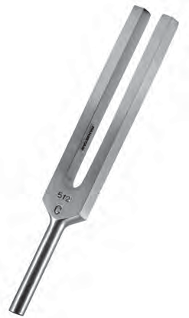

**Can you recall?**

Prong

Stem

**15.1 Tuning Fork**

Production of Sound

We have learnt that sound can be generated from a vibrating object.With an example of tuning fork, we will now learn about how a sound is produced due to such vibrations. A photograph of tuning fork is shown in Figure 15.1.

A tuning fork is made of two prongs and a stem. Keeping the stem steady, if the prongs are struck, they start vibrating.

Figure 15.2 (a) shows a stationary tuning fork. To show the state of air around the tuning fork, vertical lines are used. Here, the vertical lines are equally spaced. It indicates that the average distance between the air molecules is the same everywhere and the average air pressure in three regions ‘A’, ‘B’ and ‘C’ is also the same.

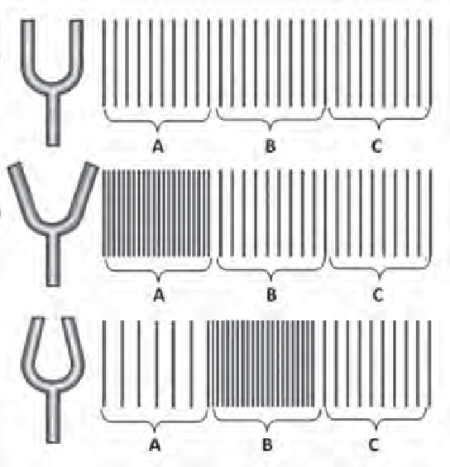If the stem is kept steady and the prongs are struck, the prongs are set into vibrations. It means that they are set into periodic motion in forward and

backward direction. We will see, step by step, the result of such a motion.

If during the vibration, the prongs of the tuning fork go away from each other, as shown in Figure

15.2 (b), the air outside the prongs is compressed and the pressure there increases. Such a state of high pressure is created in region A in the figure. The region in which air is at high pressure and high density is called compression. In the next step of vibration, the prongs of the fork come close to each other, as shown in Figure 15.2 (c). In this case, the air molecules near the prongs get more space to move away from each other. As a result, the air pressure in this region (Region A) decreases. Such region in which air is at low pressure and low density is called rarefaction.

(a)

(b)

(c)

**15.2 Production of sound by tuning fork**

However, the air molecules in this region, which were in compressed state earlier (Figure

* 1. (b), region A) transfer their energy to the air molecules in the next region (region B). So, the air in that region goes to compressed state (See Figure 15.2 (c), region B). Such a periodic motion of the prongs creates compression and rarefaction in the air and these are propagated away from the prongs. These are nothing but the sound waves. When these waves reach our ear, the ear-drum vibrates. Accordingly, specific signals reach the brain and we get a sense of hearing a sound.

If sound waves are generated in air, what moves away



**Use your brain power**

from the source? Is it the air itself or the state of compression and rarefaction created in the air?

Bell jar

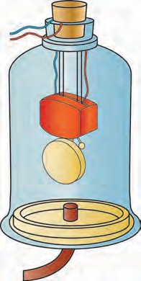

Electric bell

To vaccum pump

* 1. **Medium is necessary for propogation of sound**

**Propagation of sound and Medium:** We have learnt in the sixth standard that sound travels through some material medium like solid, liquid or gas and reaches us. But what if such medium does not exist between the source of sound and our ear?

Sound generation and propagation needs medium like air. A simple experiment can prove this. The experimental arrangement is shown in Figure 15.3. In this experiment, a vaccum tight bell jar is placed on a smooth horizontal surface. The bell jar is connected to a vacuum pump via a tube. We can remove air inside the bell-jar, using the vacuum pump. As shown in the figure, the bell jar contains an electric bell, which is connected to the power supply through the lid of the bell jar.

At the start of experiment, the vacuum pump is off and the bell-jar contains air. If the key to electric bell is now switched on, the bell start ringing and the ringing can be heard from outside the bell jar. Now, if the vacuum pump is switched on, it starts removing the air from the bell jar. As the quantity of air inside the bell jar decreases, the level of ringing sound heard outside also decreases. If the pump is operated for sufficiently long period, the quantity of air like inside the bell jar will be low. At this point the level of ringing sound will also be very low. This experiment demonstrates that sound generation and propagation needs a medium. If the air inside the bell jar is totally removed, will we be able to hear the sound of ringing bell? Why?



**Always remember**

Two astronauts on the moon talking to each other directly, will be unable to listen to each other, even if they are very close to each other. The moon does not have atmosphere. Since there is no medium which is necessary for generation and propagation of sound, between the astronauts, direct sound propagation between them is not possible. Therefore, the astronauts use some technology like the one used in our cell-phones to communicate with each other. The waves used in cell-phone do not need any medium for propagation.

**Frequency of Sound Waves :** Using figure 15.2, we learnt about how the vibrations of tuning fork result in generation of compressions and rarefactions in air. More detail observation shows that, the actual variation in the air density and pressure are as shown in Figure 15.4. If any object vibrates in the air, such sound waves are produced in the air.

Increased pressure

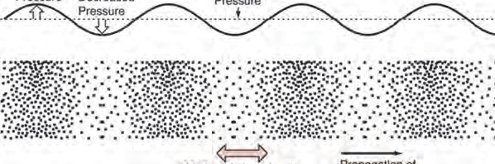

(compression)

Reduced pressure (rarefaction)

Atmospheric pressure

One oscillation consisting of compression and rarefaction

Motion of air molecules due to sound

Propagation of sound

* 1. **Cycles of compression and rarefaction in a sound wave and change in air pressure**

As shown in the Figure 15.4, one compression and one rarefaction together forms one cycle of the wave. The number of cycles formed in the air in one second will be decided by the number of times the prongs of the tuning fork (or any other vibrating body) vibrates back and forth i.e. the number of vibrations of the tuning fork in one second.

Number of such cycles that are produced in the air (or other medium) per second is called as the frequency of the sound wave. The frequency is measured in Hertz. If one cycle is completed in one second, the frequency is said to be 1 Hz. For example, the tuning fork in Figure 15.1 shows its frequency to be 512 Hz. It means that the fork vibrates 512 times per second. These vibrations will set 512 cycles of compression and rarefaction in the air, per second. Thus, the sound generated by the fork will have a frequency of 512 Hz. The frequency of a tuning fork is decided by the dimensions of the prongs (length, thickness) and the material used for making the fork.



**Try this**

Take 6-7 glass cups. Arrange them in a line and fill them with water with gradually increasing water level from one end to other. Take a pencil and strike the cups sequentially. The sound generated by each cup will be different. Why it is so?

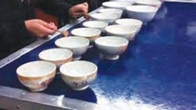

**Use of ICT**

Download videos of Jaltarang from youtube and send them to your friends by email.

When a cup is struck, waves are set up in the air column above the water level in the cup. The frequency of the generated wave depends on the height of the air column inside the glass cup. Since the water level in each glass is different, the height of the air column in each glass is also different. Therefore, the frequency of sound generated by each glass cup will also be different. So, the sound generated is different.

An ‘app’ for measurement of sound frequency may be

available on cell-phones. With the help of your teacher, use the app to measure the frequency of the sound generated from each glass cup. Do you observe any relation between the frequency of generated sound and the height of the air column in the glass-cup? This is your simple ‘Jal- tarang’! Can this experiment be performed with stainless steel pots of different sizes?

Sound and Music

From the above activity, it is clear that if the frequency of sound wave is changed, different sound is produced. Sound waves of different frequencies produce different sound notes. In the field of music, various musical instruments are used for creation of sound notes. This includes instruments like sitar, violin, guitar which use strings for production of sound and instruments like flute, shehnai which use air blown into pipes for the production of sound.



**Do you know?**

What are the frequencies of musical notes ‘sa’, ‘re’, ‘ga’,

ma’, ‘pa’, ‘dha’, ‘ni’ in the ‘madhya saptak’?

|  |  |
| --- | --- |
| Note | Frequency (Hz) |
| sa | 256 |
| re | 280 |
| ga | 312 |
| ma | 346 |
| pa | 384 |
| dha | 426 |
| ni | 480 |

In string based instruments, the frequency of vibration of the string is changed by changing the tension on the string and/or by changing the vibrating length of the string using fingers. This results in generation of different notes.

In musical instruments like flute, the holes on the flute are opened or closed to change the length of vibrating air column in the flute. The frequency of waves, therefore, changes and it results in the production of different notes. In flute, different notes can be generated by changing the way of air-blowing also.

Sound Produced by Human

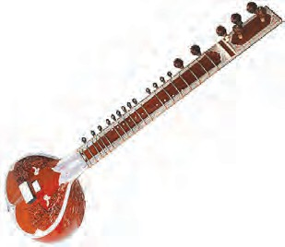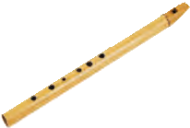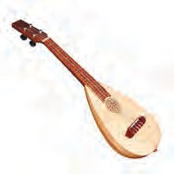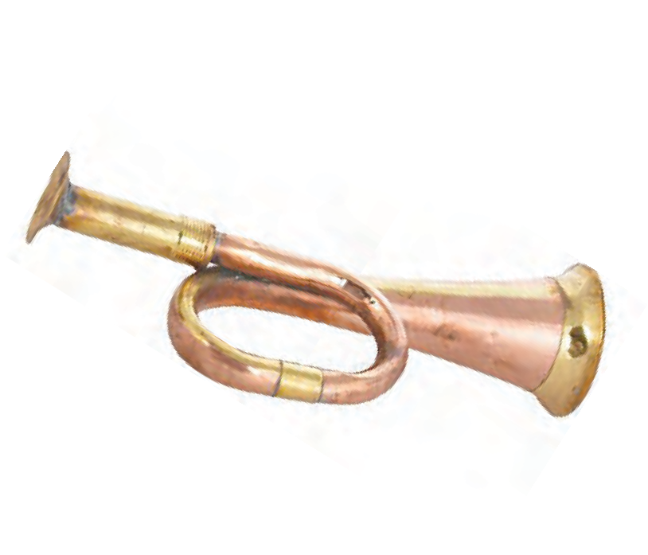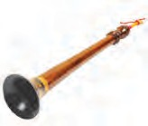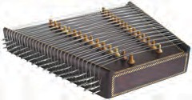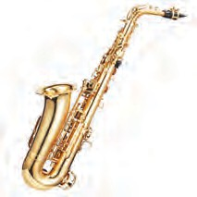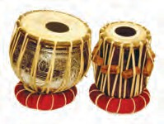

**Observe and discuss.** Identify the instruments and discuss sound production in them.

**Try this**

‘Apps’ for generation of different sound notes (sound note generator app) may be available on cell-phones. With the help of your teacher, using such an app, generate sound notes listed in the table.

Either speak a little loudly or sing a song or produce humming sound like a bee and put your fingers on your throat. Do you feel some vibrations?

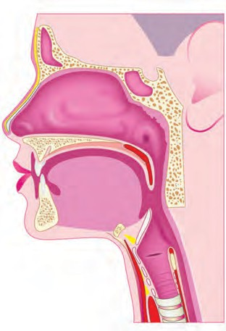

In the humans, sound is produced in the larynx. While swallowing food, we can feel with our finger a hard bump that seems to move. This is nothing but larynx. As shown in Figure 15.5, it is at the upper end of the windpipe. Two vocal cords, are stretched across the voice box or larynx in such a way that it leaves a narrow slit between them for the passage of air.

Epiglottis

(A flap that closes air-track during swallowing

Vocal Chords

When the lungs force air through the slit, the Trachea

vocal cords vibrate, producing sound. Muscles attached to the vocal cords can make the cords tight or loose. When the vocal cords are tight and thin, the type or quality of voice is different.

Take two rubber strips out of an unused bicycle tube. Place these two pieces one above the other and stretch them tight. Now blow air through the gap between them. As the air blows through the gap between the rubber strips, a sound is produced. Human larynx works in a similar way.

Vocal cords are 20 cm in length in male, about 15 cm in female and even smaller in children. Therefore the voice of male, female and children are different.

Esophagus

* 1. **: Larynx in human**

Produce a sound ‘bho…bho..’ just like a dog-barking and ‘meow.. meow..’ just like a mewing cat. Carefully notice the tension on the vocal cords, when you produce these sounds. Do you feel that the tension on the vocal cords changes when you produce these two different sounds?



**Try this**

**Sound generation by loudspeaker :** You know that sound can be produced using loudspeaker. The internal arrangement in the loudspeaker is shown in the form of cross- sectional view in Figure 15.6. It consists of a permanent magnet. A coil is wound around it and if a current flows through this coil, it also generates magnetic field. This you have learnt in earlier chapter in this book.

You must have seen that if two magnets are brought near each other, they move depending on their positions. In the same way, here, depending on the magnetic field created due to the coil, the coil moves back and forth. The frequency and amplitude of the movement of the coil depends on the variation in the current flowing through the coil. As the coil moves, the conical screen of the loudspeaker, which is attached to the coil, also moves back and forth.

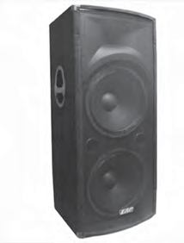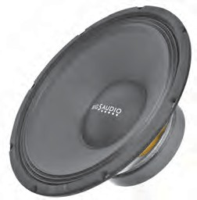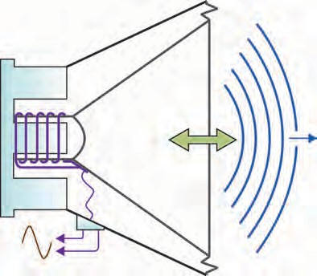

Permanent magnet

Screen

Coil

From microphone

* 1. **Internal construction of a loudspeaker**

We have seen that due to back and forth motion of the prongs of the tuning fork, sound waves are produced. In the same way, here, due to back and forth motion of the loudspeaker screen, sound waves are produced in air.

You can feel these vibrations of the loudspeaker screen, just by gently touching the screen of a loudspeaker, which is producing sound. Very loud sound can be produced by using a loudspeaker. Therefore, loudspeakers are used in public places. However, as we have learnt last year, if sound level is around 100 decibels, the sound can be harmful to us. Therefore, although the loudspeaker can generate very loud sound, there must be limit on its loudness.



**Always remember**

We should take care that others are not disturbed when we study sound and its production. Sound pollution is a major cause affecting the environment and social health. Hence we should find ways to avoid sound pollution.



**Try this**

An ‘app’ may be available on cell- phones to measure the loudness of sound in decibel. With the help of your treacher, use the app to measure the sound level of a sound from a loudspeaker at some public place. Measure the sound level at different distances from the loudspeaker. Do you observe some relation between the distance from the loudspeaker and the sound level?



**Exercises**

* + 1. **Fill in the blanck with approriate word:**
       1. The region in a sound wave, with higher pressure and density is called ............. and that with low pressure and density is called...........
       2. Medium is ...............for generation of sound.
       3. The total number of compressions and rarefactions produced per second in a sound wave is 1000. The frequency of the sound wave is .....
       4. Different sound notes have different ........
       5. In loudspeaker,........energy is coverted into energy.
    2. **Give scientific reasons :**
       1. It is essential to change the tension on the vocal cords, as we produce different sound notes from our larynx.
       2. Astronauts on the moon can not hear each other directly.
       3. As the sound wave propagates from one place to the other in air, the air itself is not required to move from one place to the other.
    3. **How are different sound notes generated in musical instruments like guitar, which uses strings for sound generation, and flute, which uses blown air for sound generation?**
    4. **How is sound produced in a human larynx and a loudspeaker?**
    5. **Explain the experiment, with neat diagram, to prove the following :**

‘Sound needs material medium for propagation.’

* + 1. **Match the following:**

|  |  |
| --- | --- |
| Human larynx | Vibrations of metal arms |
| Loudspeaker | Vibrations in air column |
| Jal-tarang | Vibrations in vocal cords |
| Tuning fork | Vibrations in strings |
| Sitar | Vibrations of screen |

**Project :**

1. Take two plastic glasses and tie a thread between them to make a toy phone. Does the voice of your friend reach you through the thread? Take metal wire instead of the thread and also change the length of thread/ wire and repeat the activity. Discuss with your friends and teacher about your conclusions.
2. Take a plastic or tin can or a plastic glass. Remove its bottom. Stretch a piece of rubber balloon across one end and fix it with a rubber band. Put a few grains of say ragi or bajra on the stretched rubber. Now ask your friend to shout 'Hoorrey..... Hoorrey. '

from the open end of the glass. Observe the dancing of the grains up and down. Discuss the reason behind this.





**16. Reflection of Light**

We get different feelings through senses. The sense of vision is the most important among our five senses. Because of this we can see the hills, rivers, trees, people and objects around us. Only with this we can see the beautiful views of nature like clouds, rainbow, flying birds, Moon, stars etc.



**Try this**

Switch off the light in your room at night for some time and then turn it on again.

Could you see the objects in the room clearly when the light was switched off ? What did you feel when it was turned on again?

From the above activity you can notice that there is some connection between the sense of vision and light. When we switch off the light at night, the objects in the room cannot be seen and they can be seen as before when the light is switched on again. Thus, we can see objects when the light coming from these objects enters our eyes. The light entering our eyes may be emitted by the object or may be reflected by that object. What is meant by light reflected by an object? To understand this, let us learn about the reflection of light.

**Reflection of light :** When light rays fall on an object their direction changes and they turn back. This is called the reflection of light.



**Try this**

**Material :** Torch light, mirror, a stand for hanging the mirror, black paper, comb, white paper, drawing board.

Activity

1. Fit a white paper tightly over a table or drawing board.
2. Leaving out some portion in the middle of the comb, cover the rest with black paper so that light can only pass through the open central portaion. (figure 16.1)
3. Hold the comb perpendicular to the white paper and throw torch light on its central portion.
4. Adjust comb and torch so as to get light rays on the white paper. Now keep a mirror in the path of this ray of light as shown in the figure.
5. What do you observe ?

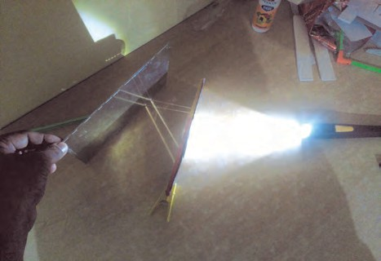

* 1. **Reflection of light**

In this activity, light rays which fall on the mirror, get reflected and travel in a different direction. The rays falling on any surface are called incident rays. The point at which an incident ray falls is called the point of incidence. the rays going away from the surface after reflection are called reflected rays. The direction of the reflected rays is decided by some rules which are called laws of reflection. Let us learn some definitions before learning about these laws.

(As shown in figure 16.2)

* 1. Draw a line PQ, showing the position of the mirror.
  2. Draw the incident ray AO and the reflected ray OB.
  3. Draw a perpendicular to the line showing the position of the mirror i.e. PQ at O. This line, ON, is called normal to the mirror. As ON is perpendicular to PQ

 PON =  QON = 900

Incident ray Normal Reflected ray

**Laws of reflection**

There are three laws of reflection. These are as given below.

1. The angle of reflection is equal to the angle of incidence.
2. The incident ray, the reflected ray and the normal lie in the same plane.
3. The incident ray and the reflected ray are on the opposite sides of the normal.

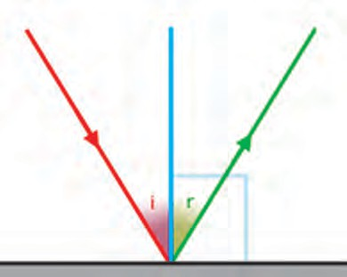

A N B

Angle of Angle of incidence reflection

Point of incidence

P Q

O

* 1. **Reflection of light**

Some terms related to reflection are as follows.

i. Ray AO is the incident ray ii. Point O is the point of incidence

iii. Ray OB is the reflected ray iv. Line ON is the normal

1. The angle AON, between incident ray and the normal is the angle of incidence (i)
2. The angle BON between the reflected ray and the normal is the angle of reflection (r)



**Try this**

**Equipment :** Mirror, drawing board, pins, white paper, protractor, scale, pencil

**Activity : P O Q**

* 1. Fit a white paper on the drawing board tightly as

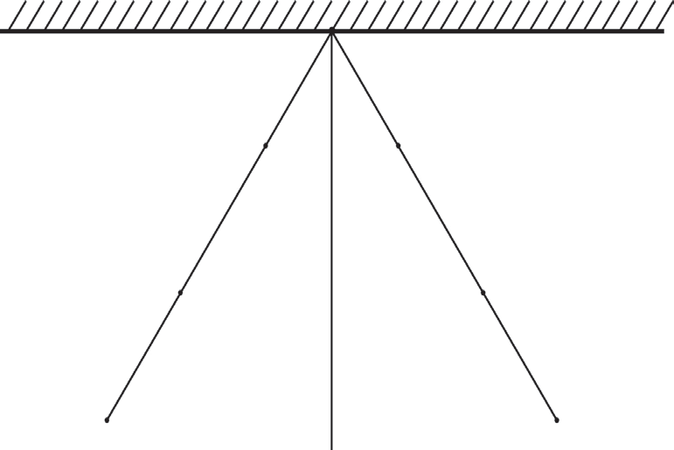

**R** • **300**

•

**U**

**S** •

•**T**

**A**

**N**

**Eye**

possible.

* 1. On the paper draw a line PQ indicating the position of the mirror. (figure 16.3)
  2. Draw a perpendicular ON to PQ at point O.
  3. Draw a ray AO making an angle of 300 with ON
  4. Fix two pins S and R along AO.
  5. Fix the mirror to a stand and place it along PQ perpendicular to the drawing board.
  6. Fix pins at T and U along the line joining the

bottom of the reflected images of the pins at S and R.

* 1. Remove the mirror and join the points T and U and extend it up to O.

|  |  |  |
| --- | --- | --- |
| **S.No.** | **Angle of incidence**  **(****i)** | **Angle of reflection**  **(****r)** |
| 1. | 300 |  |
| 2. | 450 |  |
| 3. | 600 |  |

* 1. Measure  TON.
  2. Repeat steps 4 to 9 for angle of incidence equal to 450 and 600 and write down the angles in the following table.
  3. Verification of the laws of reflection

What relation do you find between the angle of incidence and the angle of reflection? If you have done the experiment carefully, you will find that the angle of incidence is equal to the angle of reflection in all three cases. This verifies the laws of reflection.



**Try this**

What will happen when a light ray is incident perpendicular to the mirror ?

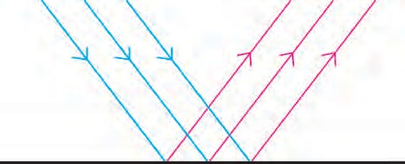

i1 r1 i2 r2 i3 r3

Figure 16.4 (a) and (b) show three parallel rays, shown in blue, incident on smooth and rough surfaces. The reflected rays drawn using laws of reflection shown in red.

1. Rays reflected from which surface are parallel to one another ?
2. What conclusion can you draw from the figure ?
3. **Regular reflection of light :** The reflection of light from a plane and smooth surface is called regular reflection of light. For regular reflection, the angles of incidence as well as of reflection are the same for all parallel rays falling on the surface. Thus, the reflected rays are also parallel to one another. If the

angles of incidence for incident rays are i , i ,

* 1. **Smooth surface**
  2. **Rough surface**

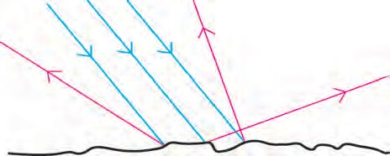

i1

r1

i3 r3

i2 r

2

* 1. **Reflection of light from a smooth and**

1 2

i ,. and their angles of reflection are r , r , r

**a rough surface**

3 1 2 3

respectively then, i1= i2 = i3 ....= r1= r2= r3 ...... (fig. 16.4 a).

1. **Irregular reflection of light :** Reflection of light from a rough surface is called irregular reflection of light. In irregular reflection, the angles of incidence for parallel rays of incidence

are not equal and therefore their angles of reflection are also not equal i i i and

i1 = r1  r

3

2

 r .......

1 2 3

Thus, the reflected rays are not parallel to one another and spread over a large surface.

This is clear from figure 16.4 (b).



**Always remember**

1. Laws of reflection are followed in both regular and irregular reflection.
2. The reflection of light in irregular reflection has not been obtained because the laws of reflection are not followed but they are obtained because the surface is rough. (irregular).
3. In irregular reflection the angles of incidence at different points are different. But at any one point, the angles of incidence and reflection are equal, i.e i1=r1, i2=r2,...

Reflection of reflected light



**Can you tell?**

1. How do you see if the barber in a saloon has cut the hair on your neck properly or not?
2. What type of image do we see in a mirror? What happens to the left and right sides?
3. How do we see the image of the Moon in water?

In saloon, there are mirrors in your front and at back. The image of the back of your head is formed in the mirror at the back. The image of this image is formed in the mirror in front of you. Thus you can see how the hair at the back side of your head is cut.

How do we see the image of the Moon in water? As moon is not self luminous, the Sun light falling on the surface of the Moon is reflected. This reflected light is again reflected by water to give us the image of the Moon. In this way light can be refleted serveral times.

**Kaleidoscope**

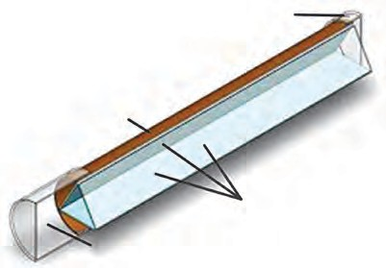

See through this

Cardboard tube

Mirrors

Cap for closing



**Try this**

**Activity :**

* 1. **Kaleidoscope**

1. Take three rectangular mirrors of the same size.
2. Using sticking tape, stick the mirrors together making a triangle with the reflecting surface facing inwards (see figure16.5)
3. Take a white paper of triangular shape and fix it with tape at one end of the mirrors closing that end.
4. Insert 4-5 coloured glass pieces in the hollow of the mirrors.
5. Close the other end also with a paper and make a hole in it.
6. Look through the hole towards light. You will see innumerable images of the glass pieces. These are formed due to reflections by the three mirrors.

You can see diferent designs in the Kaleidoscope. The speciality of a Kaleidoscope is that the designs do not easily repeat themselves. Every time the design is different. People making wall papers which are used to decorate walls and cloth designers use Kaleidoscope for making new designs.

Periscope :

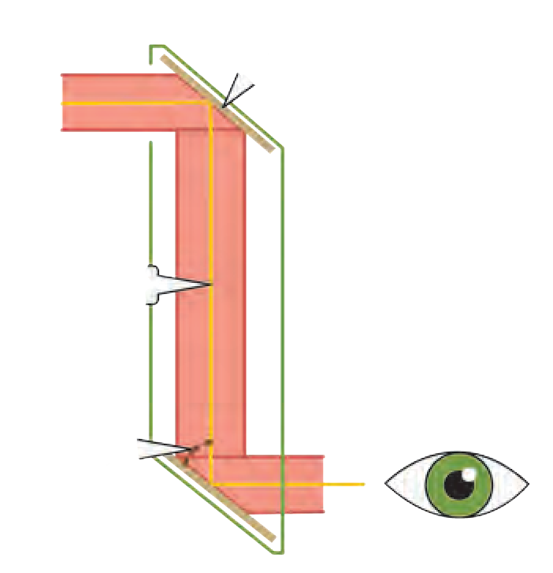

Mirror

Light ray

450

angle

**16.6 Periscope**

**Activity :**

1. Take a cardboard box. Make slits in the top and bottom sides of the box and place the two mirrors so that they make an angle of 450 with the sides of the box and are parallel to each other. Fix them with sticking tape (see figure 16.6).
2. Make two windows of 1 inch each near the two mirrors. Now see through the bottom window.
3. Make note of what you see.

From the bottom window, one can see what is in front of the top window. This device is called a periscope. This is used in submarianes to see objects above the surface of water. It is also used to observe and keep a watch on the objects or persons on the ground from an underground bunker. Kaleidoscope and Periscope both use the properties of reflection of light.

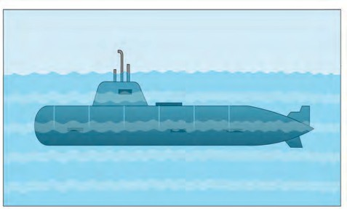

Periscope

**16.7 Periscope on a Submarine**

Solved Example

1. If the reflected ray makes an angle of 600 with the nomal, what angle must the incident ray make with the normal?

Given :

Angle of reflection = r = 600. Angle of incidence = i = ?

According to the law of reflection,

i = r But r = 600

 i= 600

The incident ray will make an angle of 600 with the normal.

1. If the angle between the incident ray and the reflected ray is 900, what are the values of the angle of incidence and angle of reflection?

**Given :** Angle between the incident ray and the reflected ray is 900.

i.e. i + r = 900 (1)

According to the law of reflection,

i = r (2)

i + i = 900 2 i = 900

 i= 450

Angle of incidence and reflection are 450.

1. The angle between the plane mirror and incident ray is 350, what is the angle of incidence and angle of reflection?

**Given :** In figure 16.2, line PQ = mirror ray AO = incident ray, line ON = normal ray OB = reflected ray.

From the figure POA = 350

PON = 90 (normal)

POA + AON = PON 350 + AON = 900

AON = 90-35 = 550

Thus, the angle of incidence AON = i = 550.

As, according to the law of reflection, i =

r

r = 550. angle of incidence and angle of reflection are 550

1. What angle will the reflected ray make with the mirror if the angle of incidence is 400 ?

**Given :** From figure 16.2.

QON = 900 (normal)

Angle of incidence = i = 400.

NOB = r = 400 - (according to the law of reflection)

NOB + QOB = QON 400 + QOB = 900

QOB = 900 - 400 = 500

The reflected ray will make an angle of 500 with the mirror.

* 1. **Fill in the blanks**



**Exercises**

* + 1. The perpendicular to the mirror at the point of incidence is called............
    2. The reflection of light from a wooden surface is. reflection.
    3. The working of Kaleidoscope is based on the properties of ..............
  1. **Draw a figure describing the following.** The reflecting surfaces of two mirrors make an angle of 900 with each other. If a ray incident of one mirror has an angle of incidence of 300, draw the ray reflected from the second mirror. What will be its angle of reflection?
  2. **How will you explain the statement ‘we cannot see the objects in a dark room’?**
  3. **Explain the difference between regular and irregular reflection of light.**
  4. **Draw a figure showing the following.**

1. Incident Ray
2. Normal
3. Angle of incidence
4. Angle of reflection
5. Point of incidence
6. Reflected ray
   1. **Study the following incident.**

Swara and Yash were looking in a water filled vessel. They could see their images clearly in the still water. At that instant, Yash threw a stone in the water. Now their images were blurred. Swara could not understand the reason for the blurring of the images.

Explain the reason for blurring of the images to Swara by answering the following question.

* + 1. Is there a relation between the reflection of light and the blurring of the images?
    2. Which types of reflection of light can you notice from this?
    3. Are laws of reflection followed in these types of reflection?
  1. **Solve the following examples.**

1. If the angle between the plane mirror and the incident ray is 400, what are the angles of incidence and reflection?

**(Ans. 500)**

1. If the angle between the mirror and reflected ray is 230, what is the angle of incidence of the incident ray?

**(Ans. 670)**

**Project :**

Apollo astronauts who stepped on the moon have kept some large mirrors there. Collect information about how the distance to the moon is measured using these.

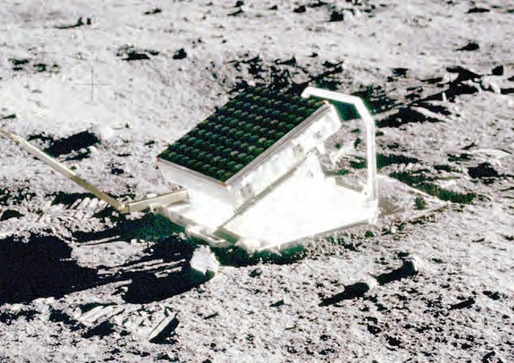





115



**17. Man made Materials**

**Can you tell?**

Make a list of 20 different manmade materials present in your home, school and places around and discuss.

We use various types of materials in our daily life. Those materials are made up of various materials like wood, glass, plastic, thread, soil, metals, rubber, etc. Out of those, wood, rock, minerals, water are natural. Human performed research on various natural materials in laboratory. With the help of it, various materials are manufactured in factories. Such materials are called as manmade materials. eg. Glass, plastic, artificial threads, thermocol, etc.

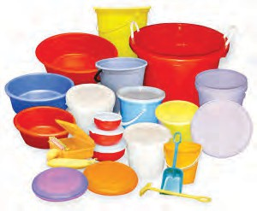Classify and make a chart of the materials used in various items in house. Make additions to that chart with reference to various materials.



**Collect information**

|  |  |  |
| --- | --- | --- |
| **Name of item** | **Material used** | |
| **Manmade** | **Natural** |
| Wooden chair |  | Wood |
| Comb | Plastic |  |

Plastic

A manmade material showing the property of plasticity and made up of organic polymers is plastic. Structure of all the plastics is not same. Some are linear while some are circular.

Depending upon the effect of heat, plastic can be classified into two types. The plastic that can be molded as per our wish is called as thermoplastic. eg. Polythene, PVC are used for manufacturing the toys, combs, plates, bowls etc. Another plastic is such that once a specific shape is given with the help of mold, its shape cannot be changed on heating. It is called as thermosetting plastic. eg. Electric switches, coverings over the handles of cookers, etc.

* 1. **Plastic material**

**Use of Information Technology**

Make a collection of various videos on process of plastic production. Using those videos, make a presentation with the help of your teacher and send it to other through email and other applications.



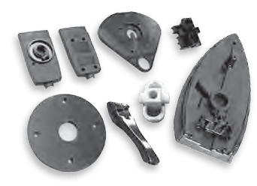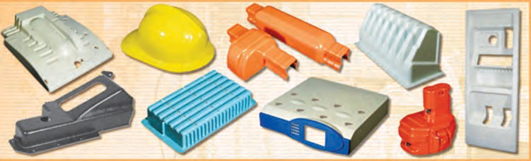

* 1. **Thermoplastic 17.3 Theromosetting plastic**

**Properties of Plastic:** Plastic does not corrode. It does not decompose. It is not easily affected by humidity, heat, rain, etc. Items of any colour can be made from it. It can be molded into any shape due to the property of plasticity. It is bad conductor of heat and electricity. Being light in weight, it is easy to carry.

Types and uses of the plastic

|  |  |
| --- | --- |
| **Thermoplastic** | |
| 1. Polyvinyl chloride (PVC) | Bottles, raincoat, pipes, handbags, shoes, electric cable insulation, furniture, ropes, toys, etc. |
| 2. Polystyrene (PS) | Thermo-insulating parts of electric appliances like refrigerators, gears of machines, toys, protective coverings like covers of CD and DVD, etc. |
| 3. Polyethylene (PE) | Milk bags, packing bags, flexible garden pipes, etc. |
| 4. Polypropylene (PP) | Parts of loudspeakers & vehicles, ropes, mattresses, laboratory appliances, etc. |

|  |  |
| --- | --- |
| **Thermosetting plastic** | |
| 1. Bakelite | Cabinets of radio, T.V., telephones, electric switches, toys, coverings over handles of cookers, etc. |
| 2. Melamine | Domestically useful items like cup – saucers, plates, trey, some spare parts of airplane engines, electric and sound insulating coverings, etc. |
| 3. Polyurethane | Surfing boards, small boats, furniture, seats in vehicles, etc. |
| 4. Polyester | Fiber glass, toners of laser printers, textile industry, etc. |

* + 1. Why are the plastic tanks used for storage of chemicals?



**Think about it.**

* + 1. Why most of domestically useful items are replaced by plastic?

Plastic and environment



**Do you know?**

1. Plastic is used in healthcare sector e.g. syringes.
2. Vessels used to cook food in microwave oven are made up of plastic.
3. Vehicles are coated with Teflon to protect from scratches. Teflon is a type of plastic.
4. There are more than 2000 different types of plastics.
5. Some types of plastic are used in assembling some parts of aeroplane.
6. Polyacrylic is a type of plastic used for manufacturing lenses & artificial teeth.
7. How many plastic carry bags are brought in your home in a day? What happens to those later on?
8. How are the used up and thrown away carry bags, water bottles, milk bags recycled?

Some materials are naturally degraded, they are called as degradable materials while some materials do not; called as non-degradable material. From the given on next page chart, we can understand that plastic is non- degradable and hence it is an environment pollutant. Which measures can we arrange to avoid this?

|  |  |  |
| --- | --- | --- |
| Material | Degradation period | Type of material |
| Vegetable | 1 – 2 weeks | Degradable |
| Cotton cloth | 1 year | Degradable |
| Wood | 10 – 15 years | Degradable |
| Plastic | Thousands of years | Non-degradable |

We should opt for the items made up of degradable material instead of plastic. Eg. jute bags, cloth bags, paper bags, etc.



**Always remember**

Each responsible citizen should follow the 4R principle; i.e.

Reduce- Minimal use Reuse- Use again

Recycle- Use again after processing Recover- Reclaiming

Then only we can save the environment from pollution.

Make a list of items in your house those can be made up of degradable material instead of plastic, where you can use. Discuss this in your classroom.



**Can you tell?**



**Make a list and discuss**

Which material is wrapped around the items of glass or similar material during transport to prevent from breaking up?

**Thermocol :** A new, easily breakable item brought at your home is usually packed in a box. So as to prevent that item from breaking while handling the box, it is always packed in one more wrapping. Usually, that wrapping is of thermocol. Now a day, the plates used in mass feasts are also made up of thermocol.

Thermocol is a form of a complex material called polystyrene. It transforms in to liquid state on heating at more than 100 ºC temperature and returns to solid state on cooling. Due to this, we can give any desired shape to it. Being a good shock-absorber, it is used in packing of delicate items.

Make list about use of thermocol in your daily life.

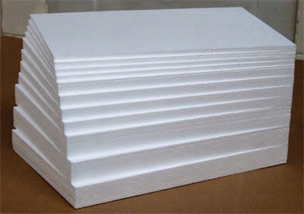Adverse effects of excessive use of thermocol on environment and human:

1. Being carcinogenic ingredients in styrene, the person in contact with thermocol for long duration may have the possibility of blood cancer like leukemia and lymphoma.
2. 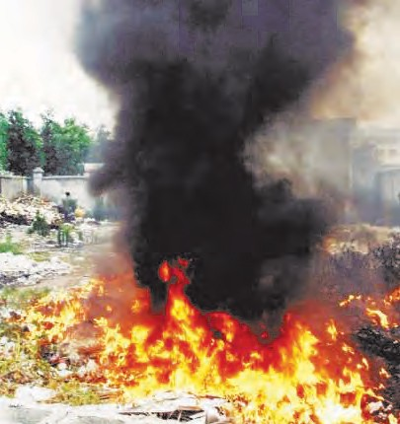**Non-biodegradable :** It takes long duration for natural degradation of thermocol; hence many people opt for destroying it by burning. However, it is still more hazardous method as it releases poisonous gases in atmosphere.
3. In mass gatherings, plates and cups used to offer the food, water, tea are made up of thermocol. It affects the health. If the food kept in thermocol is reheated, styrene may dissolve in that food. Due to this, there is possibility of health problem.
   1. **Thermocol combustion and pollution**
4. **Effect on persons working in thermocol factory :** Persons staying in contact with thermocol for long term may develop the problems of eyes, respiratory system, skin, digestive system, etc. Pregnant women may face the miscarriage. Liquid styrene may cause skin-burns.



**Make a list and discuss**

Make a list of glass items of daily use. Glass of which different colours is used in those items?

**Glass :** We use the glass material on large scale in our daily life. Glass was discovered by chance. Some Phoenician traders were cooking in desert. The cooking vessels were supported on lime-stones. When the cooking vessel was kept off the lime-stone, they observed that a transparent material has been formed. They thought that this transparent material may had been formed due to heating together of sand and lime- stone. This led to the development of technique of glass production. Glass is the non-crystalline, hard but brittle solid material formed from mixture of silica and silicate. Silica i.e. SiO2 to which we refer to as sand. Depending upon the proportion of silica and other components in the glass; there are

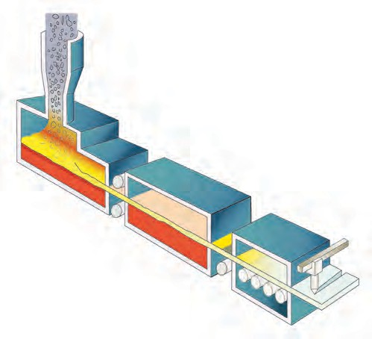

raw material

Furnace

glass strip

Molten glass

roller

cutter

different types of glass as soda-lime glass, boro-silicate glass, silica glass, alkali- silicate glass, etc.

* 1. **Glass manufacturing process**

**Production of Glass :** For glass production, mixture of sand, soda, lime, and small quantity of magnesium oxide is heated in furnace. Sand i.e. silicon dioxide melts at 1700 0C. So as to melt the mixture at low temperature, pieces of discarded glass are added to it. Due to this, mixture melts at 850 ºC. Once all the ingredients of mixture are liquified, it is heated up to 1500 ºC and immediately cooled. Due to sudden cooling, mixture becomes homogenous, amorphous and transparent instead of crystalline. This is called Soda-lime glass.

**Internet My Friend :** See the video of bangle making on internet, note the information and read out in classroom.

Properties of Glass :

1. On heating, glass becomes soft and can be moulded into any shape.
2. Density of glass depends upon its ingredients.
3. Glass is slow conductor of heat. On quick heating of cool glass or on quick cooling of hot glass, it cracks / breaks.
4. Being bad conductor of electricity, glass is used as insulator in electric appliances.
5. Being transparent, most of light passes through the glass. However, if there are oxides of either chromium, vanadium or iron in the glass, large amount of light is absorbed in glass.

Types of Glass and Uses:

**Effect of glass on environment :**

1. While glass production, mixture needs to be heated up to 1500 ºC. During this, green

house

dioxide,

gases

like

nitrogen

carbon dioxide are

sulphur dioxide,

released

through burning of fuel.

2. As the glass is non-degradable, if pieces of the waste glass material flow into water body, it may affect that ecosystem. Similarly, drainage may be blocked due to these pieces.

1. **Silica glass :** This is produced by using the silica. Items made up of silica glass show minimum expansion on heating. It is not affected by acid and alkali. Due to this, silica glass is used to produce laboratory glass-wares.
2. **Borosilicate glass :** Borosilicate glass is produced by melting the mixture of sand, soda, boric acid and aluminium oxide. This glass does not show any effect on medicines. Hence, the bottles made up of borosilicate glass are used in pharmaceutical industry to store the medicines.
3. **Alkali silicate glass :** Alkali silicate glass is produced by heating the mixture of sand and soda. As this glass is soluble in water, it called as 'water glass'.
4. **Lead glass :** Lead glass is produced by melting the mixture of sand, soda, limestone and lead oxide. Being very clear / transparent, it is used in manufacturing of light bulbs, tubes, etc.



**Collect information**

1. To prevent the degradation due to sunlight, some materials are stored in which type of bottles?
2. Which type of glass is used in

vehicles accidents?

to

avoid injuries in

1. **Optical glass :** Optical glass is produced from the mixture of sand, soda, limestone, barium oxide and boron. This type of pure glass is useful in production of spectacles, lenses, microscopic lenses, etc.
2. **Coloured glass :** Soda lime glass is colorless. So as to impart a desired colour, oxide of specific metal is mixed during manufacturing process. eg. Ferrous oxide is mixed to get bluish green glass and copper oxide to get red glass.



**Try this**

Perform the activity of forming the bent tube under the supervision of your teacher.

1. **Processed glass :** So as to improve the quality and utility, some processing is performed on glass and various types like reinforced glass, plain glass, fiber glass, fen glass, translucent glass, etc. are produced.

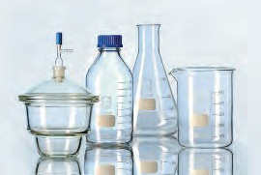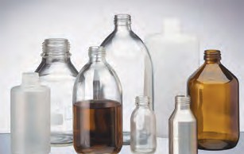

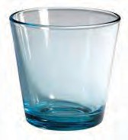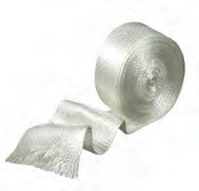

* 1. **Different types of glass and glasswares**



**Exercises**

* 1. **Try to find it.**
     1. Plastic shows property, hence it can

be moulded to any shape.

* + 1. Motor cars are coated with .......
    2. Thermocol melts at ºC.

d glass dissolves in water.

* 1. **Who is my partner?**

**‘A’ column ‘B’ column**

* + 1. Lead glass i. Plates
    2. Bakelite ii. Mattresses
    3. Thermocol iii. Electric bulb
    4. Optic glass iv. Electric switch
    5. Polypropylene v. Lens
  1. **Answer the following.**
     1. Thermocol is produced from which material?
     2. Write uses of PVC.
     3. Write the natural or manmade raw material of the following items. Mattress, glass vessel, bangle, chair, gunny bag, broom, knife, pen.
     4. Which are the main ingredients of glass?
     5. How the plastic is produced?
  2. **Distinguish between.**

a. Man made material and natural material b. Thermoplastic and thermosetting plastic.

* 1. **Answer the following in your own words.**
     1. Explain the effect and remedial plans of following materials on environment and human health.
        1. Plastic
        2. Glass.
        3. Thermocol.
     2. Which measures will you arrange to minimize the environmental problems arising due to non-degradable plastic?
  2. **Write short notes.**
     1. Glass production.
     2. Optic glass
     3. Uses of plastic.

**Project :**

* + - 1. Collect the information about the plastic used in production of utensils used in microwave oven.
      2. Collect the information about the material used in production of denture.

( A set of artificial teeth)



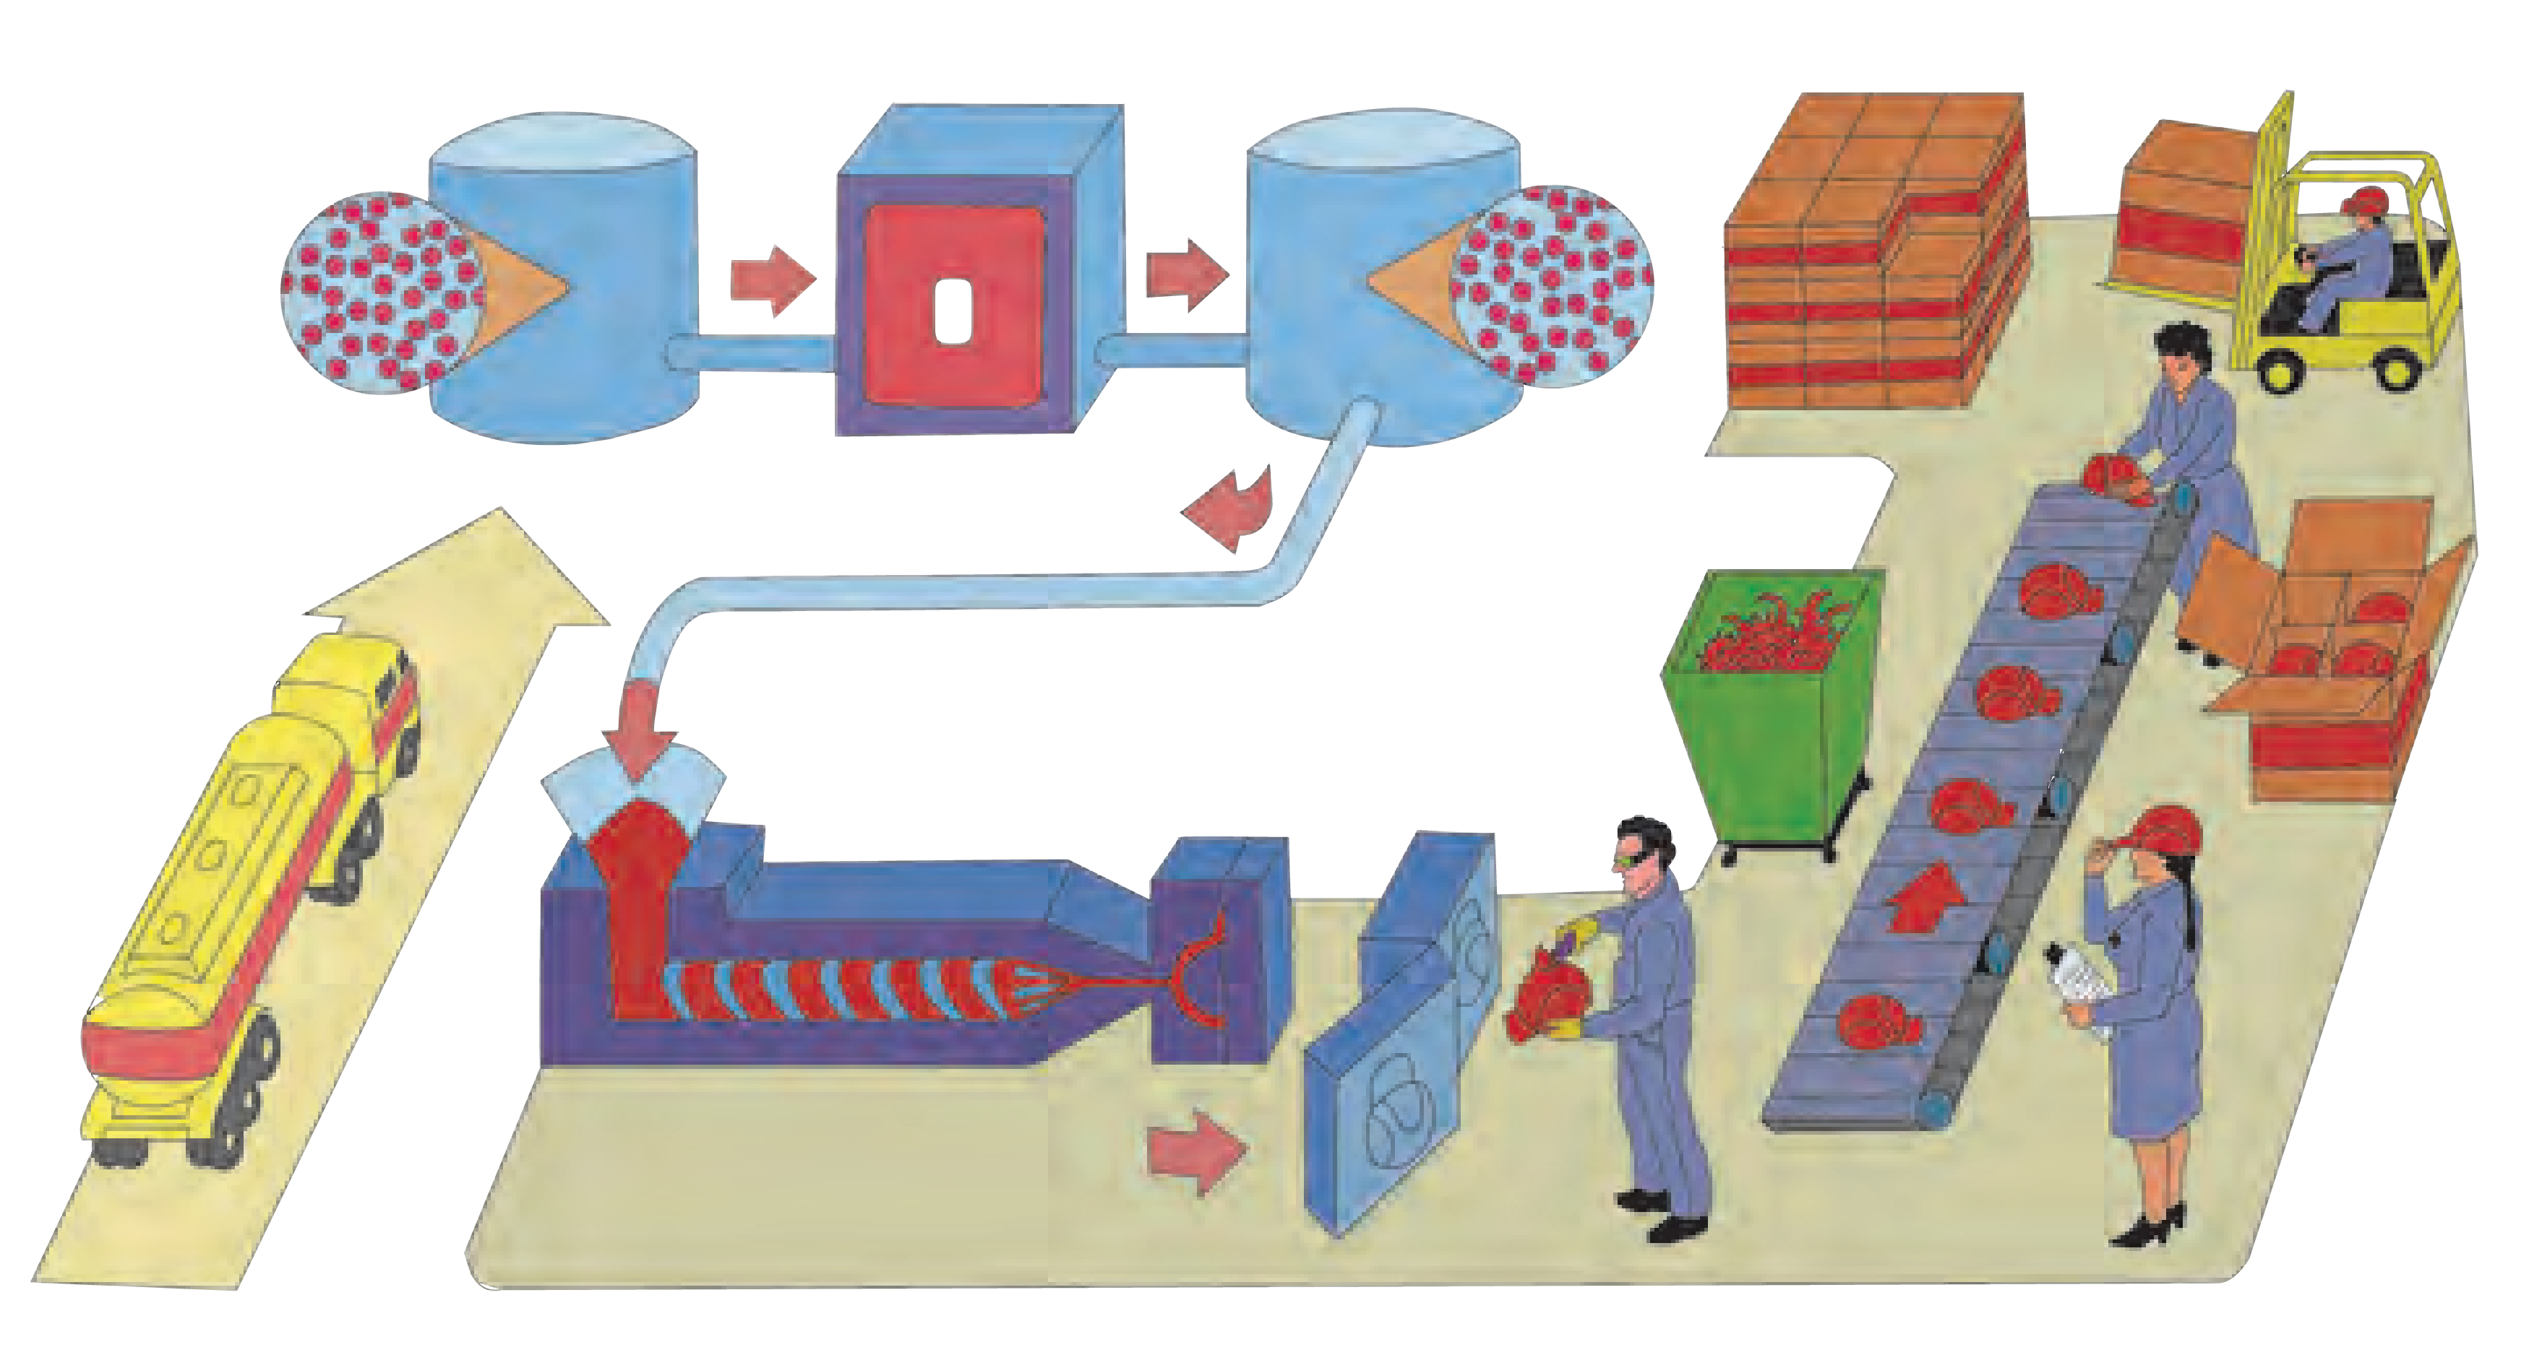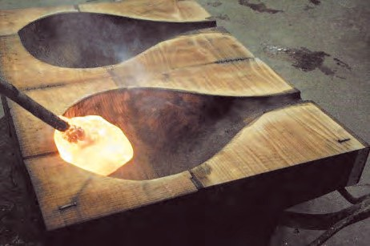

**Field Visit : Visit plastic/glass factory near by your place, collect the information on production process and prepare the report**



**18. Ecosystems**

* + - * 1. Which factors do you found in your surrounding?



**Can you recall?**

* + - * 1. Are these factors directly or indirectly related to you ?



**Classify**

Classify the following into living and non-living factors.

Sunlight, sunflower, elephant, lotus, algae, stone, grass, water, ant, soil, cat, fern, air, lion.

**Ecosystem :** The world around us is made up of living and non living factors. Living are called biotic factors while non living are called abiotic factors. There is a continuous interaction between these living and non living factors. Living organisms and their habitat, environment are corelated with each other.

The structure which is formed due to these reciprocal relationships is called an ecosystem. Biotic and abiotic factors and their interactions form an ecosystem.



Ecosystem

Abiotic factors

Chemical

Air, water, vapour, minerals, soil, Sunlight

Heterotrophic

Hydrogen, Oxygen, Nitrogen, Calcium, Iron, Potassium, Sodium

Proteins Carbohydrates Lipids

Tertiary

Consumers

Secondary Consumers

Primary

Consumers

Organic subtances

Inorganic subtances

Microbes

Animals

Plants

Decomposers

Consumers

Producers

Physical

Biotic factors



**18.1 Components of Ecosystem**

**Do you know?**

The organic substances (carbohydrates, proteins and lipids) from dead bodies of plants and animals are converted into inorganic substances (hydrogen, oxygen, calcium, iron, sodium, potassium etc.) by microorganisms. Therefore, microbes are said to be 'Decomposers'.

**Structure of an ecosystem :** Living organisms need different types of abiotic factors and they have different capacities to adapt with those abiotic factors. Some microbes need oxygen, while others don’t. Some plants need more sunlight, while others grow well in shade.

Each and every abiotic factor (air, water, soil, sunlight, temperature, humidity) affects the biotic factors in the ecosystem. The abiotic factors in an ecosystem decide which biotic factors will survive in it and what will be their number. The proportion of abiotic factors in an ecosystem is always changing as biotic factors use or excrete abiotic factors. Every biotic factor affects abiotic factors as well as other biotic factors around it. Every living organism in an ecosystem plays a particular role while living, moving in that ecosystem.

The position of any living organism in context to other living organisms and the role it is playing is called 'Niche'. Eg. A sunflower plant in a garden evolves oxygen in the air and

provides food and shelter for insects like ants, honey-bees etc.

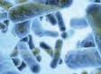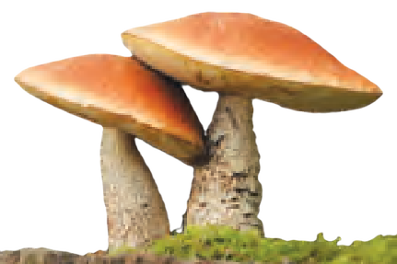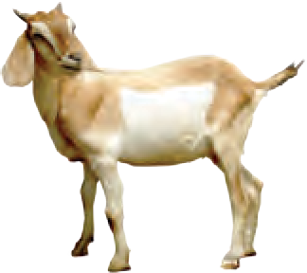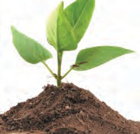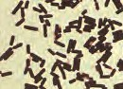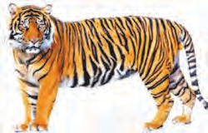

**Abiotic Factors**

Heat

Nutrients, solar energy, CO ,

**Biotic Factors**

Plants (producers)

2

nitrogen, water, minerals etc

Photosynthesis

Food production

Heat

Heat

Free minerals are recycled

Animals consume food from plants

**Microbes**

(Decomposers)

Heat

**Biotic factors** (primary, secondary, tertiary consumers)

Minerals are released

Decomposition of dead bodies

Heat

* 1. **Interactions among factors of an ecosystem**
     1. What is the role of microbes in above interaction ?



**Can you tell?**

* + 1. How do producers obtain abiotic factors?
    2. From where do the consumers get their food ?

Most of the ecosystems are complex and there is tremendous quantitative and qualitative variety of species in them. In ecosystems of tropical country like India, few species of living organisms are found every where in a large number. Remaining species of plants and animals are found in a small number. Some species are very few in number.Variety of ecosystems is found on earth. Each place has a different ecosystem. eg. Forest, pond, ocean, river etc. Types of ecosystems are formed according to size, place, climate, types of plants and animals.

Many types of ecosystems are found in biosphere. Their specific functions continue according to their environment. Though these ecosystems look independent and different they are linked to each other directly or indirectly. Therefore we can not separate these small ecosystems from each other, but can classify them according to their functions.

In some regions on earth, a large area has same climate and abiotic factors. The living organisms in those area are also similar. So a specific ecosystem developes in a vast area. Such large ecosystems are called 'Biomes'. These biomes contain many small ecosystems. Earth itself is a vast ecosytem.Two types of biomes are found on the earth. i. Land biomes ii. Aquatic biomes

**Looking back**

New words are created with the developement in science. Same is the case with the word ecosystem. ''How can we describe the inter relationship between physical and biological factors in one word ?'' In 1930, this question was asked to a scientist Ray Claffam. 'ecosystem' was his answer. His colleague A.G. Tansle used this word in 1935. 'Biotic community' is another name for 'ecosystem.'

**Land biomes :** The biomes which exist only on land are called land biomes. Due to unequal distribution of abiotic factors different types of ecosystems exist. Eg. Grasslands, evergreen forests, deserts, iceland ecosystem, ecosystems in Taiga, tropical rainforests etc.

1. 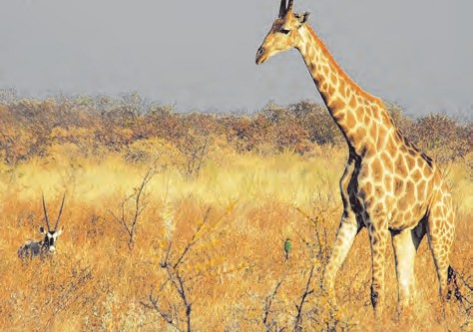**Grassland Ecosystem :** Grasslands develop where rainfall is not enough to grow big trees. Vast growth of grass is found in these ecosystems. Longer summer and limited rain develop dwarf plants in these areas. Animals like goat, sheep, giraffe, zebra, elephant, deer, chital, tiger, lion, etc. are found in this ecosystem. Similarly various birds, insects, microbes are also present.



**Collect information**

* 1. What are the possible threats to grasslands?
  2. Why did Asian Cheetah become extinct in last century?
  3. Observe Asian Cheetah on internet? describe it.
  4. **Grassland**

Complete the following chart in context to a grassland.



**Complete the table**

|  |  |  |  |  |
| --- | --- | --- | --- | --- |
| **Producers** | **Primary consumers** | **Secondary consumers** | **Tertiary consumer** | **Decomposers** |
| *Parthenium, Cynodon, Kusali* | Cow, deer, rabbit,  *Leptocorsia*, | Snakes, Birds, Jackals, Wolf, | Lion, Hyena, Vulture, Kite, | *Fusarium Aspergillus* |



**Do you know?**

About 150 years ago, Dudhwa forest was the habitat for single horned Rhino. But in 20th century this animal became extinct due to unrelenting hunting. On 1st April 1984 this rhino was restored there. They were bred in captivity and then released in their habitat. For this 27 square km grassland and forest where round the year water sources were available were selected. Two observatories were established. These efforts are successful.

Can we call a tree an independent ecosystem ?



**Complete the table**



**Think about it.**

1. **Evergreen forests :** Its a natural ecosystem where variety of plants, animals and abiotic factors is found.

|  |  |
| --- | --- |
| **National park/**  **Sanctuary** | **State** |
| 1. Geer |  |
| 2. Dachigam |  |
| 3. Ranthambore |  |
| 4. Dajipur |  |
| 5. Kaziranga |  |
| 6. Sunderban |  |
| 7. Melghat |  |
| 8. Periyar |  |

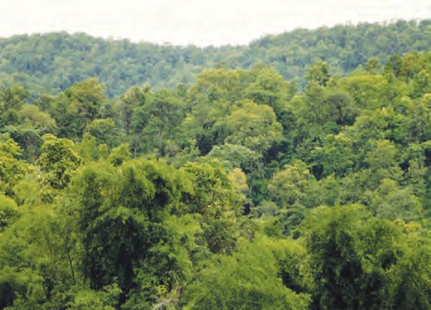

* 1. **Forest ecosystem**

Write the information about various components of forest.



**Complete the table**

|  |  |  |  |  |  |
| --- | --- | --- | --- | --- | --- |
| **Producers** | **Primary consumers** | **Secondary consumers** | | **Tertiary consumers** | **Decomposers** |
| Dipterocarpus, Teak, Pine, Sandalwood | Ant, Grasshopper, Spider, Butterfly | Snake, Bird Lizard, Jackal | | Tiger, Falcon Cheetah | *Aspergillus, Polycarpus* |
|  |  |
|  |



**Do you know?**

* Many ecosystems are conserved in around 520 sanctuaries and national parks in India.
* The Great Himalayan National park is the largest sanctuary where white panther, a rare species is conserved.
* Elephants, wild bears, wild buffalloes, deers, tigers, panthers are conserved at Kaziranga (Asam). Two third of the total number of single horned rhinos in the world is found at kaziranga.
* The sanctuary at Bharatpur is famous for aquatic birds.
* Ranthambore sanctuary is famous for tigers.
* Geer forest in Gujrat is the only habitat/shelter for the spectacular Asiatic lion.

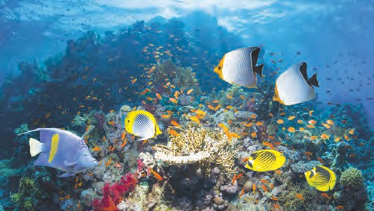**Aquatic ecosystems :** 71 % of the earth surface is covered by water and only 29 % has land on it. Therefore study of aquatic biomes becomes very important. According to area, aquatic biomes are widespread. Types of aquatic ecosystems are - Fresh water ecosytem, marine ecosystem, creek ecosystem.

* 1. Aquatic ecosystem

1. **Fresh water ecosystem :** Ponds, lakes and rivers are included in aquatic ecosystems. The transition of energy in these ecosystems is through water currents and river. Decomposers are at the bottom of water reservoirs. They decompose dead bodies of plants and animals convert into abiotic factors. Oberve such ecosystems arround you and complete the following chart.

|  |  |  |  |  |
| --- | --- | --- | --- | --- |
| **Producers** | **Primary**  **Consumes** | **Secondary**  **Consumes** | **Tertiary**  **Consumes** | **Decomposers** |
| Aquatic plants, *Ulothrix, Hydrilla, Azolla, Nitella, Typha, Pistia, Eichhornia,* | Aquatic insects, Snails, Annelids, | Small fishes, Frogs | Large fishes, Herons, Crocodiles | Bacteria, fungi, |

Are the local ecosystems like river, ponds, lakes safe ?



**Discuss**

1. **Marine Ecosystems :** Marine plants grow in these ecosystems. Shallow water contains small fishes, prawns feeding on algae. The central part of sea has less number of aquatic living organisms. Large fishes are secondary consumers. Ocean has a large amount of nutrients. The bottom of oceans has more number of decomposers. Dead bodies of plants and animals, waste materials are decomposed by bacteria.

**Internet My Friend** 1. Collect the information about mishaps in aquatic ecosystems occurred due to human interference.

2. How is Creek different from Sea?

Diminishment of ecosystem due to human



**Think about it.**

Today Divija visited a hill. Honey- bees were hovering on flowers. One of them stung Divijias hand. Divija was hurt due to that sting and said with anger that all the honey-bees from the whole world must get destroyed. Afterwords, she thought what will happen if all honey-bees are destroyed ? We won’t get honey, Nothing more. What would be

your explaination to Divija ?

**interference :** Many human activities have side effects on functions of ecosystems and cause their diminishment. Eg. mining and excessive cutting of trees changes the use of land, so interactions between biotic and abiotic factors are also affected.

Different human activities have different effects on ecosystems. They can be tranformation of an ecosystem from one to

another or extinction of a species.

Human activities responsible for diminishment of ecosystems

**Increasing use of resources due to increased population :** Humans are the consumers in an ecosystem. Ecosytems can provide basic needs in normal conditions, but due to increased population, man kept on snatching natural resources on large scale. Changing life style demands ‘more’ than 'necessary'. That has increased stress on the ecosystems and has generated vast amount of wastes.

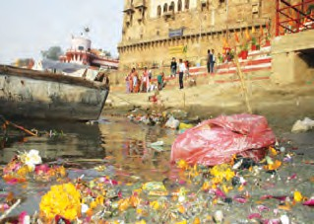

* 1. **Diminition of ecosystem**

**Urbanization :** Due to continuous process of urbanization. More and more agricultural lands, marshlands, wetlands, forests and grasslands are being destroyed for buildings and other basic facilities around. As a result of this human interference, ecosystems either change or get

completely destroyed.

**Industrialization and traffic :** Raw materials required for industrialization are obtained by destroying forests. This result in destruction of forests.

To provide the amenities for increased traffic, many times roads and railways are built through forests and wetlands.

**Tourism :** People visit scenic places mainly for nature watch, entertainment and visit to sacred places. A lot of ameneties are created for these tourists. This causes destruction of local ecosytems due to increased stress.



**Collect information**

Visit any tourist centre nearby. Collect information about effect of tourism on the ecosystem there.

**Large Dams :** Dams cover vast lands. So the forests or grassland in that area get converted into aquatic ecosystems. Dams also lessen the water current in lower area. Therfore the previous ecosystems in that running water get destroyed.

* + 1. Which biotic factors get affected due to a dam ?



**Use your brain power**

* + 1. What will be the effects on biotic factors in the running water of river ?

**Wars :** Differences and competition over land, water, mineral resources or some economic and political reasons lead to war among human races. Heavy bombing and mine explosions are done in wars. These are not only life threatening but also change or destroy natural ecosystem.

Thus natural disasters (earthquake, volcano, floods, droughts) and human interferences result in changes/destruction of ecosystems.

Natural ecosystems must be protected as they maintain balance in the biosphere.



**Exercises**

1. **Complete the following by using cor- rect option.**
   1. Air, water, minerals, soil are............... factors of an ecosystem.

(physical, organic, inorganic)

* 1. River, ponds, ocean are ............... ecosystems.

(land, aquatic, synthetic)

* 1. Man is in an ecosystem.

(producer, consumer, decomposer)

1. **Match the following**

Producers Ecosystem

* 1. Cactus 1. Forest
  2. Aquatic plants 2. Creek
  3. Mangroves 3. Aquatic
  4. Pine 4. Desert

1. **Give my information**

a. Ecosystem b. Biome c. Food web

1. **Give scientific reasons**
   1. Plants in an ecosystem are called consumers.
   2. Large dams destroy ecosystems.
   3. Rhinos were restored in Dudhwa forest.
2. **Answer the following.**
   1. What are the effects of icreased population on ecosystems ?
   2. How is urbanization responsible for destruction of ecosytems ?
   3. What are the reasons for war ?
   4. Explain the interactions among the factors of an ecosystem.
   5. Differentiate between evergreen forests and grasslands.
3. **Describe the following pictures.**

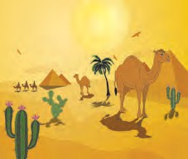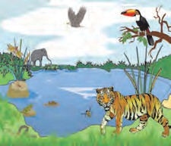

**Project :**

1. Visit an ecosystem nearby, List the biotic and abiotic factors in it. Show with pictures or sketches, how they are dependant on each other.
2. With the help of internet find out the loss of ecosystems due to wars or atomic explosions. Describe in your words.





**19. Life Cycle of Stars**

* 1. What is a galaxy?



**Can you recall?**

* 1. What are the different constituents of our solar system?
  2. What are the major differences between a star and a planet?
  3. What is a satellite?
  4. Which is the star nearest to us?

We have learnt about the structure of the universe in earlier standards. Our solar system is situated in a galaxy. A galaxy is a collection of billions of stars, their planetary systems and interstellar clouds which are present in the empty spaces between stars. The universe is made up of innumerable such galaxies. Galaxies differ in structure and shape. We can divide them into three types : spiral, elliptical and irregular galaxies. Our galaxy is a spiral galaxy and is called the Milky Way and Mandakini. A spiral galaxy is show in figure 19.1

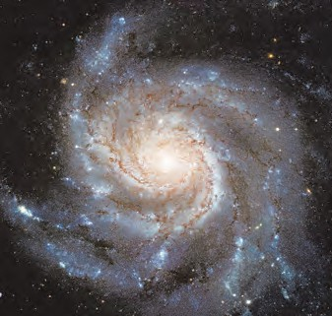How did we obtain all this information about the universe?

If we look at the sky at night we see only planets and stars, then how did we get information about the other components of the universe? The answer to the question is telescopes. Several telescopes are placed on the surface of the earth, while some others are kept aboard manmade satellites which are orbiting the earth in fixed orbits. As these telescopes are situated above the earth’s atmosphere they can observe astronomical objects more effectively. Astronomers study the observations made by all these telescopes to obtain detailed information about the universe.

* 1. **The figure shows a spiral**

**galaxy. Our solar system is situated in a similar galaxy.**

We are going to learn about all this in higher standards. Here, let us learn about the properties of stars and their life cycle.

**Properties of stars :** At night, we can see about 4000 stars with our naked eyes. Sun is an ordinary star among them. The reason to call Sun an ordinary star is that even though it appears to be larger than all others stars in the sky because of its being nearest to us, there are bilions of stars which have higher or lower mass size and temperature than those of the Sun. Stars are gigantic spheres of hot gas. Some properties of the Sun are given in the table below. Hydrogen makes up for 72% of the mass of the Sun while helium is 26%. The rest 2% is made up of elements heavier than helium.



**Do you know?**

Our galaxy has about 1011 stars. Its shape is like a disc with a bulge in the centre and its diameter is about 1018 km. The solar system is situated at a distance of 2  1017 km from its centre. The galaxy is rotating around an axis passing through its centre and perpendicular to the disc. Its period of rotation is about 2  108 yrs.

Properties of the Sun :

|  |  |
| --- | --- |
| Mass | 2 x 1030 kg |
| Radius | 695700 km |
| Surface temperature | 5800 K |
| Temperature at the centre | 1.5 x 107 K |
| Age | 4.5 x 109 yr |

The mass of the Sun is about 3.3 lakh times that of the earth and its radius is 100 times that of the earth. Other stars have



**Do you know?**

The masses of other stars are measured with respect to the mass of the Sun. This means that the mass of the Sun, written as MSun is used as the unit of mass.

masses between

1 ( MSun ) that of the Sun

10 10

and 100 times that of the Sun (100 MSun) and

their radii can between 1 to 1000 times the

10

radius of the Sun. (Fig. 19.2) The age of the Sun and other stars, which is the time elapsed after their formation, can be between a few million years to a few billion years. If the properties of the Sun had changed in its life time, it would have caused changes in the properties of the earth and in the life on the earth. Detailed studies of the properties of the earth have led scientists to conclude that the properties of the Sun have remained unchanged over its lifetime i.e. the past 4.5 billion years. According to the studies made

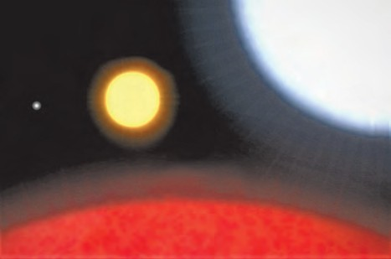

**Sun**

**White Dwarf**

**Super Giant**

**Star**

**Red Giant Star**

* 1. **A comparison of sizes of different stars**

Birth of stars

by astromomers, these properties will slowly change in further after 4.5 billion years.

Huge clouds of gas and dust are present in the empty spaces between stars in a galaxy. These are called interstellar clouds. Figure 19.3 shows a picture of such clouds taken by the Hubble space telescope. Scientists use the unit of light year for measuring large distances. **A light year is the distance travelled by light in one year.** As the speed of light is 3,00,000 km/s, the light year is equal to 9.5 x 1012 km. The sizes of interstellar clouds are about a few light years, i.e. light takes a few years to go from one end of a cloud to the other. From this you can imagine the huge size of the cloud.



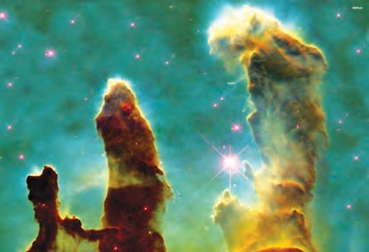

* 1. **A picture of interstellar clouds taken by the Hubble space telecope**

**Do you know?**

Due to some disturbance, these clouds start contracting. Because of the contraction, their density starts increasing and their temperature also starts to increase and a dense sphere of hot gas is formed from the cloud. Once the temperature and density at the centre of the sphere increase sufficiently, nuclear energy (energy generated through fusion of atomic nuclei) generation starts there. Because of this energy generation, the gas sphere becomes self luminous and a star is formed or we can say that a star is born. In the Sun, this energy is generated by the fusion of hydrogen nuclei to form helium nuclei. This means that the hydrogen at the centre of the star acts as a fuel and energy is generated by the burning of this fuel.

Light takes about 1 s to reach us from the moon while it takes 8 minutes to reach us from the Sun. It takes 4.2 years to reach us from the star alpha Centauri which is the star closest to the Sun.



**Do you know?**

When a gas sphere contracts, its temperature increaes. This happens because of transformation of its gravitational potential energy into heat energy.

More than one star can be produced by the contraction of a huge interstellar cloud. Figure

* 1. 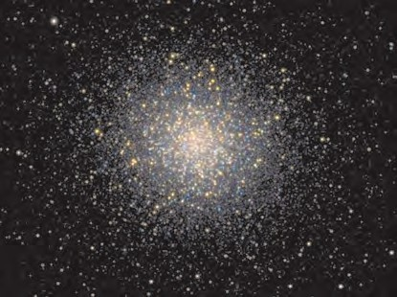shows a cluster of thousands of stars. Most of these stars have formed from a single gigantic interstellar cloud.



**Can you recall?**

What is meant by balanced and unbalanced forces?

**Stability of stars :** If we burn an incense stick in one corner of a room, the fragrance spreads all over the room instantaneously. Similarly, when we remove the lid of a vessel containing boiling water, the steam spreads in the surrounding region. This means that hot gas spreads everywhere. Then, why doesn’t the hot gas in the stars disperse in space? And why have the properties of the Sun remained unchanged over the last 4.5 billion years?

**19.4 : A large cluster of stars. Most of these stars have formed from a single interstellar cloud.**

The answer to these questions is the gravitational force. The gravitational force between the gas particles of the star keeps these particles together. If the gravitational force which is constantly trying to bring the gas particles close together and the pressure of the hot gas which is constantly trying do disperse the gas are balanced, then the star remains stable. The gravitatinal force is acting inwards, towards the centre of the star while the gas pressure is acting outwards, i.e. away from the centre of the star (see figure 19.5).

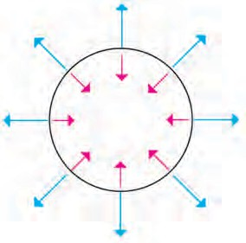

Pressure of hot gas

Gravitation



**Think about it.**

**Do you know?**

You must have played tug of war. In this, two ends of a rope are pulled on two sides by two groups. When the forces applied by both sides are equal, they balance each other and the centre of the rope remains static. When the force on one side of the rope is larger than that on the other side, the centre of the rope moves towards that side. Something similar happens in the case of a star. When the gravitational force and gas pressure are balanced, the star is stable. But when one of them is more than the other, the star either contracts or expands.

1. If there was no gas pressure in the Sun, it will collapse to a point in 1-2 hours.



1. Gas pressure depends on the density and temperature of the gas. Higher the temperature and density, higher is the pressure.

Evolution of stars

Evolution of a star means change in its properties with time resulting in its passing through different stages. We have seen that the properties of the Sun have not changed in the past 4.5 billion years. Stars evolve very slowly for most of their life time. As stars are continuously emitting energy, their energy is constantly decreasing.

For their stability to remain intact i.e. for maintaining a balance between the gas pressrue and the gravitational force, it is necessary that the temperature remains constant. For the temperature to remain constant, energy must be generated inside the star. This generation of energy occurs because of burning of fuel at the centre of the star. The reason for the evolution of stars is the burning of and therefore, the decrease in the amount of fuel in their centre. When the fuel in the centre finishes, the energy generation stops. As a result, the temperature of the star starts decreasing. Due to the decrease in temperature, the gas pressure decreses and the balance between gas pressure and gravitatinal forece cannot be maintained. As the gravtational force is now higher than the gas pressure, the star starts contracting. This causes another fuel to start burning e.g. when hydrogen at the centre is finished, helium starts undergoing fusion and energy generation starts again. How many fuels will be used depends on the mass of the star.

Higher the mass of the star higher is the number of fuels used. During this a lot of changes occur in the star. As a number of processes occur inside the star, it sometimes contracts and expands at other times and the star goes through different stages. When all possible fuels are exhausted, the energy generation finally stops and the temperature of the star starts decreasing. The balance between gravitational force and gas pressure cannot be maintained. Let us now see how the evolution of the stars ends and what the end stages of stars are.

**End stages of stars :** The higher the mass of the star faster is its rate of evolution. The different stages during the evolution of the star which is the path of evolution of the star, also depends on its mass. How does the evolution finally stop?

We have seen that when the energy generation stops, the temperature decreases causing the gas pressure to decrease. The star contracts and its density increases. When the density becomes very high, some new types of pressures are generated which do not depend on the temperature of the gas. In such case, the gas pressure remains constant even after the energy generation stops completely and the temperature of the gas goes on decreasing. The stability of the star can remain intact for ever and this can be considered as the end stage of a star.

There are three ways of evolution of stars depending on their initial mass. Thus, we can divide stars in three groups. The path of evolution and end stage for all stars in the same group is the same. Lets us learn more about it.

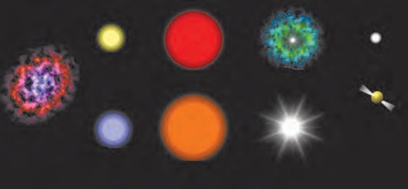

Low mass star

Red giant

Explosion

Interstellar cloud

Neutron star

High mass star

Super giant Supernova Black

explosion hole

White dwarf

Life cycle of stars

* 1. **Evalution of stars based on their mass and their end stages**

1. **End stages of stars having initial mass less than 8 time the mass of the Sun (Mstar < 8 MSun) :** Stars in this group undergo huge expansion and their radius increases by a factor of 100 to 200. In this stage they are called red giant stars. This name is given because of the large size and because of the fact that the stars look reddish due to their lower temperature. The size of a red giant star in comparison to other types of stars is shown in figure 19.2. At

the end of its evolution, these stars explode and their outer gas envelope is thrown out. The inner part contracts and its size becomes similar to the size of the earth. As the mass of the star is much higher than that of the earth and the size is similar to that of the earth, the density in the star becomes very high. In this state, the pressure due to the electrons in the star becomes independent of temperature and is able to balance the gravitatinal force for ever. In this state, the star looks white and due to its small size it is called a white dwarf. After this its temperature keeps decreasing but its size and mass remain unchanged for ever and so white dwarf is the end stage of stars in this mass range.



**is at the centre.**

**Do you know?**

When the sun will become a red giant, its diameter will increase so much that it will swallow Mercury and Venus. It is possible that the earth will also be absorbed by the Sun. It will take 4-5 billion years for the Sun to reach this state.

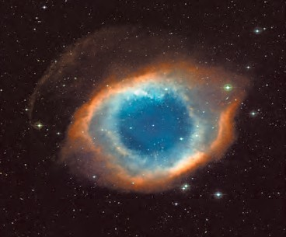

* 1. **: The outer gaseous envelop which is thrown out during the formation of a white dwarf which**

1. **End stages of stars having mass between 8 and 25 time the mass of the Sun (8 MSun < MStar < 25 MSun) :** These stars also go through the red giant stage and later through the supergiant stage during which their size may increase 1000 times. The huge explosion, called the supernova explosion, which occurs at last is very powerful and so much energy is given off that we can see the star during the day also.

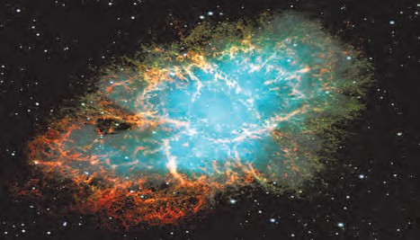The central portion which is left behind after the explosion, contracts and its size becomes as small as about 10 km. In this state, the stars are completely made up of neutrons and are called neutron stars. The pressure of these neutrons is independent of temperature and is capable of balancing the gravitatinal force for ever. Neutron star is the end stage of these stars.

* 1. **A recent picture of the supernova explosion which was first seen in 1054 A.D.**



**Do you know?**

1. As the size of the white dwarfs is similar to that of the earth, their density is very large. One spoonful material of the white dwarf will weight a few tons. As neutron stars are much smaller than the white dwarfs, their density is even higher and one spoonful material of these stars will weigh as much as the weight of all living beings on the earth.
2. A star in our galaxy exploded about 7500 years back. As the star is about 6500 light years away from us, the light emitted in the explosion took 6500 years to reach us. It was first seen on the earth by the Chinese in the year 1054. It was so bright that it could be seen during the day also for 2 years. After 1000 years of the explosion, the gases emitted during the explo- sion are seen to be expanding with velocities higher than 1000 km/s.
3. End stages of stars having mass larger than 25 times the mass of the Sun (Mstar > 25 MSun)

These stars evolve like the stars in the

second group but after the supernova explosion, no pressure is capable of balancing their huge gravitational force and they continue contracting for ever. As their size becomes smaller, their density and their gravitational force increase tremendously. All nearby objects get attracted towards these stars and nothing can come out of them, not even light. Also, any light falling



**Exercises**

1. **Search and you will find**.
   1. Our galaxy is called.........
   2. For measuring large distances. is

used as a unit.

* 1. The speed of light is km/s.
  2. There are about stars in our galaxy.
  3. The end stage of the Sun will be......
  4. Stars are born out of clouds.
  5. Milky way is a galaxy.
  6. Stars are spheres of gas.
  7. The masses of other stars are measured relative to the mass of the.............
  8. Light takes ................ to reach us from the Sun while it takes........... to reach us from the moon.
  9. The larger the mass of a star the faster is its.......
  10. The number of fuels used in the life of a star depends on its............

1. **Who is telling lies?**
   1. Light year is used to measure time.
   2. End stage of a star depends on its initial mass.
   3. A star ends its life as a neutron star when the pressure of its electrons balances its gravity.

on these stars does not get reflected and gets absorbed inside the star. Thus, we cannot see the star at all but can probably see a minute black hole at its place. This end stage of the star is therefore, called a black hole. Thus, we have seen that, depending on mass, there are three paths of evolution and three end stages of stars. These are shown in the following table.

|  |  |
| --- | --- |
| **Initial mass of the star** | **End stage of the star** |
|  8 M  Sun | White dwarf |
| Between 8 to 25 MSun | Neutron star |
| * 25 M   Sun | Black hole |

* 1. Only light can emit from the blank hole.
  2. The Sun will pass through the supergiant stage during its evolution.
  3. The Sun will end its life as a white dwarf.

1. **Answer the following question.**
   1. How do stars form?
   2. Why do stars evolve?
   3. What are the three end stages of stars?
   4. Why was the name black hole given?
   5. Which types of stars end their life as a neutron star?
2. **A. If you are the Sun, write about your properties in your own words.**

**B. Describe white dwarfs.**

**Project :**

1. Use your imagination and make models of the Milky Way and the solar system.
2. Write the effects : If the Sun disappears

..........





**Figures courtesy : ESO and Nasa**

Std 8th the last class in upper primary level. To prepare the students for next years internal practical work assessment and develope experimental skill, a sample list of experiments is given below. It is expected that these experiments must be perforemed according to the list.

|  |  |
| --- | --- |
| **Sr.**  **No.** | **Title of the Experiment** |
| 1 | To observe lactobacilli in curd/butter milk. |
| 2 | To observe fungus on the bread |
| 3 | To study balanced and unbalanced forces by using the materials available in day to day life |
| 4 | To study the types of inertia |
| 5 | To study Archimedes principle |
| 6 | To verify the magnetic effect of electric current |
| 7 | To prepare the compound iron oxide in the lab and to study its properties. |
| 8 | To perform a comparative study of physical and chemical properties of metals and nonmetals |
| 9 | To perform a comparative study of non-polluted and polluted water bodies in the surroundings |
| 10 | To study the model of human respiratory system |
| 11 | To study the structure of heart with the help of its model |
| 12 | To identify acids and bass using indicators |
| 13 | To prove that a medium is necessary for porpagation of sound |
| 14 | To study the reflection of light and laws of reflection using plane mirror. |
| 15 | To study the biotic and abiotic factors found in an ecosystem around |



**Notes**

135

**Notes**

